

Project Report On

**Automation Testing On ToolsQA Website**

By

SANDHYA KARADE

*School of coding certified software tester*

Batch: 2020-5334

Under the Guidance of,

Mrs. Priyanka Desle

(Technical Trainer)

**EduBridge**

**Introduction**

This Project aims to do overall testing like functional testing, GUI testing on website to check quality of application. It helps to improve quality of website and saves time for manually doing this testing. In this project our main focus is to check functionalities available on website. Also it includes title check and all links count with their working status.

In this project our main focus is to test the functionality of Forms module and Alert, Frames and Windows Module. We will check how the Student Registration Form works in the forms option and we will check the details of how Alert, Frame and Windows Module work with the help of Selenium Webdriver,TestNG and if there is any defect in those websites. We will raise the defect in Jira tool.

**Software Requirements**

Operating System : Windows 10

Browser : Latest version of Google Chrome

Platform : Eclipse IDE

Files : JDK, Selenium Jar files, Common IO file

Automation Tool : Selenium WebDriver

Programming Language : Java

**Project Script:**

***Module No.1 - Elements***

TC01- Launch the chrome browser

System.*setProperty*("webdriver.chrome.driver", "C:\\Users\\Surabhi\\Desktop\\Selenium jar\\chromedriver.exe");

WebDriver w=**new**ChromeDriver();

TC02- Open toolsQA URL

w.get ("https://www.demoqa.com/");

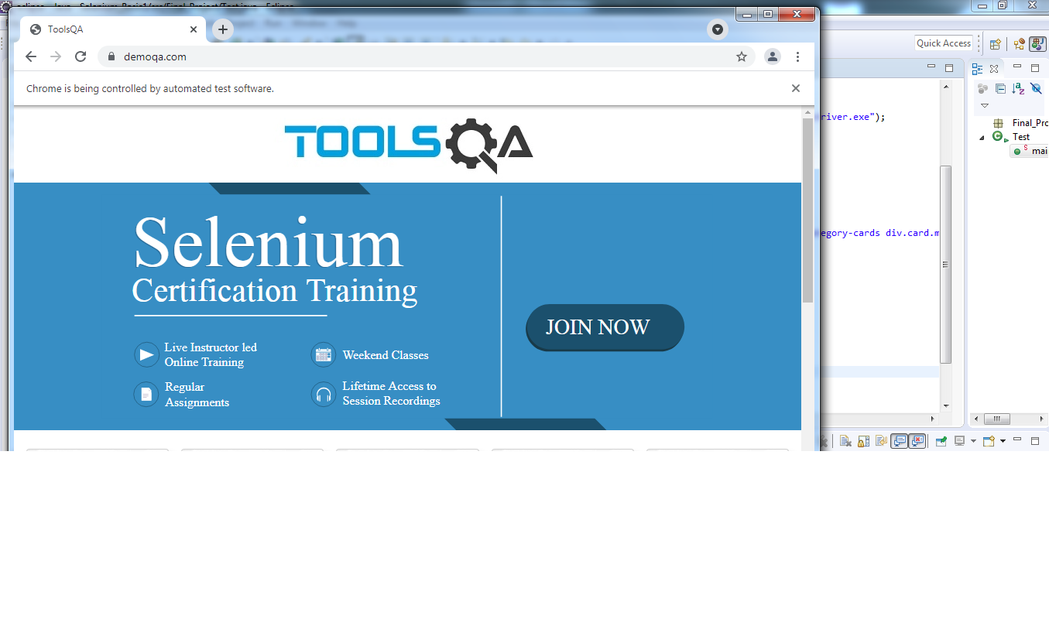

TC03- To Maximize the window

w.manage ().window ().maximize();//for maximize the window



TC04- To Get current page URL

System.out.println (w.getCurrentUrl());

**OUTPUT-** https://demoqa.com/

TC05- To scroll down

JavascriptExecutorjs = (JavascriptExecutor) w;

js.executeScript ("window.scrollTo (0, 1000)");

TC06- To click on Elements field

w.findElement(By.cssSelector("div.body-height:nth-child(2) div.home-content div.home-body div.category-cards div.card.mt-4.top-card:nth-child(1) div:nth-child(1) div.avatar.mx-auto.white>svg:nth-child(1)")).click();

TC07- To get page title

System.***out***.println (w.getTitle ());

**OUTPUT-** ToolsQA

TC08- To click on Text box field

w.findElement(By.id("item-0")).click();

TC09- To enter name in name field

w.findElement(By.id("username")).sendKeys("Sharayu D");

TC10- To enter Email

w.findElement(By.id("userEmail")).sendKeys("surabhi759@gmail.com");

TC11- To enter current address in text field

w.findElement(By.id("currentAddress")).sendKeys("New koradi");

TC12- To enter permanent address in text field

w.findElement(By.id("permanentAddress")).sendKeys("Plot. no. 175,New Koradi");

TC13- To scroll down

JavascriptExecutor js1 = (JavascriptExecutor) w;

js1.executeScript("window.scrollTo(0,200)");

TC14- To click on submit button

w.findElement(By.xpath("//button[@id='submit']")).click();

TC15- To print output in console

System.out.println("Registration done successfully!!!!");

**OUTPUT**- Registration done successfully!!!!

TC16- To click on check boxes

w.findElement(By.id("item-1")).click();

TC17- To click on home check box

w.findElement(By.xpath("//body/div[@id='app']/div[1]/div[1]/div[2]/div[2]/div[1]/div[1]/ol[1]/li[1]/span[1]/button[1]/*[1]")).click();

TC18- To click on desktop check box

w.findElement(By.xpath("//body/div[@id='app']/div[1]/div[1]/div[2]/div[2]/div[1]/div[1]/ol[1]/li[1]/ol[1]/li[1]/span[1]/label[1]/span[1]/*[1]")).click();

TC19- To click on documents check box

w.findElement(By.xpath("//body/div[@id='app']/div[1]/div[1]/div[2]/div[2]/div[1]/div[1]/ol[1]/li[1]/ol[1]/li[2]/span[1]/label[1]/span[1]/*[1]")).click();

TC20- To click on documents check box

w.findElement(By.xpath("//body/div[@id='app']/div[1]/div[1]/div[2]/div[2]/div[1]/div[1]/ol[1]/li[1]/span[1]/button[1]/*[1]")).click();

TC21- To click on radio button field

w.findElement(By.xpath("//span[contains(text(),'Radio Button')]")).click();

TC22- To click on “Impressive” radio button

w.findElement(By.xpath("//label[contains(text(),'Impressive')]")).click();

TC23- To print and get text of the radio button in console

System.out.println(w.findElement(By.xpath("//body/div[@id='app']/div[1]/div[1]/div[2]/div[2]/div[1]/p[1]")).getText());

**OUTPUT-** You have selected Impressive

TC24- To click on “Yes” radio button

w.findElement(By.xpath("//*[@id=\"app\"]/div/div/div[2]/div[2]/div[1]/div[2]/label")).click();

TC25- To print and get text of the radio button in console

System.out.println(w.findElement(By.xpath("//*[@id=\"app\"]/div/div/div[2]/div[2]/div[1]/div[2]/label")).getText());

**OUTPUT-** You have selected yes

TC24- To click on “No” radio button

w.findElement(By.xpath("//*[@id=\"app\"]/div/div/div[2]/div[2]/div[1]/div[4]/label")).click();

System.out.println("you select "+w.findElement(By.xpath("//*[@id=\"app\"]/div/div/div[2]/div[2]/div[1]/div[4]/label")).getText());

TC25- To scroll down

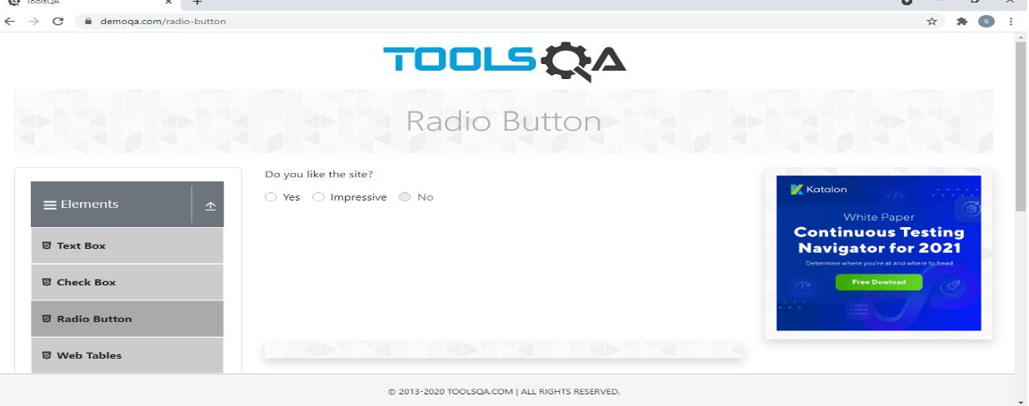**OUTPUT/DEFECT-** Enable to click on “NO” radio button

TC25- To scroll down

JavascriptExecutor js2 = (JavascriptExecutor) w;

js2.executeScript("window.scrollTo(0,200)");

TC26- Click on web tabs

w.findElement(By.id("item-3")).click();

TC27- Click on add button

w.findElement(By.id("addNewRecordButton")).click();

TC28- To enter the name in first name text field

w.findElement(By.id("firstName")).sendKeys("Sharayu");

TC29- To enter the last name in last name text field

w.findElement(By.id("lastName")).sendKeys("Durugkar");

TC30- To enter the user Email in user Email text field

w.findElement(By.id("userEmail")).sendKeys("surabhi7591@gmail.com");

TC31- To enter the age in age text field

w.findElement(By.id("age")).sendKeys("56");

TC32- To enter the salary in salary text field

w.findElement(By.id("salary")).sendKeys("50000000");

TC33- To enter the data in department text field

w.findElement(By.id("department")).sendKeys("IT");

TC34- Click on submit button and print on console

w.findElement(By.id("submit")).click();

System.***out***.println("Added successfully!!!");

**OUTPUT-** Added successfully!!!

TC35- Click on Search button

w.findElement(By.id("searchBox")).sendKeys("Sharayu");

w.findElement(By.id("basic-addon2")).click();

TC36- Click on buttons field

w.findElement(By.id("item-4")).click();

TC37- To double click on button and print on console

Actions A=new Actions(w);

WebElementelementLocator = w.findElement(By.*id*("doubleClickBtn"));

A.doubleClick(elementLocator).perform();

System.***out***.println("Double clicked");

**OUTPUT-** Double clicked

TC38- To right click on button and print on console

A.contextClick(w.findElement(By.id("rightClickBtn"))).perform();

System.out.println("Right clicked");

**OUTPUT-** Right clicked

TC39- To click on click button and print on console

A.click(w.findElement(By.id("Iv2dU"))).perform();

System.out.println("clicked successfully!!!!");

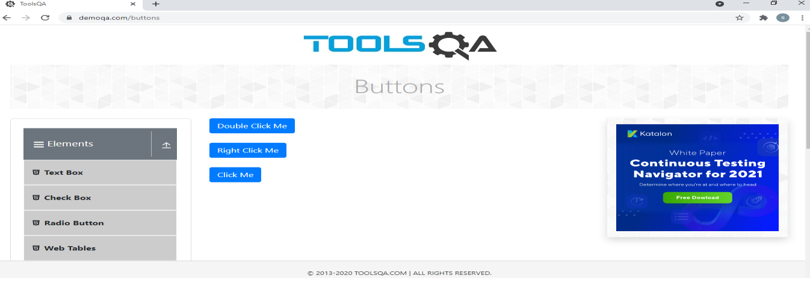

**OUTPUT/DEFECT-** Enable to click on click button

TC40- To scroll down

JavascriptExecutor js3 = (JavascriptExecutor) w;

js3.executeScript("window.scrollTo(0,1000)");

TC41- Click on links field

w.findElement(By.id("item-5")).click();

TC42- Click on “Home” link, opens new window and back to current window and get output on console

w.findElement(By.*linkText*("Home")).click();

Set <String> windows = w.getWindowHandles();

Iterator <String> IT = windows.iterator();

String parent_window = IT.next();

String child_window = IT.next();

w.switchTo().window(child_window);

Thread.sleep(10000);

w.switchTo().window(parent_window);

System.***out***.println(" Window open successfully!!!!");

**OUTPUT-** Window open successfully!!!!

TC43- Click on “Created” link, scroll down and print output on console

w.findElement(By.*linkText*("Created")).click();

JavascriptExecutor js4 = (JavascriptExecutor) w;

js4.executeScript("window.scrollTo(0,200)");

System.***out***.println("Link has responded with status 201 and status text Created");

**OUTPUT-** Link has responded with status 201 and status text Created

TC44- Click on “No content” link and print the output

w.findElement(By.linkText("No Content")).click();

System.out.println("Link has responded with status 204 and status text No Content");

**OUTPUT-** Link has responded with status 204 and status text No Content

TC45- Click on “Moved” link and print the output

w.findElement(By.linkText("Moved")).click();

System.out.println("Link has responded with status 204 and status text moved permanently");

**OUTPUT-** Link has responded with status 204 and status text moved permanently

TC45- Click on “Bad Request” link and print the output

w.findElement(By.linkText("Bad Request")).click();

System.out.println("Link has responded with status 400 and status text Bad Request");

**OUTPUT-** Link has responded with status 400 and status text Bad Request

TC46- Click on “Unauthorized” link and print the output

w.findElement(By.linkText("Unauthorized")).click();

System.out.println("Link has responded with status 401 and status text Unauthorized");

**OUTPUT-** Link has responded with status 401 and status text Unauthorized

TC46- Click on “Forbidden” link and print the output

w.findElement(By.linkText("Forbidden")).click();

System.out.println("Link has responded with status 403 and status text Forbidden");

**OUTPUT-** Link has responded with status 403 and status text Forbidden

TC46- Click on “Not Found” link and print the output

w.findElement(By.linkText("Not Found")).click();

System.out.println("Link has responded with status 404 and status text Not Found");

**OUTPUT-** Link has responded with status 404 and status text Not Found

TC47- To scroll down

JavascriptExecutor js5 = (JavascriptExecutor) w;

js5.executeScript("window.scrollTo(0,1000)");

TC48-Click on “Upload Download” field

w.findElement(By.xpath("//span[contains(text(),'Upload and Download')]")).click();

TC49-Click on “Download” field and print on output

w.findElement(By.id("downloadButton")).click();

System.out.println("Downloaded successfully");

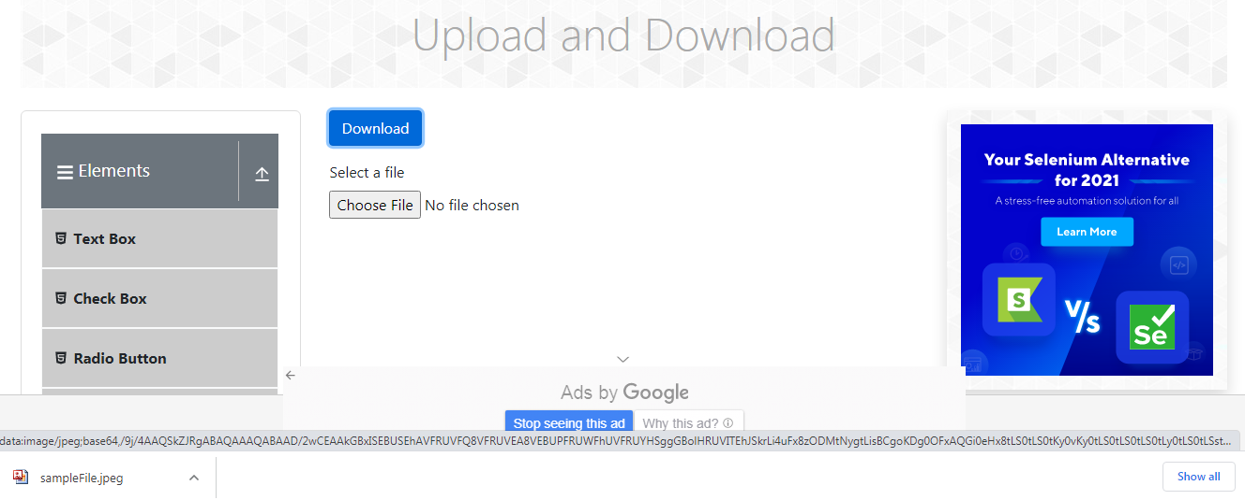

**OUTPUT-** Downloaded successfully

TC50-Click on “Upload file” field and print on output

w.findElement(By.xpath("//input[@id='uploadFile']")).sendKeys("C:\\Users\\Surabhi\\Desktop\\project\\IMG2.png ");

System.out.println("File successfully uploaded!!!");

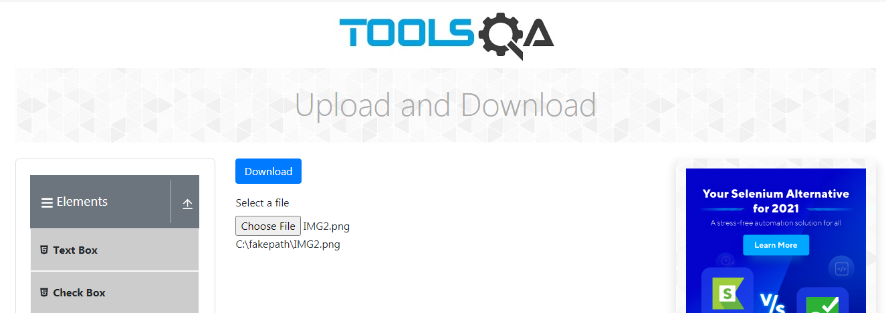**OUTPUT-** File successfully uploaded!!!

***Module No.2 - Forms***

TC51: To Click on Forms field Scroll Down

JavascriptExecutorjs = (JavascriptExecutor) w;

js.executeScript("window.scrollBy(0,500)");

WebElement E=w.findElement(By.xpath("/html[1]/body

[1]/div[2]/div[1]/dXiv[1]/div[2]/div [1]/div[2]/div[1]/div[3]/h5[1]"));

 js.executeScript("arguments[0].scrollIntoView();", E);  
 E.click();

TC52: To take screenshot for forms option

 TakesScreenshot t1= (TakesScreenshot) w;

File src1=t1.getScreenshotAs(OutputType.FILE)

 Files.copy(src1, new File ("D:\\Selenium_Screenshot\\Forms.png"));

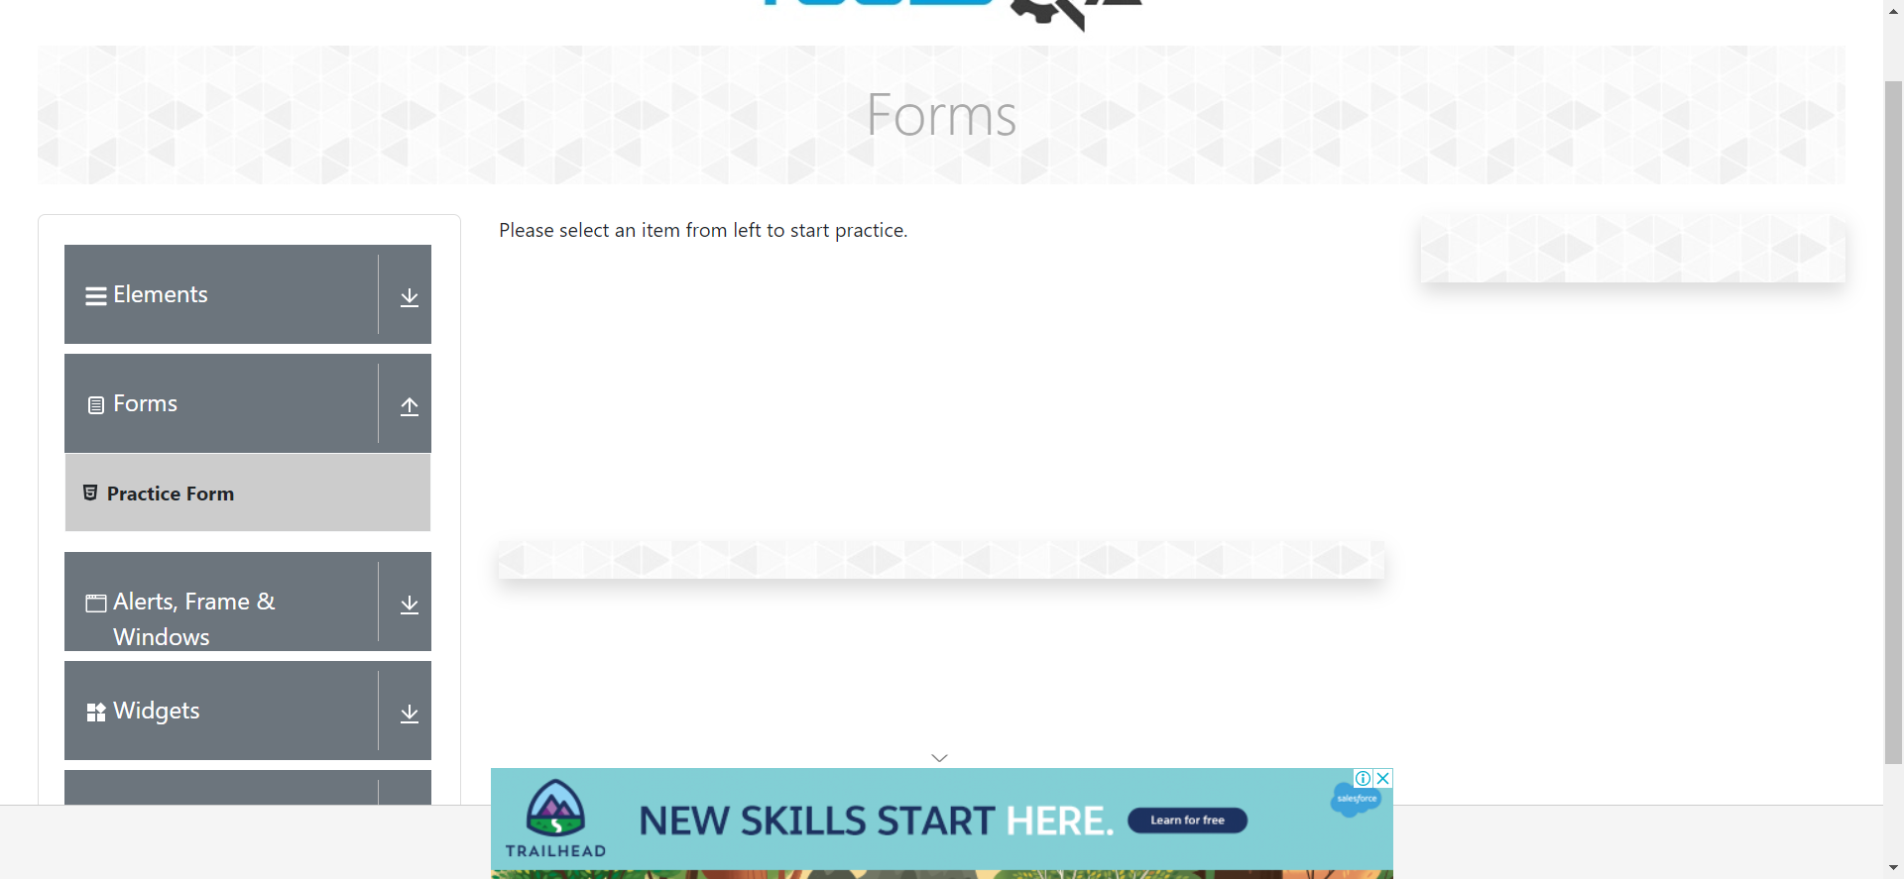

TC53: To click on Practice Form.

w.findElement(By.cssSelector("div.body-height:nth-child(2) div.container.playgound-body div.row div.col-12.mt-4.col-md-3:nth-child(1) div.left-panneldiv.accordiondiv.element-group:nth-child(2) div.element-list.collapse.showul.menu-list li.btn.btn-light >span.text:nth-child(2)")).click();

TC54: Maximize the window

w.manage().window().maximize();

TC55:To take screenshot for Practice form option

TakesScreenshot t2= ( TakesScreenshot) w;  
File src2=t2.getScreenshotAs(OutputType.FILE);  
Files.copy(src2, new File("D:\\Selenium_Screenshot\\Practice.png"));

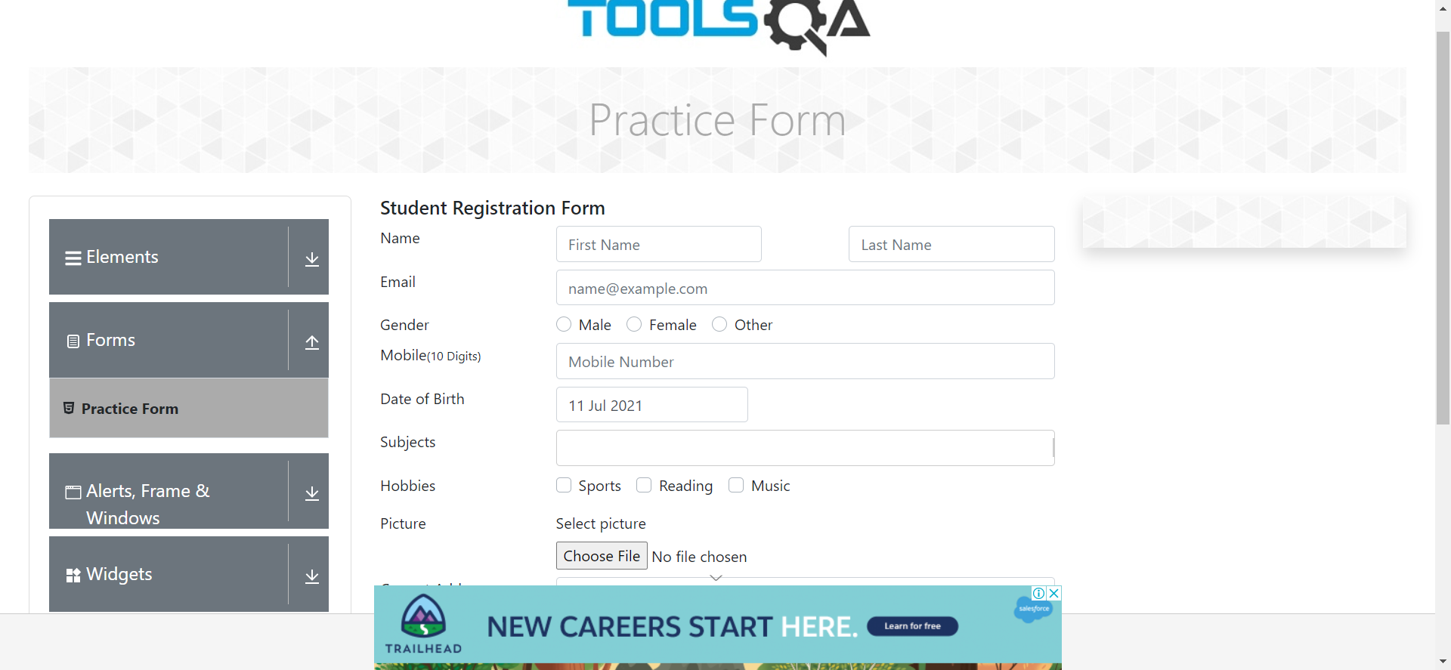

TC56 :To Check the functionality of student registration form with valid First Name, Last Name, Email Id

w.findElement(By.cssSelector("input#firstName")).sendKeys("Shaurya");  
w.findElement(By.cssSelector("input#lastName")).sendKeys("Gejage");   
w.findElement(By.cssSelector("input#userEmail")).sendKeys("[shambhugejage@gmail.com](mailto:shambhugejage@gmail.com)");

TC57: To Check the functionality of student registration form with selecting valid Gender

w.findElement(By.xpath("/html/body/div/div/div/div[2]/div[2]/div[1]/form/div[3]/div[2]/div[1]/label")).click(); *//Gender*

TC58: To Check the functionality of student registration form by entering valid mobile number

w.findElement(By.cssSelector("input#userNumber")).sendKeys("9632587412"); *//MobileNo*

TC59: To Check the functionality of student registration form with selecting valid Data of birth.

w.findElement(By.id("dateOfBirthInput")).click(); *//Select Date box*

Select s=new Select(w.findElement(By.xpath("/html/body/div/div/div/div[2]

/div[2]/div[1]/form/div[5]/div[2]/div[2]/div[2]/div/div/div[2]/div[1]/div[2]/div[1]/select")));   
s.selectByVisibleText("March");*//month*

Select s1=new Select(w.findElement(By.xpath("/html/body/div/div/div/div[2]/div[2]/div[1]/form/div[5]/div[2]/div[2]/div[2]/div/div/div[2]/div[1]/div[2]/div[2]/select")));  
s1.selectByVisibleText("2019");*//year*

w.findElement(By.xpath("/html/body/div/div/div/div[2]/div[2]/div[1]/form/div[5]/div[2]/div[2]/div[2]/div/div/div[2]/div[2]/div[2]/div[1]")).click();*//date*

TC60: To take screenshot for Student registration form with valid First Name, Last Name, Email Id, with selecting Gender by entering valid mobile number and selecting valid Data of birth.

TakesScreenshot t3= (TakesScreenshot) w;  
File src3=t3.getScreenshotAs(OutputType.FILE);  
Files.copy(src3, new File ("D:\\Selenium_Screenshot\\BeforSubjectExecution.png"));

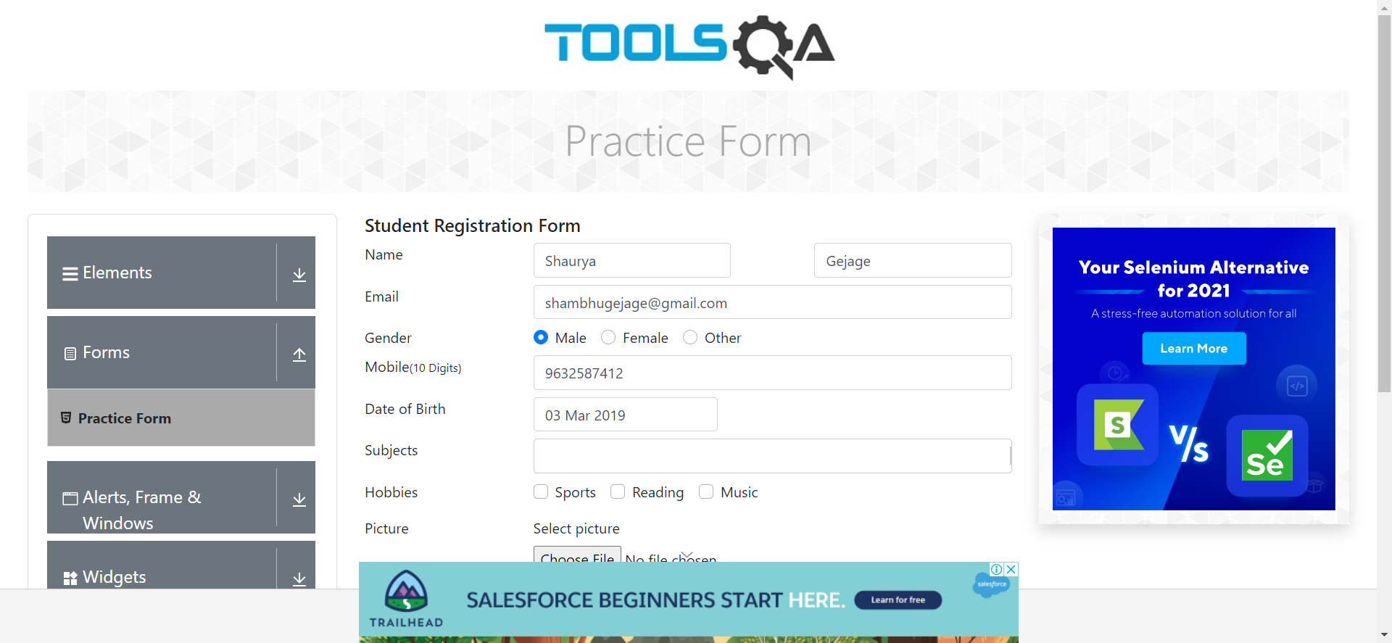

TC61 :To Check the functionality of student registration form with selecting valid Subject

w.findElement(By.cssSelector("div.body-height:nth-child(2) div.container.playgound-body div.row div.col-12.mt-4.col-md-6:nth-child(2) div.practice-form-wrapper div.mt-2.row:nth-child(6) div.col-md-9.col-sm-12 div.css-2b097c-container div.subjects-auto-complete__control.css-yk16xz-control>div.subjects-auto-complete__value-container.subjects-auto-complete__value-container--is-multi.css-1hwfws3")).sendKeys("Commerce"); *//subject*

**OUTPUT**:-Subject is not entering properly therefore it is Defect

Defect 01 : To Raise defect for Subject in Jira Tool

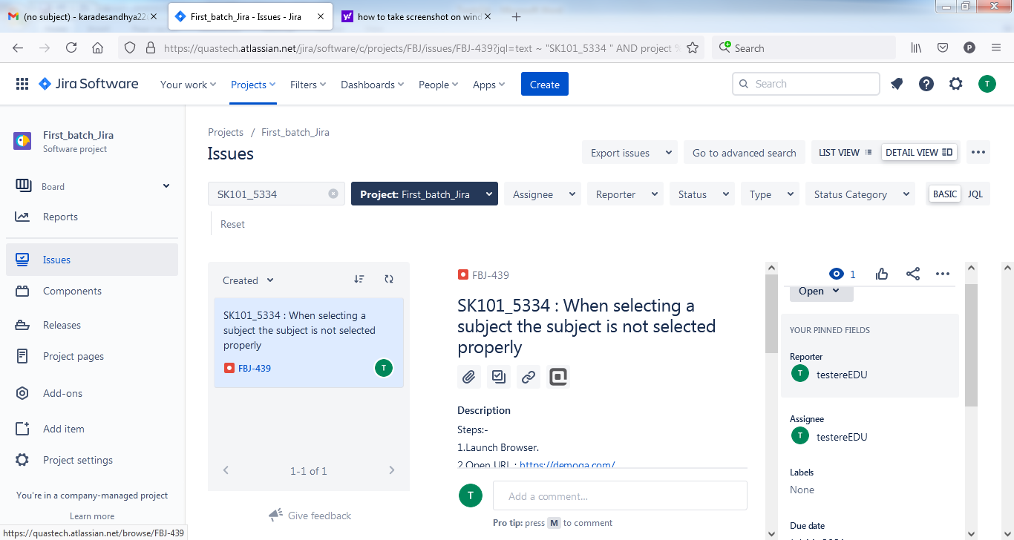

TC62 :To Check the functionality of student registration form click on hobbies Checkbox button with valid hobby name

w.findElement(By.cssSelector("div.body-height:nth-child(2) div.container.playgound-body div.row div.col-12.mt-4.col-md-6:nth-child(2) div.practice-form-wrapper form:nth-child(2) div.mt-2.row:nth-child(7) div.col-md-9.col-sm-12 div.custom-control.custom-checkbox.custom-control-inline:nth-child(1) >label.custom-control-label")).click();//Sports

w.findElement(By.cssSelector("div.body-height:nth-child(2) div.

container.playgound-bodydiv.row div.col-12.mt-4.col-md-6:nth-child(2) div.practice-form-wrapper form:nth-child(2) div.mt-2.row:nth-child(7)div.col-md-9.col-s12div.customcontrol.customcheckbox.custom

-control-inline:nth-child(2)>label.custom-controllabel")).click(); //reading

TC63: To Check the functionality of student registration form with uploading picture

w.findElement(By.cssSelector("#uploadPicture")).sendKeys("C:\\Users\\Rohan\\OneDrive\\Desktop\\Peacock.jpg");*//UploadPicture*

TC64: To Check the functionality of student registration form enter valid Current address

w.findElement(By.cssSelector("#currentAddress")).sendKeys("Oasis City,Narhe Pune");*//Address*

TC65:To Click on Submit button Scroll Down

JavascriptExecutor js1 = (JavascriptExecutor) w;  
 js1.executeScript("window.scrollBy(0,1000)");

w.findElement(By.id("submit")).click();

TC66: To Check the functionality of student registration form with selecting valid State and City.

Select S1=new Select(w.findElement(By.cssSelector("div.body-height:nth-child(2) div.container.playgound-body div.row div.col-12.mt-4.col-md-6:nth-child(2) div.practice-form-wrapper div.mt-2.row:nth-child(10) div.col-md-4.col-sm-12:nth-child(2) div.css-2b097c-container div.css-yk16xz-control > div.css-1hwfws3"))); //State

S1.selectByVisibleText("Uttar Pradesh");

Select S2=new Select(w.findElement(By.cssSelector("div.body-height:nth-child(2) div.container.playgound-body div.row div.col-12.mt-4.col-md-6:nth-child(2) div.practice-form-wrapper div.mt-2.row:nth-child(10) div.col-md-4.col-sm-12:nth-child(3) div.css-2b097c-container div.css-yk16xz-control > div.css-1hwfws3"))); //City

S2.deselectByVisibleText("Agra");

**OUTPUT:-** State and City is selecting properly therefore it is Defect

Defect 02: To Raise defect for State and City in Jira Tool

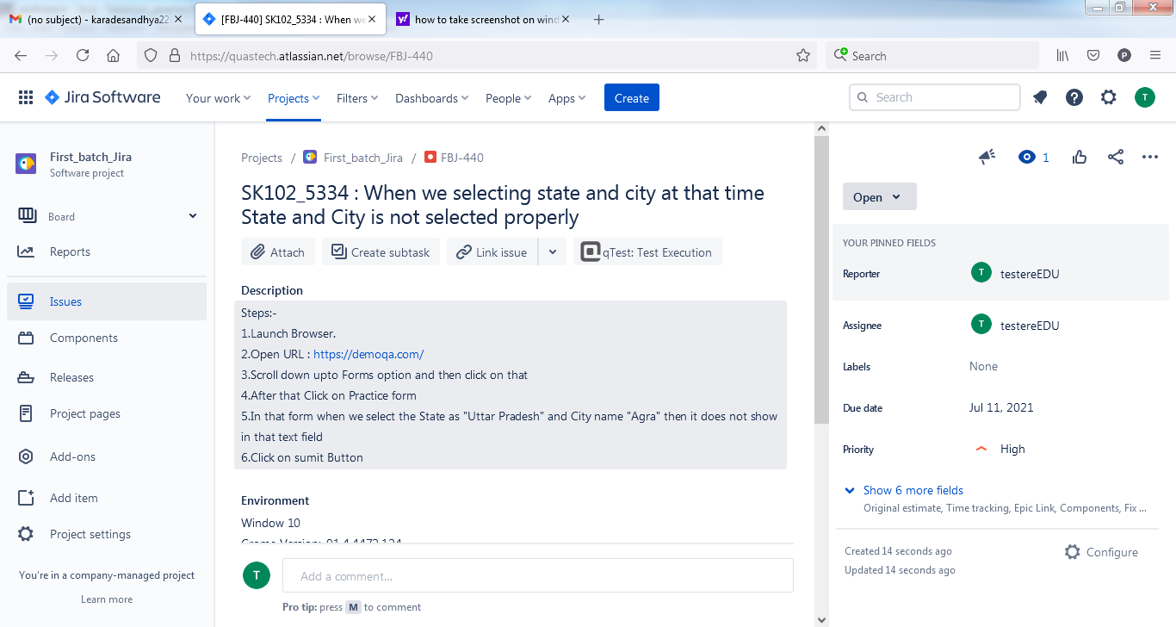

TC67:-To Take Screenshot For information of the student

TakesScreenshot t4= (TakesScreenshot) w;  
File src4=t4.getScreenshotAs(OutputType.FILE);  
Files.copy(src4, new File ("D:\\Selenium_Screenshot\\Registration.png"));

Thread.sleep(2000);

This form will look like this after filling all the information of student

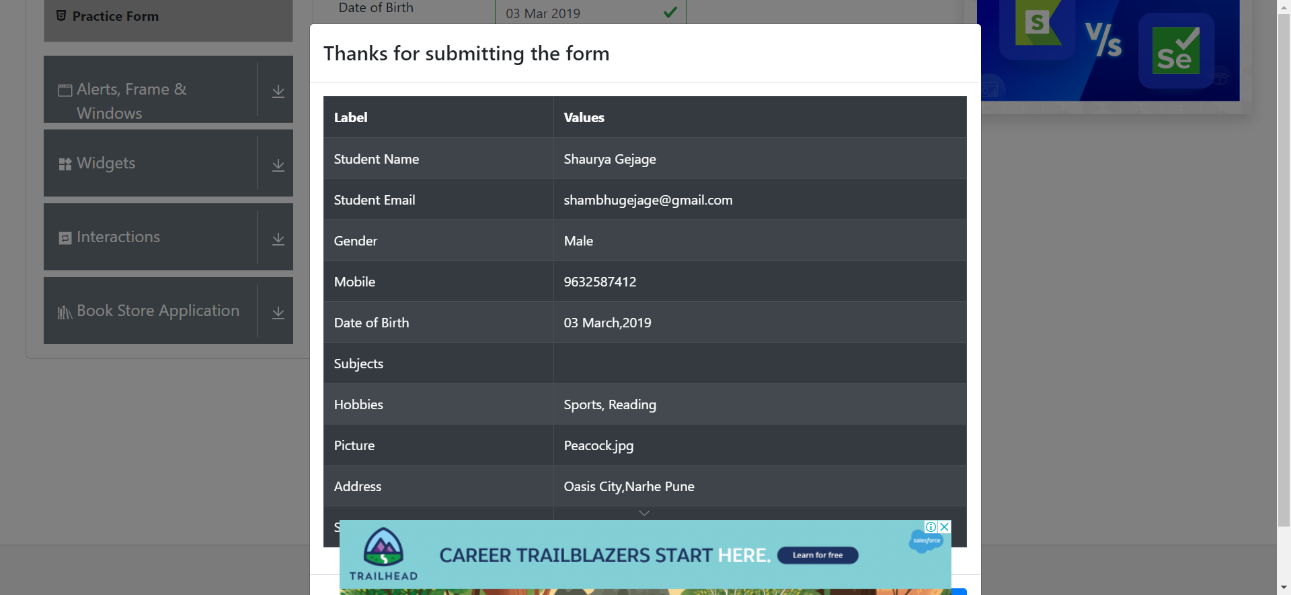

***Module No.2 - Alerts, Frame and Windows***

TC68: To click on Alerts, Frame and Windows option.

Scroll down

w.findElement(By.xpath("/html[1]/body[1]/div[2]/div[1]/div[1]/div[2]/div[1]/div[1]/div[1]/div[3]/span[1]/div[1]/div[1]")).click();  
Thread.sleep(2000);  
System.out.println("--------------Alerts,Frame & Windows-------------");

TC69:-To Take Screenshot For Alerts, Frame and Windows

TakesScreenshot t5= (TakesScreenshot) w;  
File src5=t5.getScreenshotAs(OutputType.FILE);  
Files.copy(src5, new File ("D:\\Selenium_Screenshot\\Main_Option.png"));

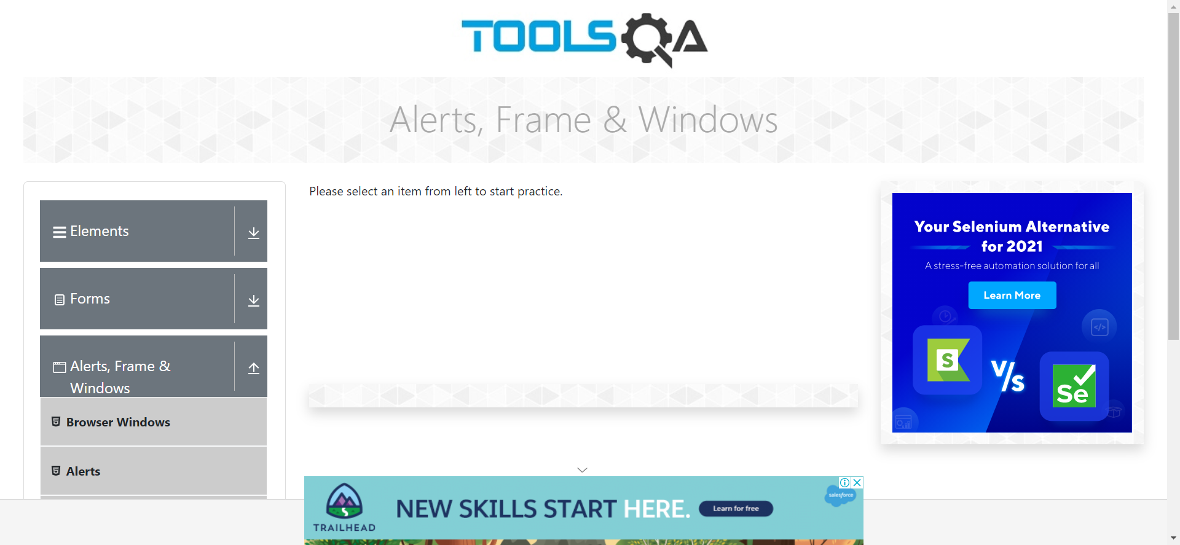

***A . Browser Window***

TC70: To Check the functionality of Browser Windows option.

 w.findElement(By.xpath("/html[1]/body[1]/div[2]/div[1]/div[1]/div[2]/div[1]/div[1]/div[1]/div[3]/div[1]/ul[1]/li[1]/span[1]")).click();   
System.out.println("A....Browser Window");

TC71: To Maximize the window

 w.manage().window().maximize();

TC72:To take Screenshot for browser window

TakesScreenshot t_win= (TakesScreenshot) w;  
File w1=t_win.getScreenshotAs(OutputType.FILE);  
Files.copy(w1, new File ("D:\\Selenium_Screenshot\\Windows.png"));  
Thread.sleep(2000);

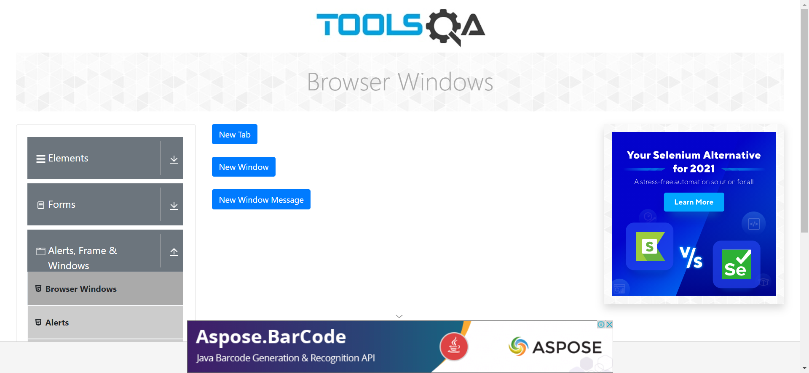

TC73: To Check the functionality of New Tab Button**.**

w.findElement(By.cssSelector("#tabButton")).click();  
  
 Set <String> windows= w.getWindowHandles();     
Iterator <String> it= windows.iterator();

String p_window=it.next();     
String c_window=it.next();  
w.switchTo().window(p_window);  
Thread.sleep(3000);  
w.switchTo().window(c_window);  
Thread.sleep(3000);  
System.out.println(w.findElement(By.id("sampleHeading")).getText());

**OUTPUT on Console:-**This is a sample page

TC74: To Check the functionality of New Window Button .

w.findElement(By.id("windowButton")).click();  
Set <String> Windows2= w.getWindowHandles();    
Iterator <String> it2= Windows2.iterator();   
  
String P2=it2.next();     
String C2=it2.next();  
w.switchTo().window(P2);  
Thread.sleep(3000);  
w.switchTo().window(C2);  
Thread.sleep(3000);  
w.manage().window().maximize();  
System.out.println(w.findElement(By.xpath("//*[@id=\"sampleHeading\"]")).getText());  
System.out.println("New Window Opened");  
w.switchTo().window(P2);

**OUTPUT on Console:-**This is a sample page

TC75: To Check the functionality of New Window Message Button .

w.findElement(By.id("messageWindowButton")).click();  
Set <String> Windows3= w.getWindowHandles();    
Iterator <String> it3= Windows3.iterator();  
  
String P3=it3.next();     
String C3=it3.next();  
w.switchTo().window(P3);  
Thread.sleep(3000);  
w.switchTo().window(C3);  
Thread.sleep(3000);  
w.manage().window().maximize();  
System.out.println(w.findElement(By.cssSelector("body")).getText());  
  
System.out.println("New Message Window Opened");  
w.switchTo().window(P3);

**OUTPUT on Console:-** This is a sample page

***B. Alert***

TC76:Scroll down for click on Alert Option

JavascriptExecutor js2 = (JavascriptExecutor) w;  
js2.executeScript("window.scrollBy(0,1000)");

Thread.sleep(2000);

TC77: To Check the functionality of Alerts option**.**

  w.findElement(By.xpath("/html[1]/body[1]/div[2]/div[1]/div[1]/div[2]/div[1]/div[1]/div[1]/div[3]/div[1]/ul[1]/li[2]/span[1]")).click();  
 System.out.println("B....Alert");

TC78: Take screenshot of Alerts window

 TakesScreenshot a1= (TakesScreenshot) w;  
File f1=a1.getScreenshotAs(OutputType.FILE);  
Files.copy(f1, new File ("D:\\Selenium_Screenshot\\Alert.png"));  
Thread.sleep(2000);

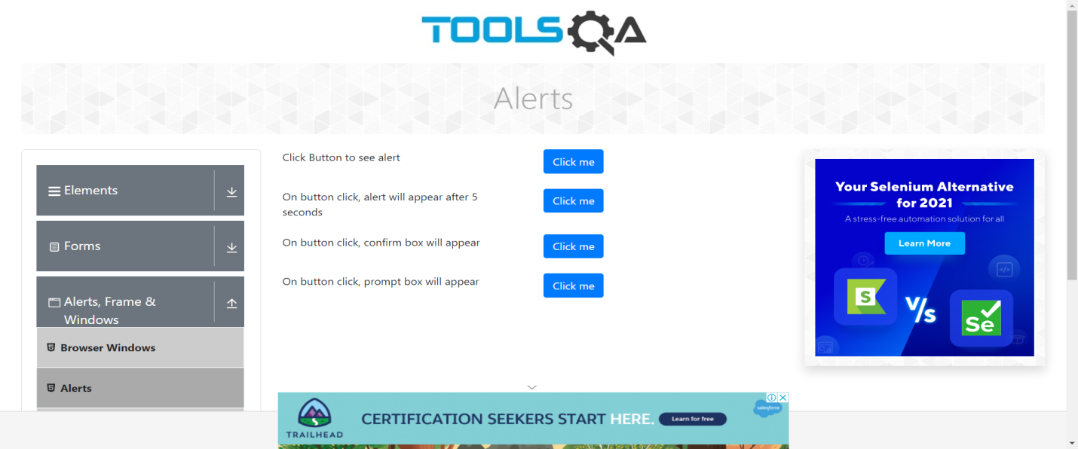

TC79:To Check the functionality of Click Button to see Alert simple Alert.

w.findElement(By.xpath("//*[@id=\"alertButton\"]")).click();  
Thread.sleep(2000);  
Alert A1 = w.switchTo().alert();      
System.out.println(A1.getText());  Thread.sleep(2000);  
A1.accept();//to click OK button  
System.out.println("Simple Alert accepted ");  
Thread.sleep(2000);

**OUTPUT on Console**:-You clicked a button

TC81: To Check the functionality of On Button Click, Alert will appear after 5 second.

w.findElement(By.id("timerAlertButton")).click();  
Thread.sleep(2000);  
  
Alert A2 = w.switchTo().alert();  
System.out.println(A2.getText());  
Thread.sleep(2000);  
A2.accept();  
System.out.println("Wait Alert accepted ");  
Thread.sleep(2000);

System.out.println("Defect 03:-In Alert option wait alert ok Button is Not clickable by Automatic way but its work manually Properly");

TC82: Take screenshot for second Alert button

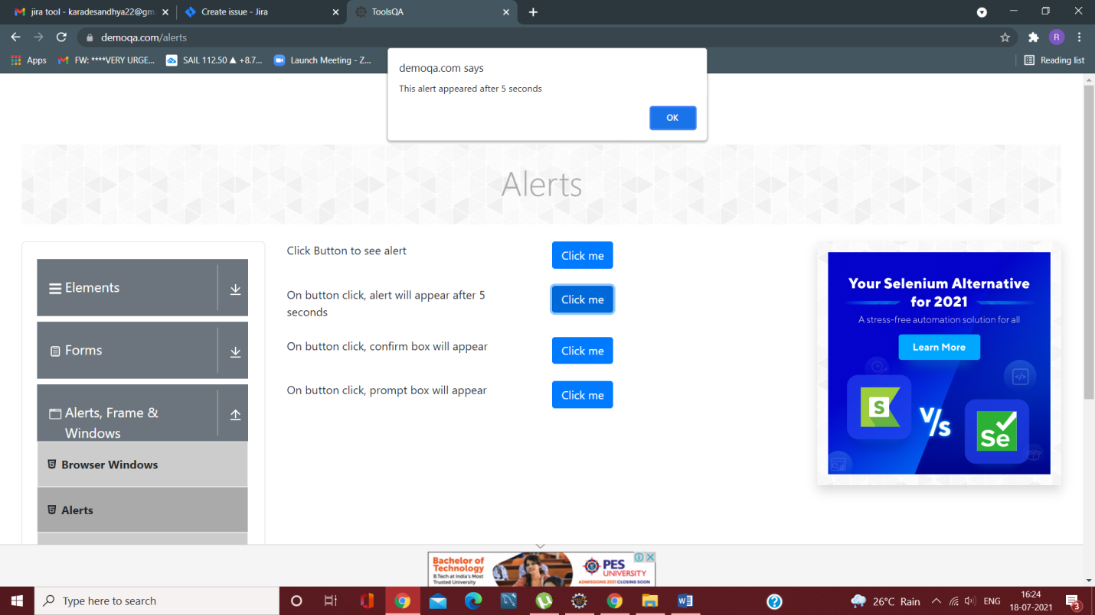

Defect 03:-In Alert option wait alert ok Button is Not clickable by Automatic way but its work manually Properly

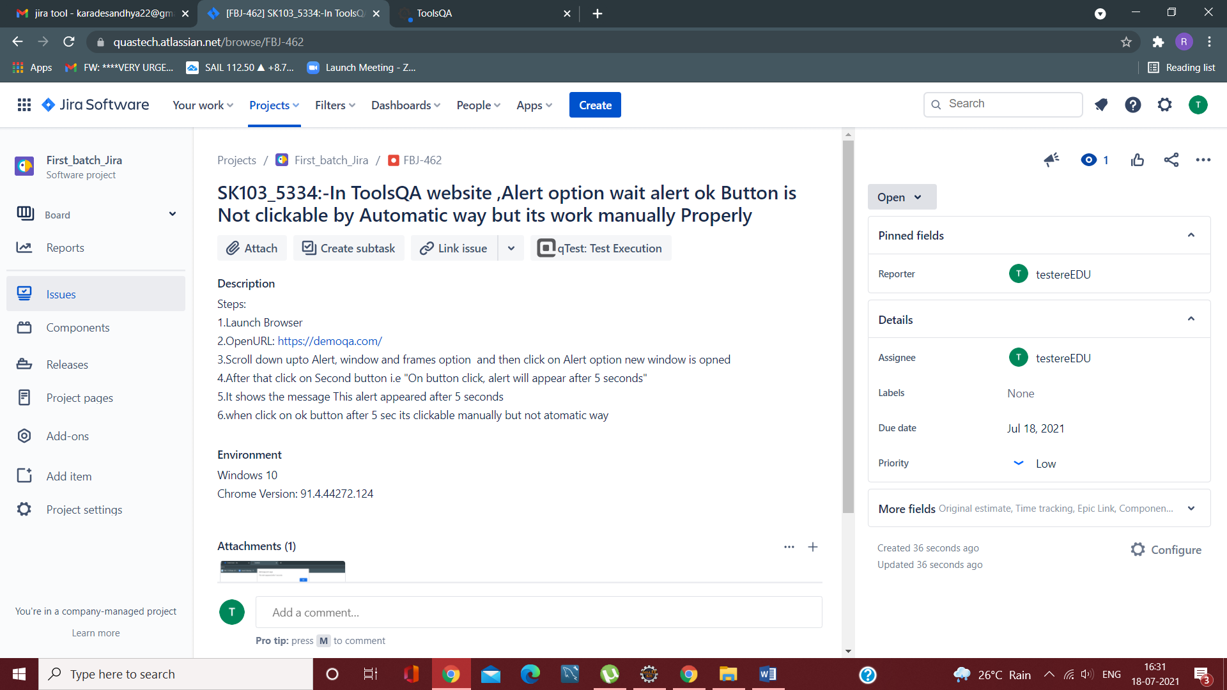

TC83: Accepting Confirm Alert

w.findElement(By.id("confirmButton")).click();  
Thread.sleep(2000);  
  
Alert A3 = w.switchTo().alert();  
Thread.sleep(2000);  
System.out.println(A3.getText());  
A3.accept();  
System.out.println("Confirm Alert accepted ");  
Thread.sleep(2000);

**OUTPUT on Consle:-**Do you confirm action?

TC84: Take screenshot for ConfimedAlert button

TakesScreenshot T3= (TakesScreenshot) w;  
File Src3=T3.getScreenshotAs(OutputType.FILE);  
Files.copy(Src3, new File ("D:\\Selenium_Screenshot\\ confirm.png"));

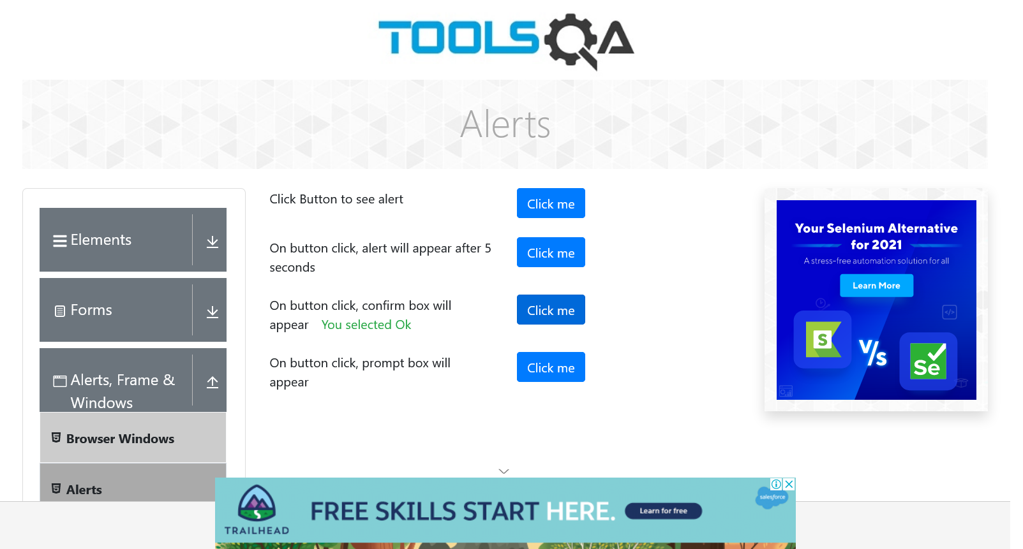

TC85:Dissmiss Confirm Alert

w.findElement(By.id("confirmButton")).click();  
Thread.sleep(2000);  
  
Alert D1 = w.switchTo().alert();  
Thread.sleep(2000);  
System.out.println(D1.getText());  
D1.dismiss();  
System.out.println("Confirm Alert dismissed");  
Thread.sleep(2000);

TC86: Accepting Prompt Alert

w.findElement(By.xpath("/html[1]/body[1]/div[2]/div[1]/div[1]/div[2]/div[2]/div[1]/div[4]/div[2]/button[1]")).click();  
Alert A4 = w.switchTo().alert();  
A4.sendKeys("Sandhya"); Thread.sleep(2000);  
System.out.println(A4.getText());  
Thread.sleep(2000);  
A4.accept();   
System.out.println("Promt Alert accepted ");Thread.sleep(2000);

**OUTPUT on console:-**Please enter your name

TC87: Take screenshot for prompt Alert button

TakesScreenshot T4= (TakesScreenshot) w;  
File Src4=T4.getScreenshotAs(OutputType.FILE);  
Files.copy(Src4,new File("D:\\Selenium_Screenshot\\prompt.png"));

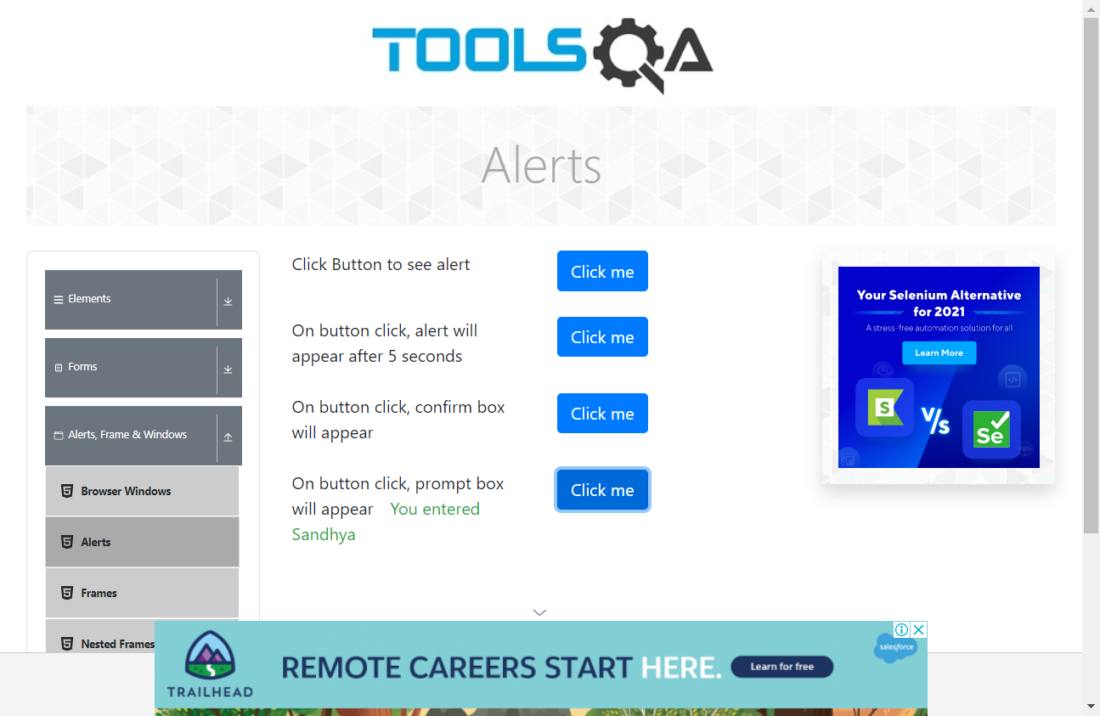

Defect 04:-In Alert option promt alert not showing text while running the program

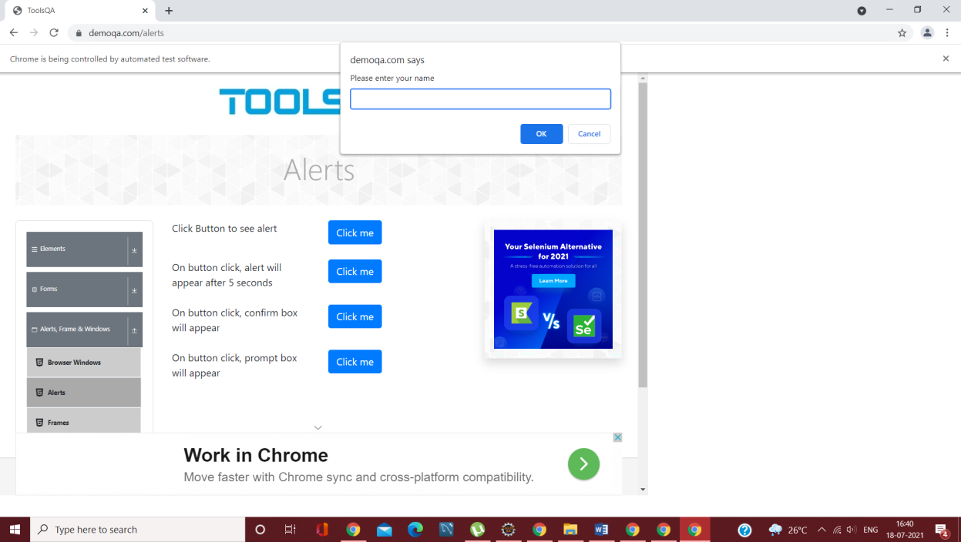

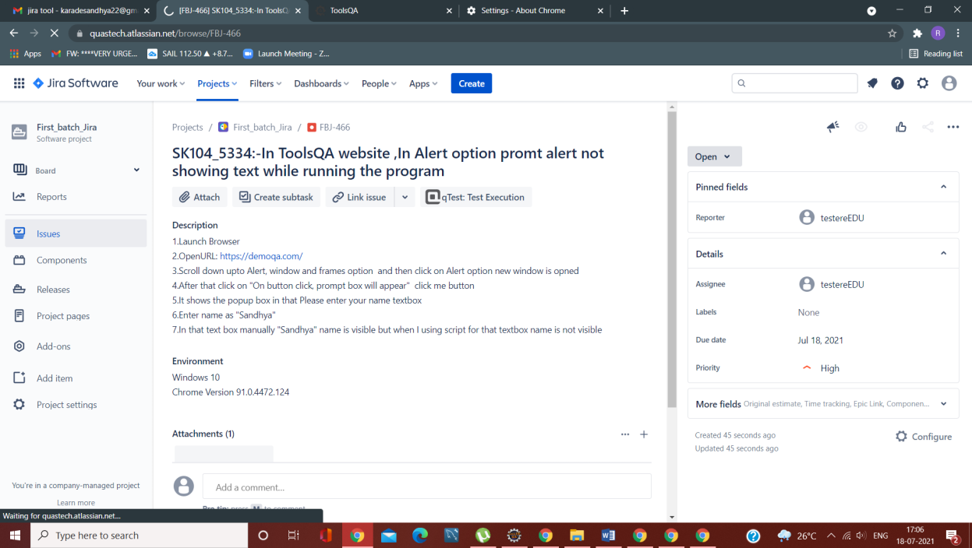

TC88: Dismiss Prompt Alert

w.findElement(By.xpath("/html[1]/body[1]/div[2]/div[1]/div[1]/div[2]/div[2]/div[1]/div[4]/div[2]/button[1]")).click();  
Thread.sleep(2000);

Alert A5 = w.switchTo().alert();

System.out.println(A5.getText());  
Thread.sleep(2000);  
A5.dismiss();   
System.out.println("Promt Alert dismissed");  
Thread.sleep(2000);  
w.navigate().back();

***C.Frames***

TC89: To get Frames option scroll down

JavascriptExecutor js3 = (JavascriptExecutor) w;  
js3.executeScript("window.scrollBy(0,1000)");

TC90: To click on Frames option

w.findElement(By.xpath("/html[1]/body[1]/div[2]/div[1]/div[1]/div[2]/div[1]/div[1]/div[1]/div[3]/div[1]/ul[1]/li[3]/span[1]\r\n")).click();

TC90: Page up

 js3.executeScript("window.scrollBy(0,-500)");

TC91: To take screenshot for Frames option

TakesScreenshot t1= (TakesScreenshot) w;  
File src1=t1.getScreenshotAs(OutputType.FILE);  
Files.copy(src1, new File ("D:\\Selenium_Screenshot\\Frames.png"));

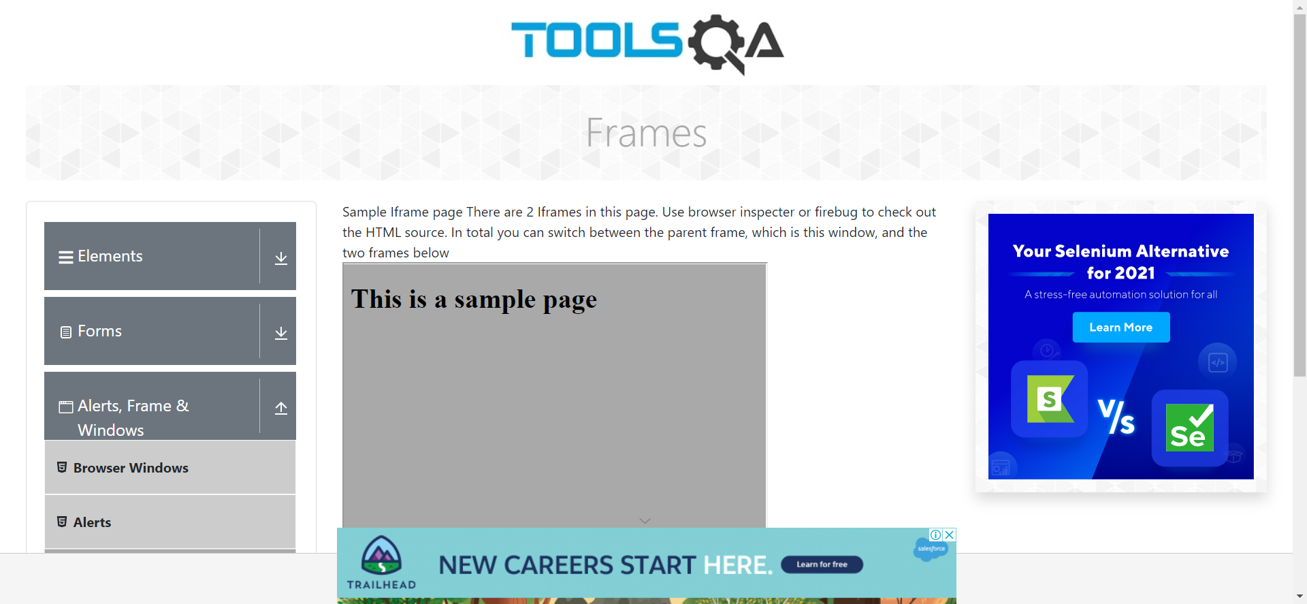

TC92: To Check Total no of iframes in that page

 List<WebElement> list=w.findElements(By.tagName("iframe"));  
System.out.println("Total no of iframs are = " + list.size());

**OUTPUT on Console:-**Total no of iframs are = 6

TC93: Switch between Frames

w.switchTo().frame("frame2");  
System.out.println(w.findElement(By.id("sampleHeading")).getText());  
w.switchTo().defaultContent();

w.findElement(By.xpath("//*[@id=\"sampleHeading\"]")).getText();  
w.close();

**OUTPUT on console:**-This is a sample page

***D.Nasted Frames***

TC94: To get NastedFrames option scroll down

JavascriptExecutorjs = (JavascriptExecutor) w;  
js.executeScript("window.scrollBy(0,500)");

Thread.sleep(2000);

TC95: To click on NastedFrames option

w.findElement(By.xpath("//span[contains(text(),'Nested Frames')]")).c;  
js.executeScript("arguments[0].scrollIntoView();", E1);  
E1.click();

TC96:Scroll up

 js.executeScript("window.scrollBy(0,-500)");

TC97:- To take screenshot for NastedFrames option

TakesScreenshot t1= (TakesScreenshot) w;  
File src1=t1.getScreenshotAs(OutputType.FILE);  
Files.copy(src1, new File ("D:\\Selenium_Screenshot\\NastedFrames.png"));

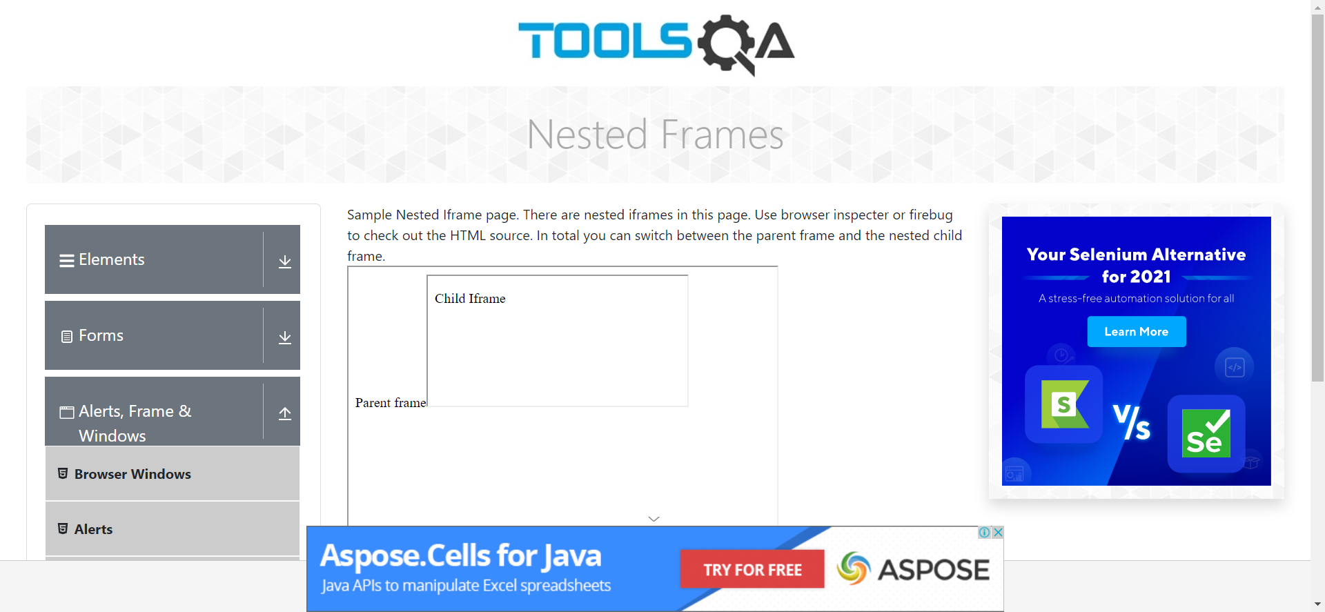

TC98:ToCheck Total no of iframes in that page

List<WebElement> list=w.findElements(By.tagName("iframe"));  
System.out.println("Total no of iframs are = " + list.size());

**OUTPUT on Console:-**Total no of iframs are = 4

**OUTPUT on Console:-**Total no of iframs are = 4

***D.Modal_Dialogs***

TC99: To get Modal Dialogs option scroll down page

JavascriptExecutorjs = (JavascriptExecutor) w;  
js.executeScript("window.scrollBy(0,500)");

TC100: To Click on Modal Dialogs option

w.get("<https://demoqa.com/modal-dialogs>");  
System.out.println("E....Modal Dialog");

TC101: To Take screenshot for Modal Dialogs Page

TakesScreenshot t1= (TakesScreenshot) w;  
File src1=t1.getScreenshotAs(OutputType.FILE);  
Files.copy(src1, new File ("D:\\Selenium_Screenshot\\Modal_Dialogs.png"));

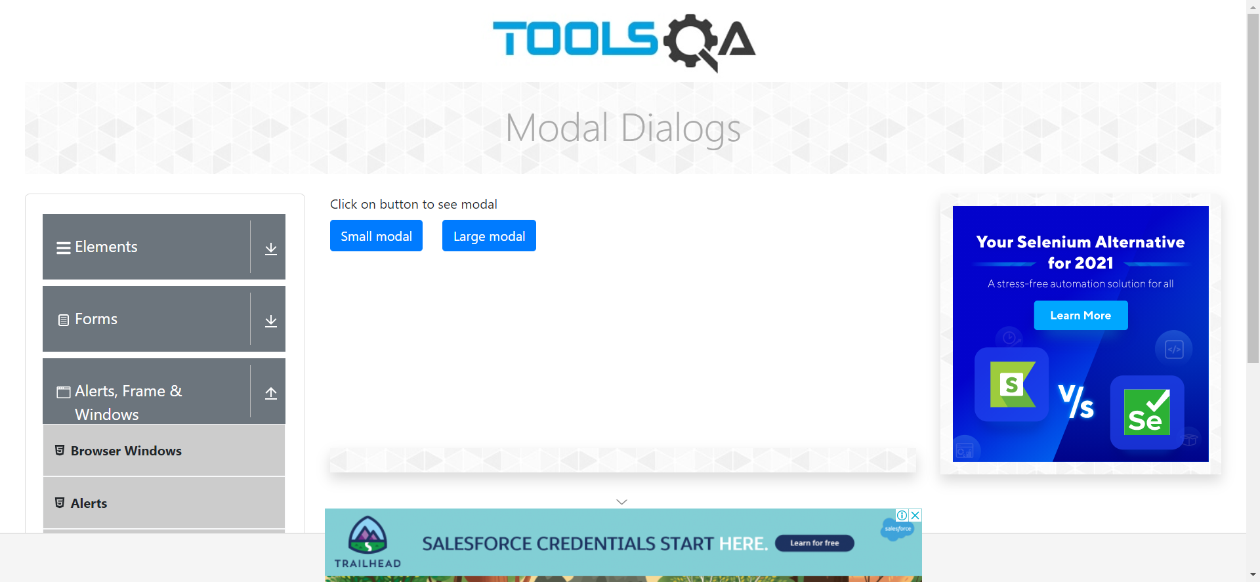

TC102: To Click on Small Model button

w.findElement(By.id("showSmallModal")).click();  
Thread.sleep(2000);

TC103: To Take screenshot for Small Modal

TakesScreenshot t2= (TakesScreenshot) w;  
File src2=t2.getScreenshotAs(OutputType.FILE);  
Files.copy(src2, new File ("D:\\Selenium_Screenshot\\SmallModal.png"));

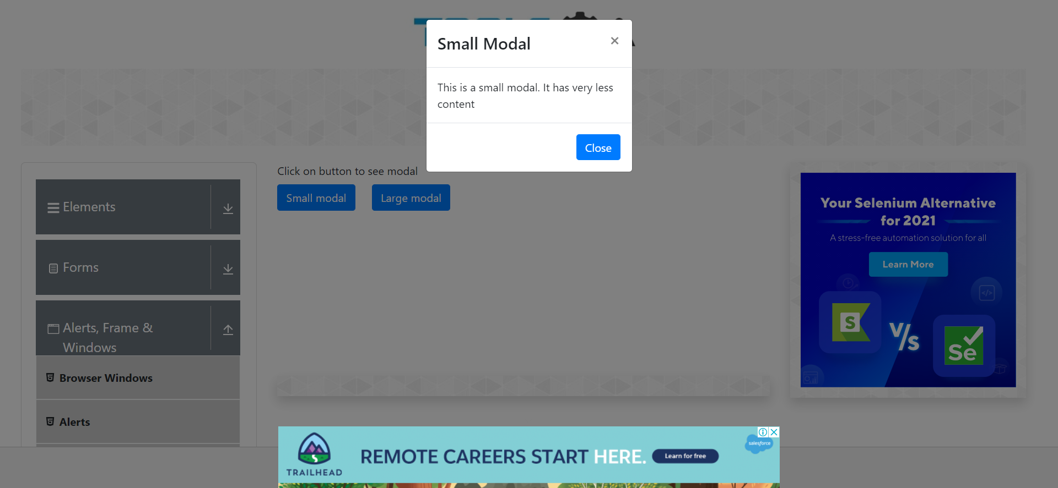

TC104: To Print small modal message on console

WebElement S=w.findElement(By.xpath("/html/body/div[4]/div/div/div[2]"));  
System.out.println(S.getText());

**Output on Console:-**This is a small modal. It has very less content

TC105:To click on Close Option i.e ‘x’sign

w.findElement(By.xpath("/html/body/div[4]/div/div/div[1]/button/span[1]")).click();

TC106:To click on Close Button

w.findElement(By.id("closeSmallModal")).click();

TC107: To Click on Large Model button

w.findElement(By.id("showLargeModal")).click();  
Thread.sleep(2000);

TC108: To Take screenshot for Large Modal

TakesScreenshot t3= (TakesScreenshot) w;  
File src3=t3.getScreenshotAs(OutputType.FILE);  
Files.copy(src3, new File ("D:\\Selenium_Screenshot\\LargeModal.png"));

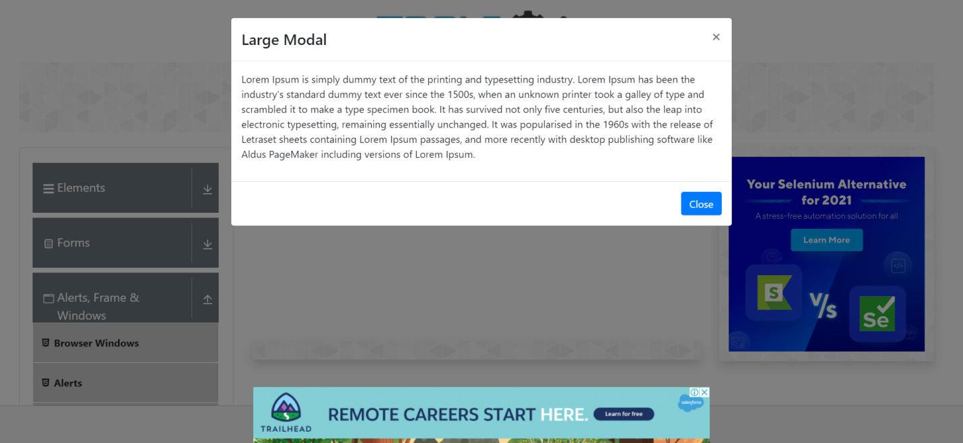

TC109:To Print large modal message on console

WebElement L=w.findElement(By.xpath("/html/body/div[4]/div/div/div[2]/p"));  
System.out.println(L.getText());

**Output on Console:-**Lorem Ipsum is simply dummy text of the printing and typesetting industry. Lorem Ipsum has been the industry's standard dummy text ever since the 1500s, when an unknown printer took a galley of type and scrambled it to make a type specimen book. It has survived not only five centuries, but also the leap into electronic typesetting, remaining essentially unchanged. It was popularised in the 1960s with the release of Letraset sheets containing Lorem Ipsum passages, and more recently with desktop publishing software like Aldus PageMaker including versions of Lorem Ipsum.

TC110:To click on Close Option i.e ‘x’sign

w.findElement(By.xpath("//span[contains(text(),'×')]")).click();

TC111:To click on Close Button

w.findElement(By.id("closeLargeModal")).click();

TC112:Close the window

w.close();

***Module No.4– Widgets***

TC113 - Launch the chrome browser

System.*setProperty*("webdriver.chrome.driver", "C:\\Users\\Admin\\Desktop\\Selenium Jar\\chromedriver.exe");

WebDriver w=**new**ChromeDriver();

TC114 - Open toolsQA URL

w.get ("https://www.demoqa.com/");



TC115 - To Maximize the window

w.manage ().window ().maximize();//for maximize the window



TC116 - To Get current page URL

System.out.println (w.getCurrentUrl ());

**OUTPUT-** https://demoqa.com/

TC117 - To scroll down

JavascriptExecutorjs = (JavascriptExecutor) w;

js.executeScript ("window.scrollTo (0, 1000)");

TC118 - To click on Widgets field

w.findElement(By.cssSelector("div.body-height:nth-child(2) div.home-content div.home-body div.category-cards > div.card.mt-4.top-card:nth-child(4)")).click();

TC119 - To get page title

System.***out***.println (w.getTitle ());

**OUTPUT-** ToolsQA

TC120 - To click onAccordian

w.findElement(By.cssSelector("div.body-height:nth-child(2) div.container.playgound-body div.row div.col-12.mt-4.col-md-3:nth-child(1) div.left-panneldiv.accordiondiv.element-group:nth-child(4) div.element-list.collapse.showul.menu-list li.btn.btn-light:nth-child(1) >span.text:nth-child(2)")).click();

TC121 - To scroll down

JavascriptExecutor js1 = (JavascriptExecutor) w;

js1.executeScript("window.scrollTo(0,200)");

TC122 - To click on Auto Complete

w.findElement(By.xpath("//body/div[@id='app']/div[1]/div[1]/div[2]/div[1]/div[1]/div[1]/div[4]/div[1]/ul[1]/li[2]")).click();

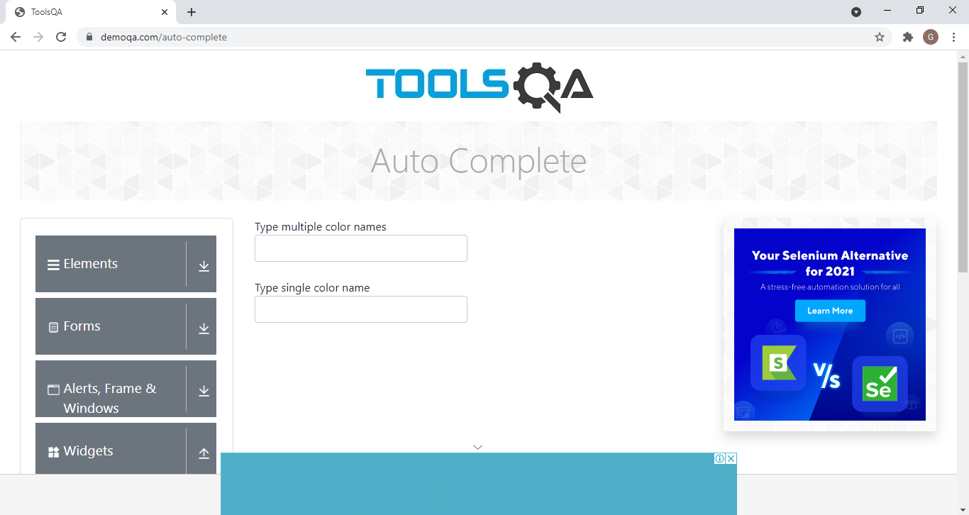

**OUTPUT/DEFECT –** Enable to enter the text in that textfields.

TC123 - To scroll down

JavascriptExecutor js2 = (JavascriptExecutor) w;

js2.executeScript("window.scrollTo(0,000)");

TC124 - To click on Date Picker

w.findElement(By.xpath("//body/div[@id='app']/div[1]/div[1]/div[2]/div[1]/div[1]/div[1]/div[4]/div[1]/ul[1]/li[3]")).click();

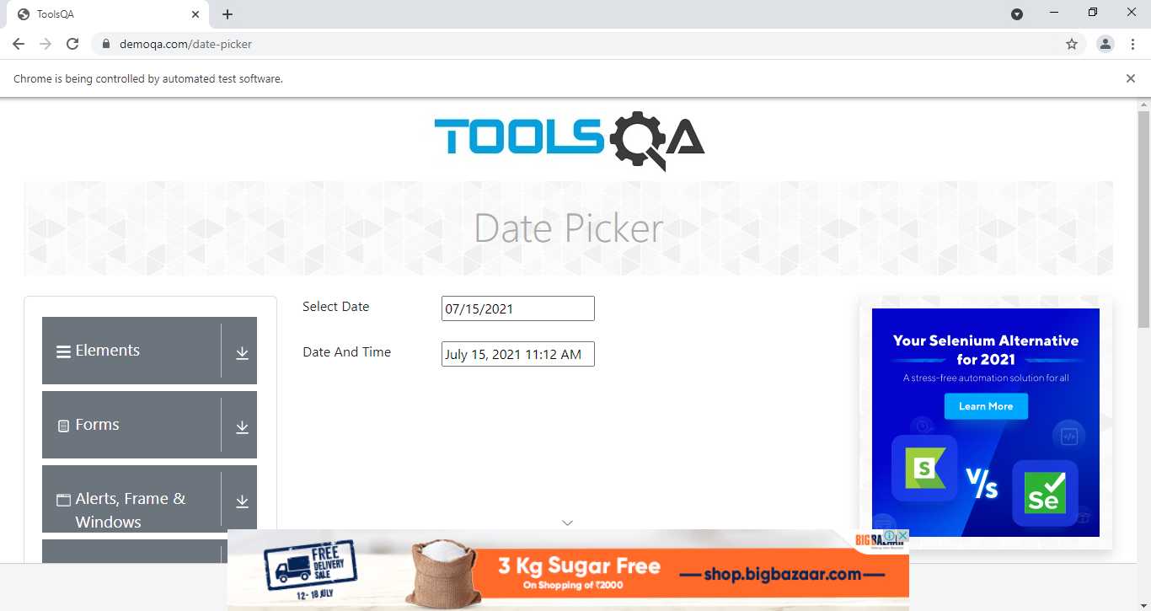

**OUTPUT/DEFECT-** Enable to enter the new date and time in that text fields.

TC125 - To scroll down

JavascriptExecutor js2 = (JavascriptExecutor) w;

js2.executeScript("window.scrollTo(0,000)");

TC126 -To click on Slider

w.findElement(By.xpath("//body/div[@id='app']/div[1]/div[1]/div[2]/div[1]/div[1]/div[1]/div[4]/div[1]/ul[1]/li[4]")).click();

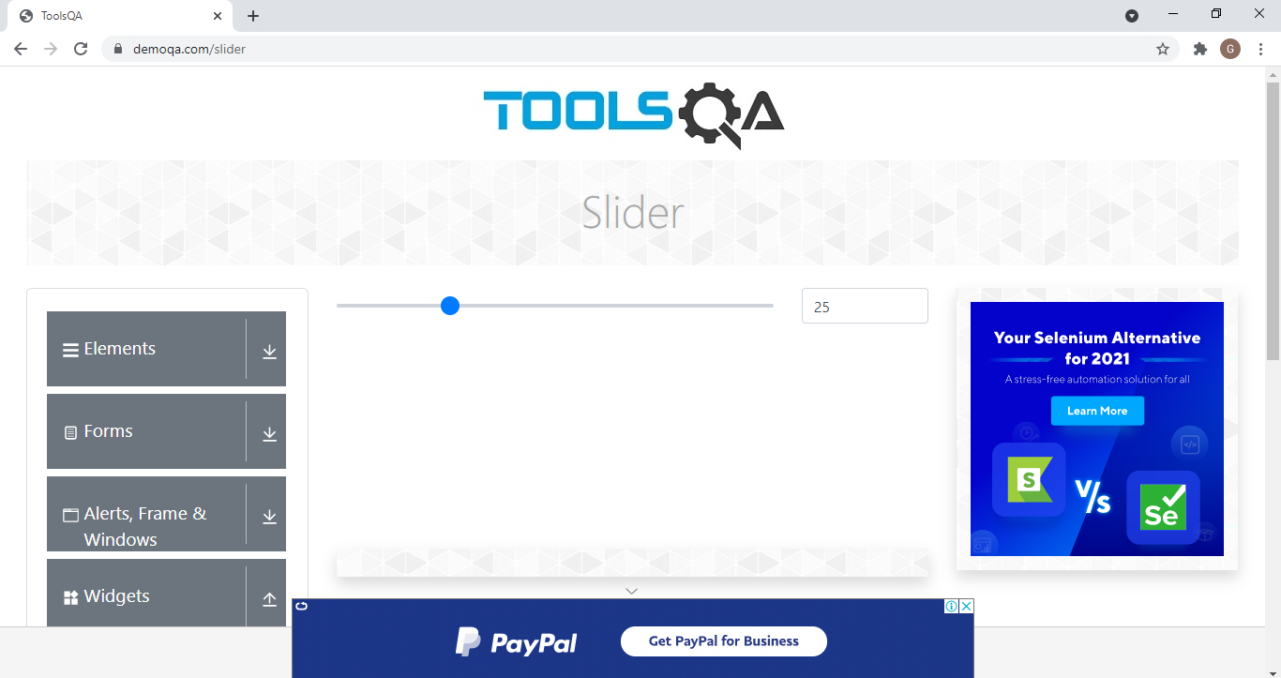

**OUTPUT/DEFECT-** Enable to scroll the slider

TC127 - To scroll down

JavascriptExecutor js2 = (JavascriptExecutor) w;

js2.executeScript("window.scrollTo(0,000)");

TC128 -To click on Progress Bar

w.findElement(By.xpath("//span[contains(text(),'Progress Bar')]")).click();

TC129 -To click on Start button

w.findElement(By.id("startStopButton")).click();

TC130 -To click on Stop button

w.findElement(By.xpath("//button[@id='startStopButton']")).click();

TC131 - To scroll down

JavascriptExecutor js2 = (JavascriptExecutor) w;

js2.executeScript("window.scrollTo(0,000)");

TC132-To click on Tabs

w.findElement(By.xpath("//body/div[@id='app']/div[1]/div[1]/div[2]/div[1]/div[1]/div[1]/div[4]/div[1]/ul[1]/li[6]")).click();

TC133-To click on What

w.findElement(By.id("demo-tab-what")).click();

TC134 -To click on Origin

w.findElement(By.id("demo-tab-origin")).click();

TC135 -To click on Use

w.findElement(By.id("demo-tab-use")).click();

TC136 - To scroll down

JavascriptExecutor js2 = (JavascriptExecutor) w;

js2.executeScript("window.scrollTo(0,000)");

TC137 -To click on Tool Tips

w.findElement(By.xpath("//body/div[@id='app']/div[1]/div[1]/div[2]/div[1]/div[1]/div[1]/div[4]/div[1]/ul[1]/li[7]")).click();

TC138 - To scroll down

JavascriptExecutor js2 = (JavascriptExecutor) w;

js2.executeScript("window.scrollTo(0,000)");

TC139 -To click on Menu

w.findElement(By.xpath("//body/div[@id='app']/div[1]/div[1]/div[2]/div[1]/div[1]/div[1]/div[4]/div[1]/ul[1]/li[8]")).click();

TC140 -To click on Main Item 2

w.findElement(By.xpath("//a[contains(text(),'Main Item 2')]")).click();

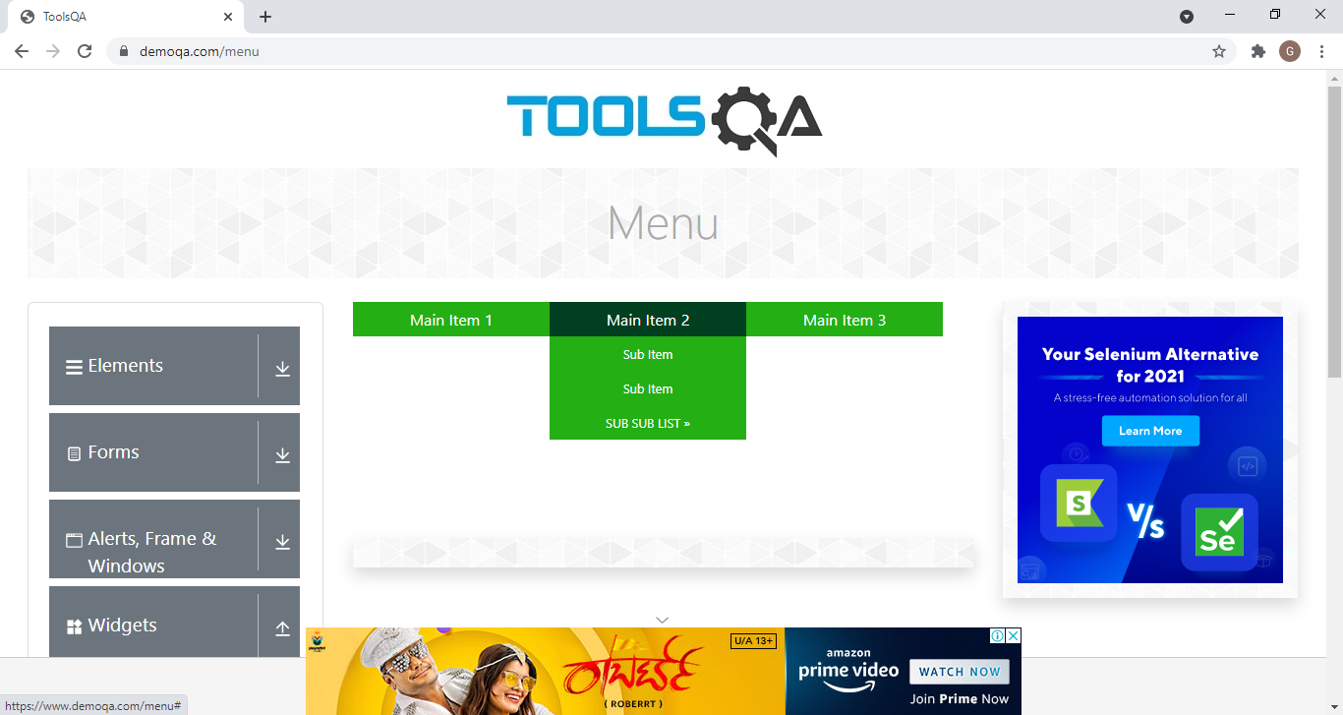

**OUTPUT/DEFECT-** Enable to click the element of SUB SUB LIST.

TC141 -To click on Select Menu

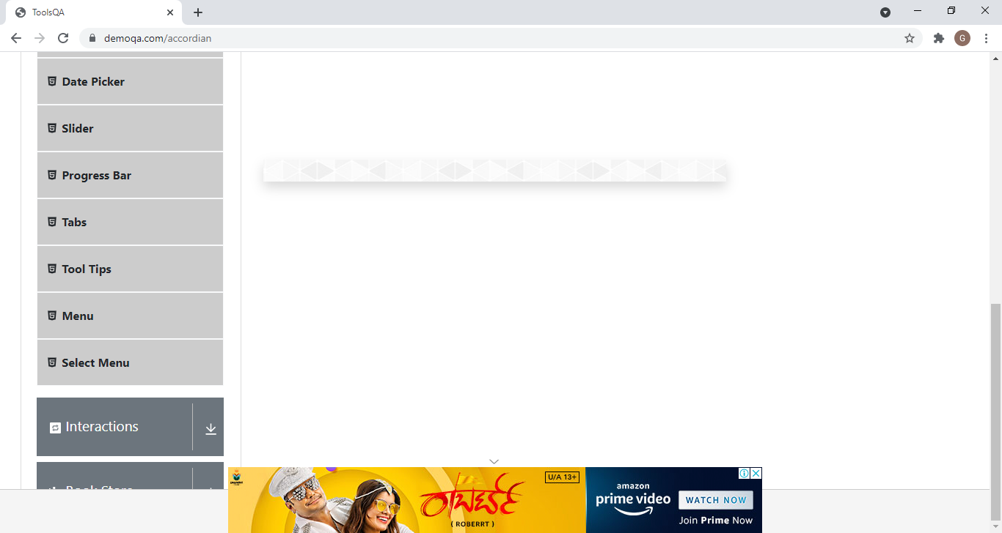

**OUTPUT/DEFECT-** Select Menu button is not working.

***Module No.5 - Interactions***

TC142- Launch the Firefox browser and open ToolsQA Website

TestNG Test Script

WebDriver W;

@BeforeTest

**publicvoid** Set() {

System.*setProperty*("webdriver.gecko.driver", "C:\\Users\\hp\\Desktop\\Seleniumjar\\geckodriver.exe");

W = **new**FirefoxDriver();

W.get("https://demoqa.com/");

System.***out***.println("Web browser launch");



TC143- To verify the functionality of Interactions module of ToolsQA Website

TestNG Test Script

@Test

**publicvoid** mainpage1() **throws**InterruptedException {

WebElement apps1= W.findElement(By.*xpath*("//h5[contains(text(),'Interactions')]"));

JavascriptExecutorjs1 = (JavascriptExecutor) W;

js1.executeScript("arguments[0].scrollIntoView();" , apps1);

apps1.click();

System.***out***.println("scrollintoview");

Thread.*sleep*(2000);

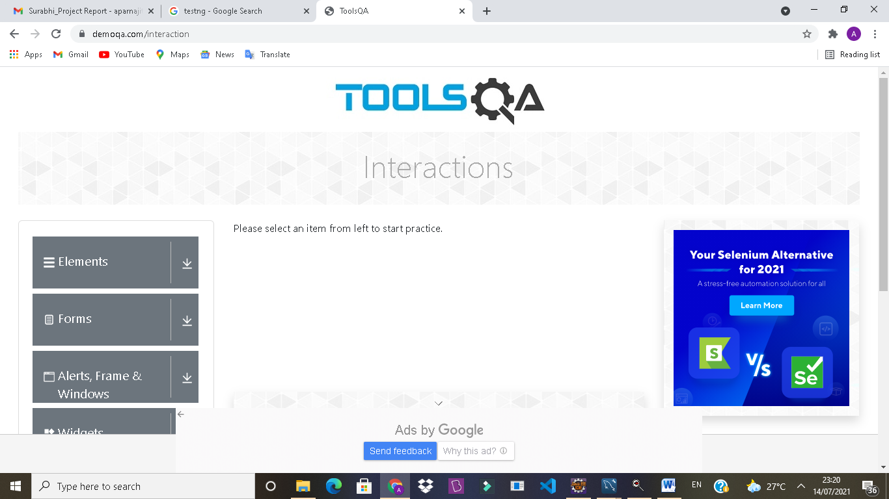

TC144- To verify the functionality of scrolling in ToolsQA Website

TestNG Test Script

JavascriptExecutorjs = (JavascriptExecutor) W;

js.executeScript("window.scrollTo(0,document.body.scrollHeight)");

System.***out***.println("page end");

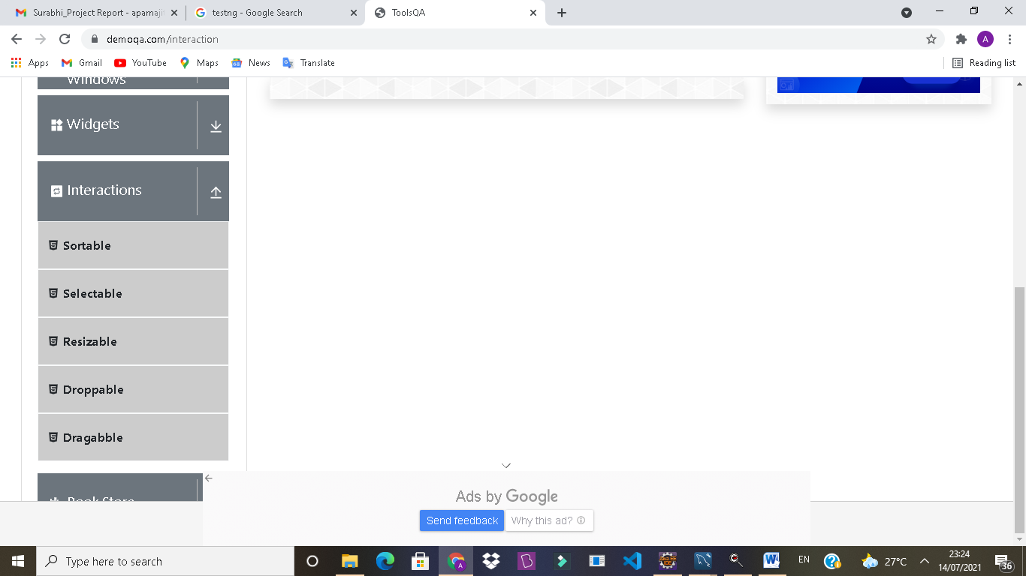

**OUTPUT/DEFECT:**

In interactions module arrow functionality is Not working by scripting way and also without clicking an arrow ,it automatically open the subsection of interaction

TC145- To verify and display the Current URL as well as Tittle of Current page

TestNG Test Script

System.***out***.println("Current URL is " +W.getCurrentUrl());

System.***out***.println(("Tittle of page is " +W.getTitle()));

**OUTPUT-** CurrentURL is https://demoqa.com/interaction

Tittle of page is ToolsQA

TC146- To verify the functionality of submodule (sortable section) of Interactions module

TestNG Test Script

@Test(dependsOnMethods = {"mainpage1"})

**publicvoid**sortablepage() **throws**InterruptedException {

W.navigate().to("https://demoqa.com/sortable");

**OUTPUT/DEFECT:**

Interaction submodule unable to click by scripting method

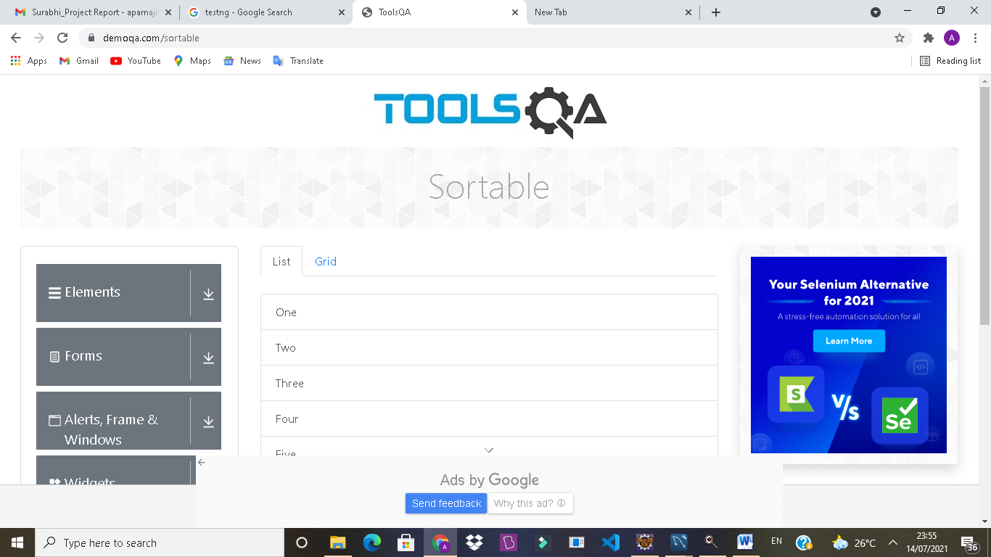

TC147- To verify the functionality of List in sortable section

TestNG Test Script

//******************ListSection*************

//*******************Drag************************

WebElementdraglist1 = W.findElement(By.*xpath*("//body/div[@id='app']/div[1]/div[1]/div[2]/div[2]/div[1]/div[1]/div[1]/div[1]/div[1]"));

WebElementdraglist2 = W.findElement(By.*xpath*("//body/div[@id='app']/div[1]/div[1]/div[2]/div[2]/div[1]/div[1]/div[1]/div[1]/div[2]"));

WebElementdraglist3 = W.findElement(By.*xpath*("//body/div[@id='app']/div[1]/div[1]/div[2]/div[2]/div[1]/div[1]/div[1]/div[1]/div[3]"));

WebElementdraglist4 = W.findElement(By.*xpath*("//body/div[@id='app']/div[1]/div[1]/div[2]/div[2]/div[1]/div[1]/div[1]/div[1]/div[4]"));

WebElementdraglist5 = W.findElement(By.*xpath*("//body/div[@id='app']/div[1]/div[1]/div[2]/div[2]/div[1]/div[1]/div[1]/div[1]/div[5]"));

WebElementdraglist6 = W.findElement(By.*xpath*("//body/div[@id='app']/div[1]/div[1]/div[2]/div[2]/div[1]/div[1]/div[1]/div[1]/div[6]"));

//*******************Drop****************************

WebElementdroplist6 = W.findElement(By.*xpath*("//body/div[@id='app']/div[1]/div[1]/div[2]/div[2]/div[1]/div[1]/div[1]/div[1]/div[6]"));

WebElementdroplist5 = W.findElement(By.*xpath*("//body/div[@id='app']/div[1]/div[1]/div[2]/div[2]/div[1]/div[1]/div[1]/div[1]/div[5]"));

WebElementdroplist4 = W.findElement(By.*xpath*("//body/div[@id='app']/div[1]/div[1]/div[2]/div[2]/div[1]/div[1]/div[1]/div[1]/div[4]"));

WebElementdroplist3 = W.findElement(By.*xpath*("//body/div[@id='app']/div[1]/div[1]/div[2]/div[2]/div[1]/div[1]/div[1]/div[1]/div[3]"));

WebElementdroplist2 = W.findElement(By.*xpath*("//body/div[@id='app']/div[1]/div[1]/div[2]/div[2]/div[1]/div[1]/div[1]/div[1]/div[2]"));

WebElementdroplist1 = W.findElement(By.*xpath*("//body/div[@id='app']/div[1]/div[1]/div[2]/div[2]/div[1]/div[1]/div[1]/div[1]/div[1]"));

Actions act = **new**Actions(W);

act.dragAndDrop(draglist1,droplist6).build().perform();

Thread.*sleep*(3000);

act.dragAndDrop(draglist6,droplist1).build().perform();

Thread.*sleep*(3000);

act.dragAndDrop(draglist2,droplist5).build().perform();

Thread.*sleep*(3000);

act.dragAndDrop(draglist5,droplist2).build().perform();

Thread.*sleep*(3000);

act.dragAndDrop(draglist3,droplist4).build().perform();

Thread.*sleep*(3000);

act.dragAndDrop(draglist4,droplist3).build().perform();

Thread.*sleep*(3000);

TC148- To verify the functionality of Grid in sortable section

TestNG Test Script

//***************Grid section*************

W.findElement(By.*linkText*("Grid")).click();

WebElementdraggrid1 = W.findElement(By.*xpath*("//body/div[@id='app']/div[1]/div[1]/div[2]/div[2]/div[1]/div[1]/div[2]/div[1]/div[1]/div[1]"));

WebElementdropgrid9 =W.findElement(By.*xpath*("//div[contains(text(),'Nine')]"));

WebElementdraggrid2 = W.findElement(By.*xpath*("//body/div[@id='app']/div[1]/div[1]/div[2]/div[2]/div[1]/div[1]/div[2]/div[1]/div[1]/div[1]"));

WebElementdropgrid8 =W.findElement(By.*xpath*("//div[contains(text(),'Eight')]"));

WebElementdraggrid3 = W.findElement(By.*xpath*("//body/div[@id='app']/div[1]/div[1]/div[2]/div[2]/div[1]/div[1]/div[2]/div[1]/div[1]/div[1]"));

WebElementdropgrid7 =W.findElement(By.*xpath*("//div[contains(text(),'Seven')]"));

WebElementdraggrid4 = W.findElement(By.*xpath*("//body/div[@id='app']/div[1]/div[1]/div[2]/div[2]/div[1]/div[1]/div[2]/div[1]/div[1]/div[1]"));

WebElementdropgrid6 = W.findElement(By.*xpath*("//body/div[@id='app']/div[1]/div[1]/div[2]/div[2]/div[1]/div[1]/div[2]/div[1]/div[1]/div[3]"));

WebElementdraggrid5 = W.findElement(By.*xpath*("//body/div[@id='app']/div[1]/div[1]/div[2]/div[2]/div[1]/div[1]/div[2]/div[1]/div[1]/div[1]"));

WebElementdropgrid4 = W.findElement(By.*xpath*("//body/div[@id='app']/div[1]/div[1]/div[2]/div[2]/div[1]/div[1]/div[2]/div[1]/div[1]/div[3]"));

WebElementdraggrid6 = W.findElement(By.*xpath*("//body/div[@id='app']/div[1]/div[1]/div[2]/div[2]/div[1]/div[1]/div[2]/div[1]/div[1]/div[1]"));

WebElementdropgrid5 = W.findElement(By.*xpath*("//body/div[@id='app']/div[1]/div[1]/div[2]/div[2]/div[1]/div[1]/div[2]/div[1]/div[1]/div[3]"));

WebElementdraggrid7 = W.findElement(By.*xpath*("//div[contains(text(),'Seven')]"));

WebElementdropgrid3 = W.findElement(By.*xpath*("//body/div[@id='app']/div[1]/div[1]/div[2]/div[2]/div[1]/div[1]/div[2]/div[1]/div[1]/div[5]"));

WebElementdraggrid8 = W.findElement(By.*xpath*("//div[contains(text(),'Eight')]"));

WebElementdropgrid2 = W.findElement(By.*xpath*("//body/div[@id='app']/div[1]/div[1]/div[2]/div[2]/div[1]/div[1]/div[2]/div[1]/div[1]/div[7]"));

WebElementdraggrid9 = W.findElement(By.*xpath*("//div[contains(text(),'Nine')]"));

WebElementdropgrid1 = W.findElement(By.*xpath*("//body/div[@id='app']/div[1]/div[1]/div[2]/div[2]/div[1]/div[1]/div[2]/div[1]/div[1]/div[9]"));

Actions act1 = **new**Actions(W);

act1.dragAndDrop(draggrid1,dropgrid9).build().perform();

Thread.*sleep*(5000);

act1.dragAndDrop(draggrid2,dropgrid8).build().perform();

Thread.*sleep*(5000);

act1.dragAndDrop(draggrid3,dropgrid7).build().perform();

Thread.*sleep*(5000);

act1.dragAndDrop(draggrid4,dropgrid6).build().perform();

Thread.*sleep*(5000);

act1.dragAndDrop(draggrid5,dropgrid4).build().perform();

Thread.*sleep*(5000);

dfddddddd

act1.dragAndDrop(draggrid6,dropgrid5).build().perform();

Thread.*sleep*(5000);

act1.dragAndDrop(draggrid7,dropgrid3).build().perform();

Thread.*sleep*(5000);

act1.dragAndDrop(draggrid8,dropgrid2).build().perform();

Thread.*sleep*(5000);

act1.dragAndDrop(draggrid9,dropgrid1).build().perform();

Thread.*sleep*(5000);

}

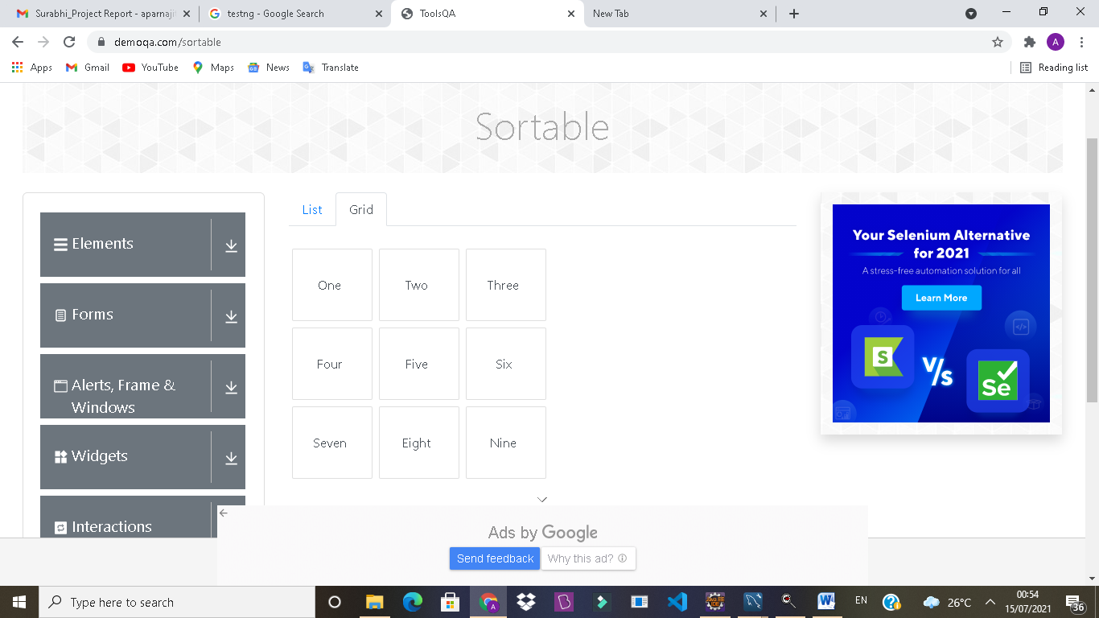

TC149- To verify the functionality of navigating submodule (selectable section) page from sortable section

TestNG Test Script

@Test(dependsOnMethods = {"sortablepage"})

**publicvoid**selectablepage() **throws**InterruptedException {

W.navigate().to("https://demoqa.com/selectable");

**OUTPUT/DEFECT:**

Interaction submodule unable to click by scripting method

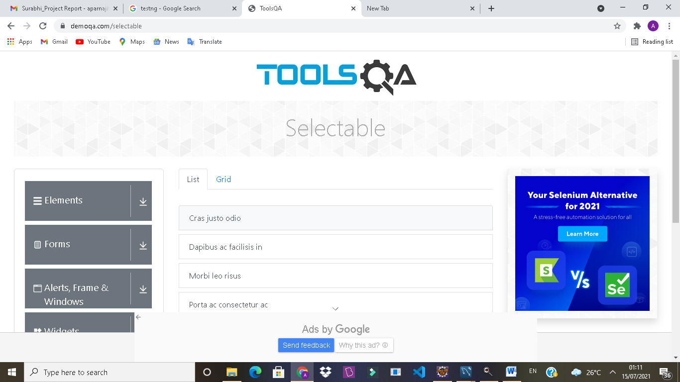

TC150- To verify the functionality of List in selectable section whether it selecting all elements or not

TestNG Test Script

//********************Listsection**************

//********************select********************

W.findElement(By.xpath("//li[contains(text(),'Crasjustoodio')]")).click();

W.findElement(By.xpath("//li[contains(text(),'Dapibus ac facilisis in')]")).click();

W.findElement(By.xpath("//li[contains(text(),'Morbileorisus')]")).click();

W.findElement(By.xpath("//li[contains(text(),'Porta ac consectetur ac')]")).click();

Thread.sleep(5000);

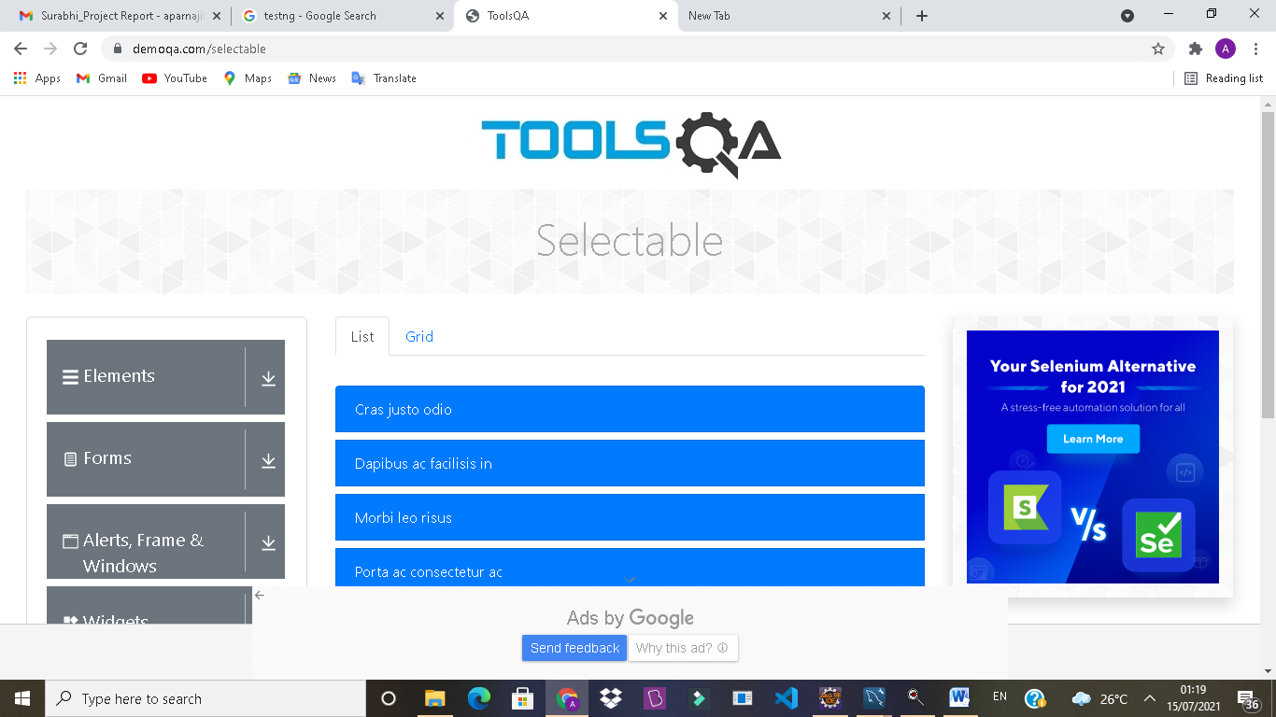

TC151- To verify the functionality of List in selectable section whether it removing all elements from selection or not

TestNG Test Script

//********************Listsection**************

//***************Removeselection******************

W.findElement(By.xpath("//li[contains(text(),'Dapibus ac facilisis in')]")).click();

W.findElement(By.xpath("//li[contains(text(),'Morbileorisus')]")).click();

W.findElement(By.xpath("//li[contains(text(),'Crasjustoodio')]")).click();

W.findElement(By.xpath("//li[contains(text(),'Porta ac consectetur ac')]")).click();

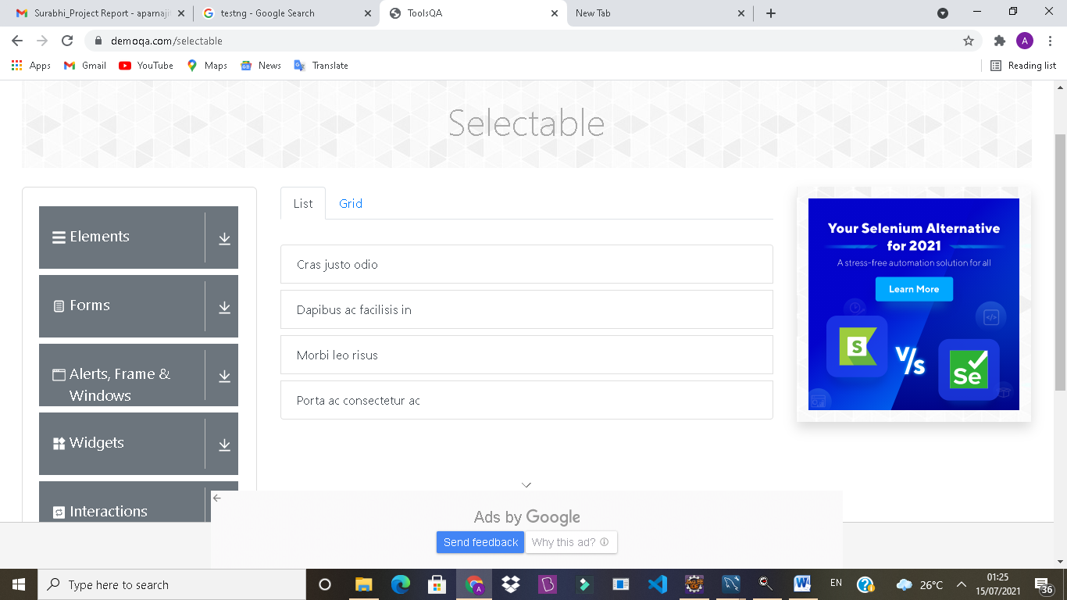

TC152- To verify the functionality of Grid in selectable section whether it selecting all elements or not

TestNG Test Script

//********************Gridsection**************

//********************select********************

W.findElement(By.*linkText*("Grid")).click();

W.findElement(By.*xpath*("//li[contains(text(),'One')]")).click();

W.findElement(By.*xpath*("//li[contains(text(),'Two')]")).click();

W.findElement(By.*xpath*("//li[contains(text(),'Three')]")).click();

W.findElement(By.*xpath*("//li[contains(text(),'Four')]")).click();

W.findElement(By.*xpath*("//li[contains(text(),'Five')]")).click();

W.findElement(By.*xpath*("//li[contains(text(),'Six')]")).click();

**OUTPUT/DEFECT:**

Unable to select 7,8,9by scripting method in grid selection

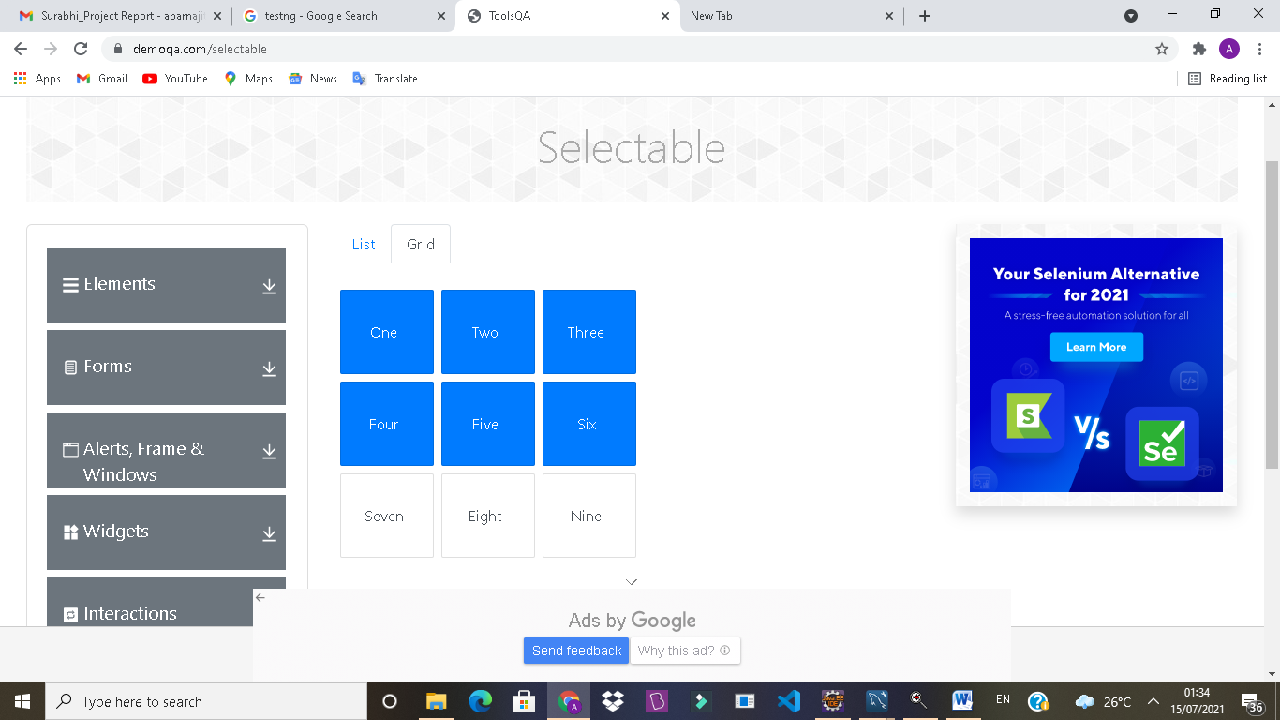

TC153- To verify the functionality of Grid in selectable section whether it removing all elements from selection or not

TestNG Test Script

//********************Gridsection**************

//***************Removeselection******************

Thread.*sleep*(5000);

W.findElement(By.*xpath*("//li[contains(text(),'One')]")).click();

W.findElement(By.*xpath*("//li[contains(text(),'Two')]")).click();

W.findElement(By.*xpath*("//li[contains(text(),'Three')]")).click();

W.findElement(By.*xpath*("//li[contains(text(),'Four')]")).click();

W.findElement(By.*xpath*("//li[contains(text(),'Five')]")).click();

W.findElement(By.*xpath*("//li[contains(text(),'Six')]")).click();

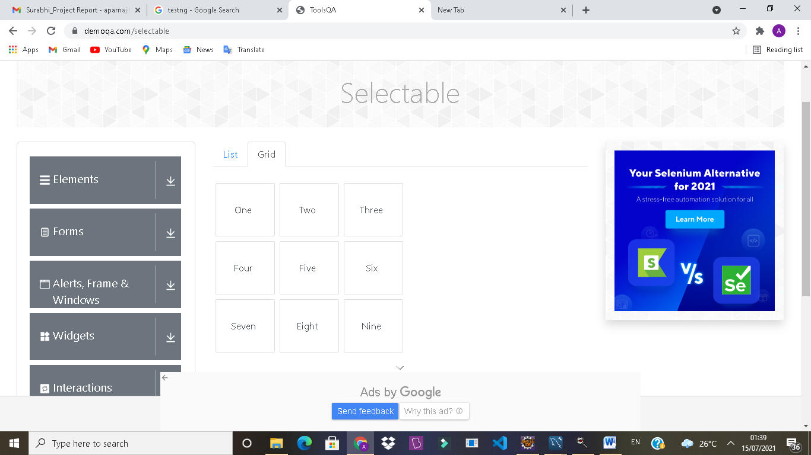

TC154- To verify the functionality of navigating submodule (Resizable section) page from selection page

TestNG Test Script

@Test(dependsOnMethods = {"selectablepage"})

**publicvoid**resizablepage() **throws**InterruptedException {

W.navigate().to("https://demoqa.com/resizable");

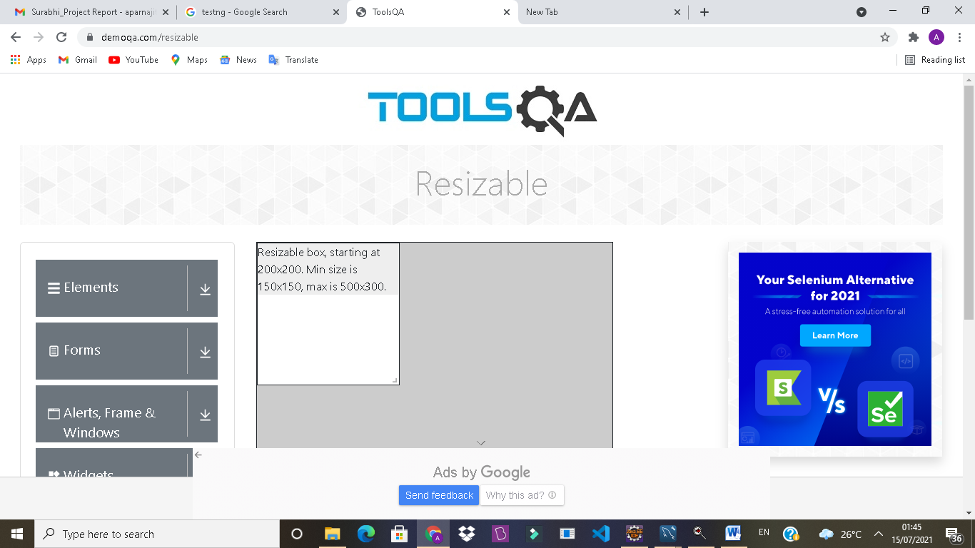

TC155- To verify the functionality of resizable to check whether it resizing according to script or not

TestNG Test Script

WebElementresizeElement = W.findElement(By.*xpath*("//body/div[@id='app']/div[1]/div[1]/div[2]/div[2]/div[1]/div[1]/div[1]/span[1]"));

WebElementresizeElement1 = W.findElement(By.*xpath*("//body/div[@id='app']/div[1]/div[1]/div[2]/div[2]/div[1]/div[2]/div[1]/span[1]"));

Actions actionsResize = **new**Actions(W);

//provide the x and y offset values

actionsResize.dragAndDropBy(resizeElement, 150,170).perform();

Thread.*sleep*(3000);

JavascriptExecutorjs23 = (JavascriptExecutor) W;

js23.executeScript("window.scrollTo(0,document.body.scrollHeight)");

System.***out***.println("page end");

actionsResize.dragAndDropBy(resizeElement1, 100, 50).perform();

Thread.*sleep*(3000);

System.***out***.println("Done Resizing");

}

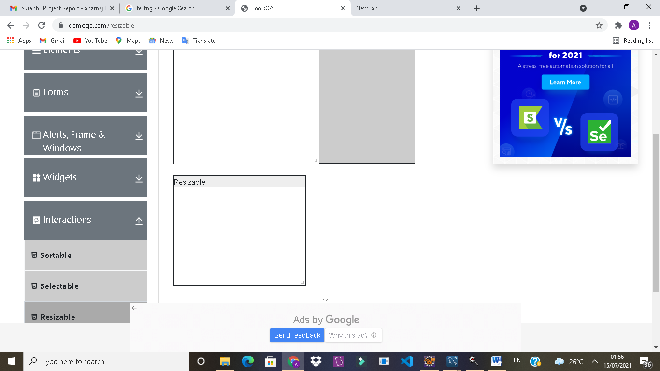

TC156- To verify the functionality of navigating submodule (Droppable section) page from Resizing page

TestNG Test Script

@Test(dependsOnMethods = {"resizablepage"})

**publicvoid**dropablepage() **throws**InterruptedException {

W.navigate().to("https://demoqa.com/droppable");

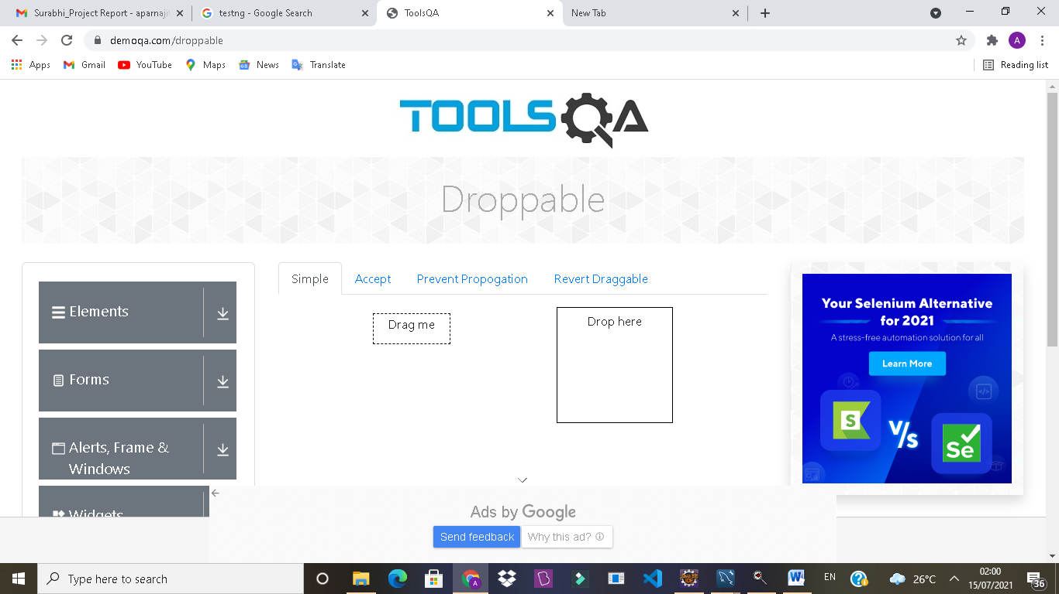

TC157- To verify the functionality of simple subsection in droppable, to check whether it dropping according to script or not

TestNG Test Script

WebElementdragsimple = W.findElement(By.*id*("draggable"));

WebElementdropsimple = W.findElement(By.*id*("droppable"));

Actions actsimple = **new**Actions(W);

actsimple.dragAndDrop(dragsimple,dropsimple).build().perform();

Thread.*sleep*(3000);

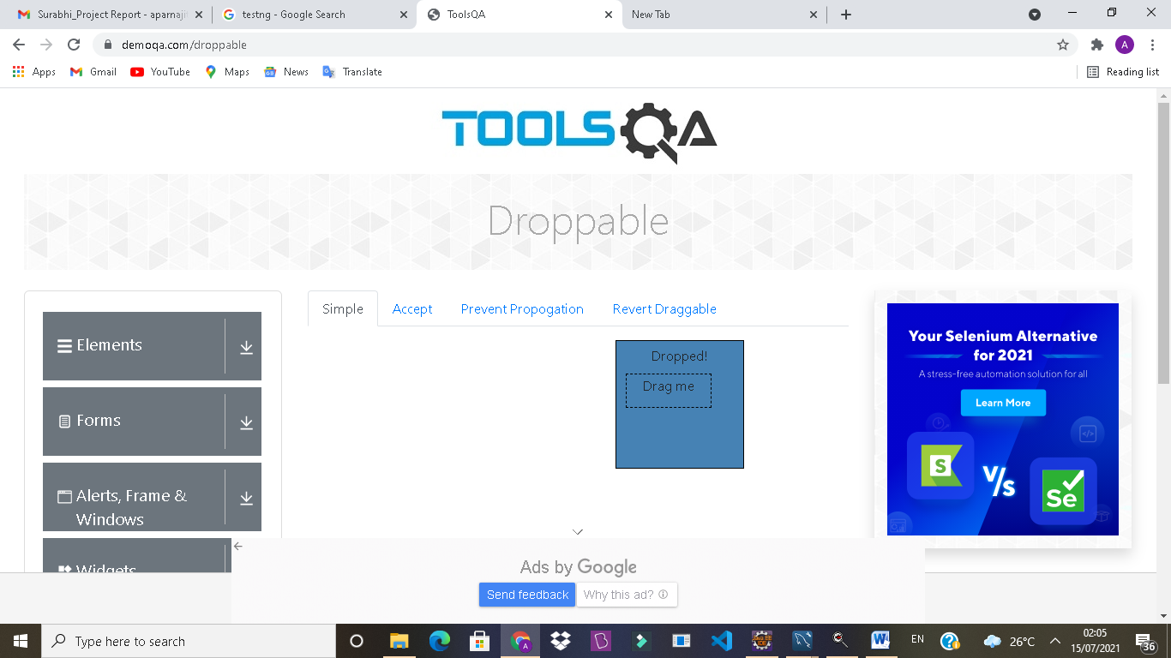

TC158- To verify the functionality of accept subsection in droppable, to check whether it dropping according to script or not

TestNG Test Script

W.findElement(By.*linkText*("Accept")).click();

WebElementdragaccept1 = W.findElement(By.*id*("acceptable"));

WebElementdragaccept2 = W.findElement(By.*id*("notAcceptable"));

WebElementdropaccept = W.findElement(By.*xpath*("//div[@id='acceptDropContainer']//div[@id='droppable']"));

Actions actaccept = **new**Actions(W);

actaccept.dragAndDrop(dragaccept1,dropaccept).build().perform();

actaccept.dragAndDrop(dragaccept2,dropaccept).build().perform();

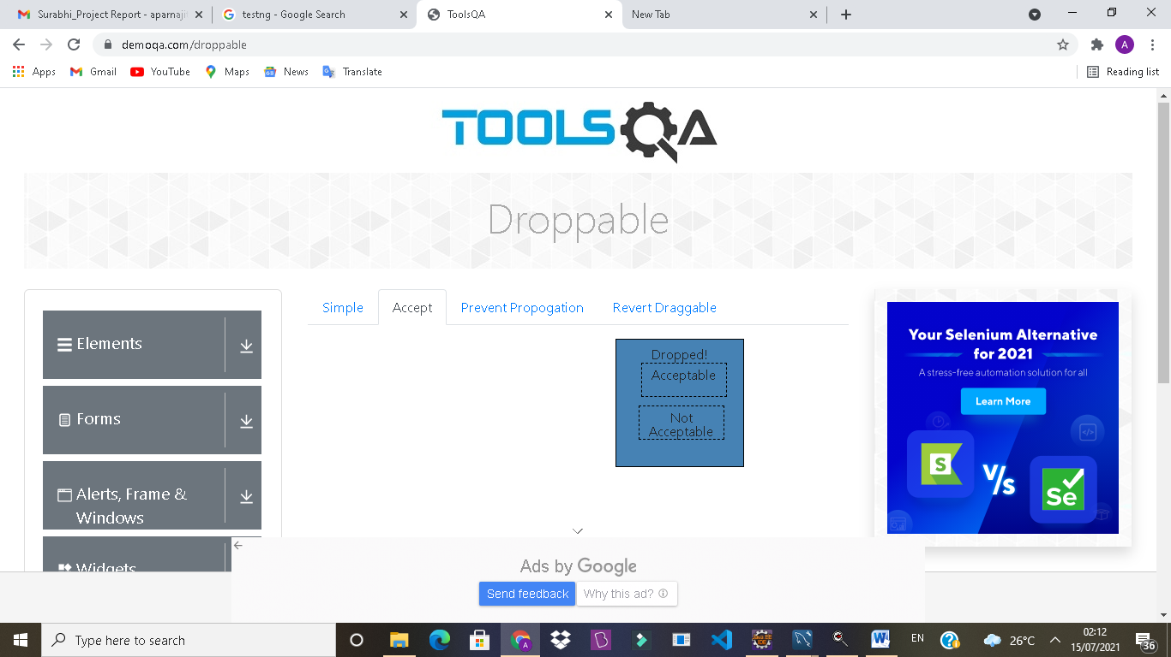

**OUTPUT/DEFECT:**

Dropping the box of Not Acceptable

TC159- To verify the functionality of Prevent Propogation subsection in droppable, to check whether it dropping according to script or not

TestNG Test Script

W.findElement(By.*linkText*("PreventPropogation")).click();

WebElementdragprevent1W.findElement(By.*id*("dragBox"));

WebElementdropprevent1 = W.findElement(By.*id*("notGreedyInnerDropBox"));

WebElementdropprevent2 = W.findElement(By.*xpath*("//div[@id='greedyDropBoxInner']"));

Actions actprevent = **new**Actions(W);

actprevent.dragAndDrop(dragprevent1,dropprevent1).build().perform();

Thread.*sleep*(3000);

actprevent.dragAndDrop(dragprevent1,dropprevent2).build().perform();

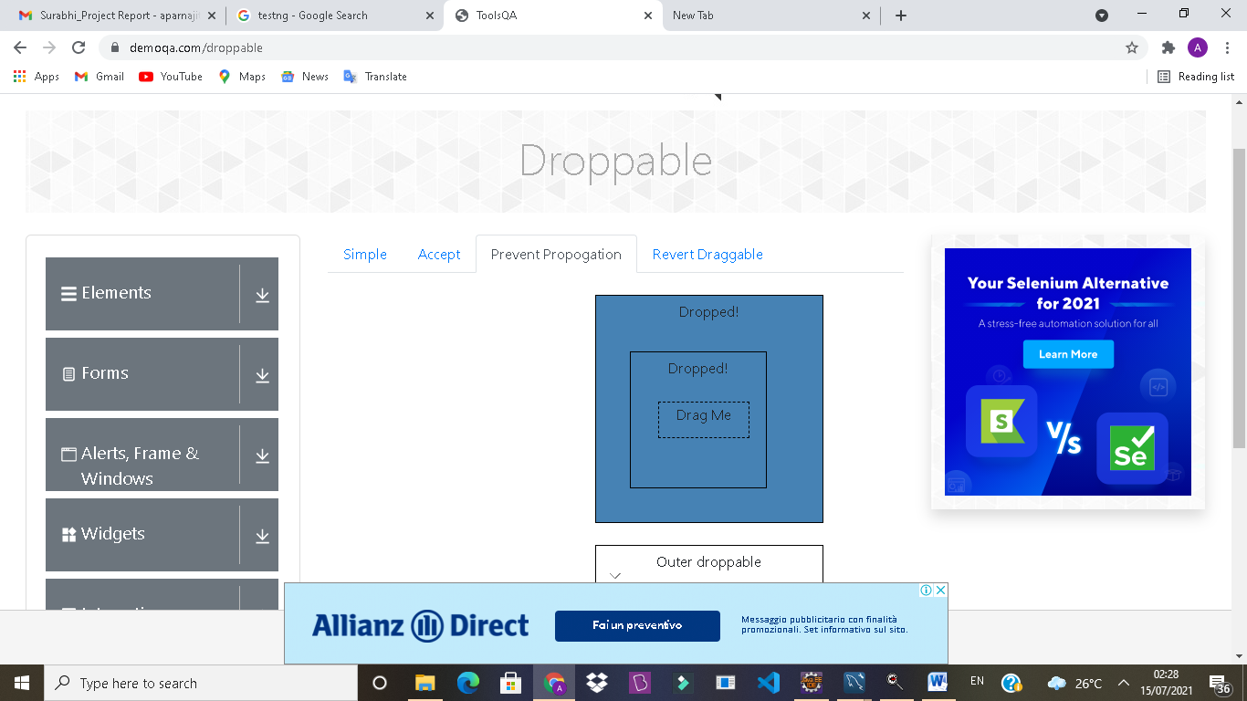

**OUTPUT/DEFECT:**

Not Dropping as per the requirement

TC160- To verify the functionality of Revert Droppable subsection in droppable, to check whether it dropping according to script or not

TestNG Test Script

W.findElement(By.*linkText*("RevertDraggable")).click();

WebElementdragrevert1 = W.findElement(By.*id*("revertable"));

WebElementdragrevert2 = W.findElement(By.*id*("notRevertable"));

WebElementdroprevert = W.findElement(By.*xpath*("//div[@id='revertableDropContainer']//div[@id='droppable']"));

Actions actrevert = **new**Actions(W);

actrevert.dragAndDrop(dragrevert1,droprevert).build().perform();

actrevert.dragAndDrop(dragrevert2,droprevert).build().perform();

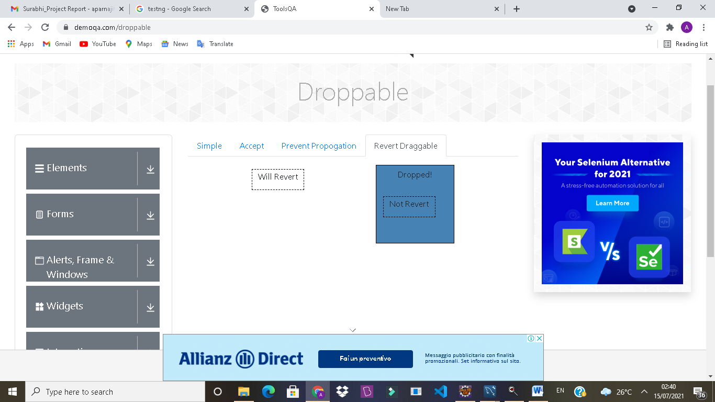

TC161-To verify the functionality of navigating submodule (Draggable section) page from Droppable page

TestNG Test Script

@Test(dependsOnMethods = {"dropablepage"})

**publicvoid**dragablepage() **throws**InterruptedException {

W.navigate().to("https://demoqa.com/dragabble");

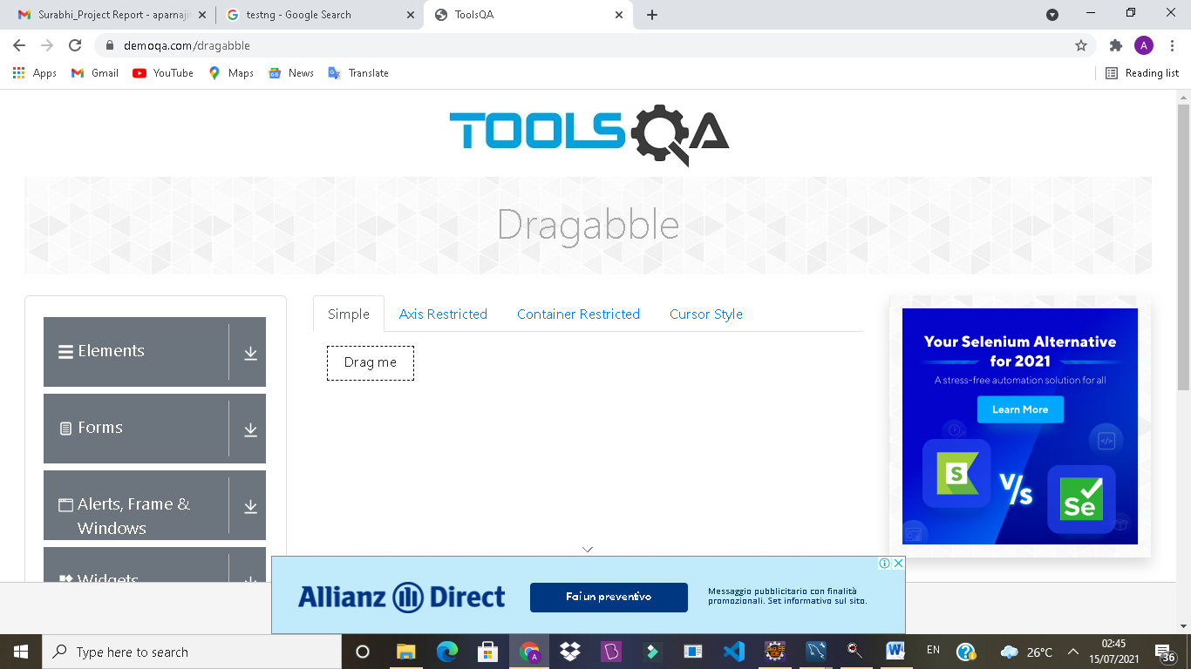

TC162- To verify the functionality of simple subsection in dragabble, to check whether it dragging according to script or not

TestNG Test Script

WebElementdragable=W.findElement(By.*xpath*("//div[@id='dragBox']"));

Actions actdrag=**new**Actions(W);

actdrag.dragAndDropBy(dragable, 60,70).build().perform();

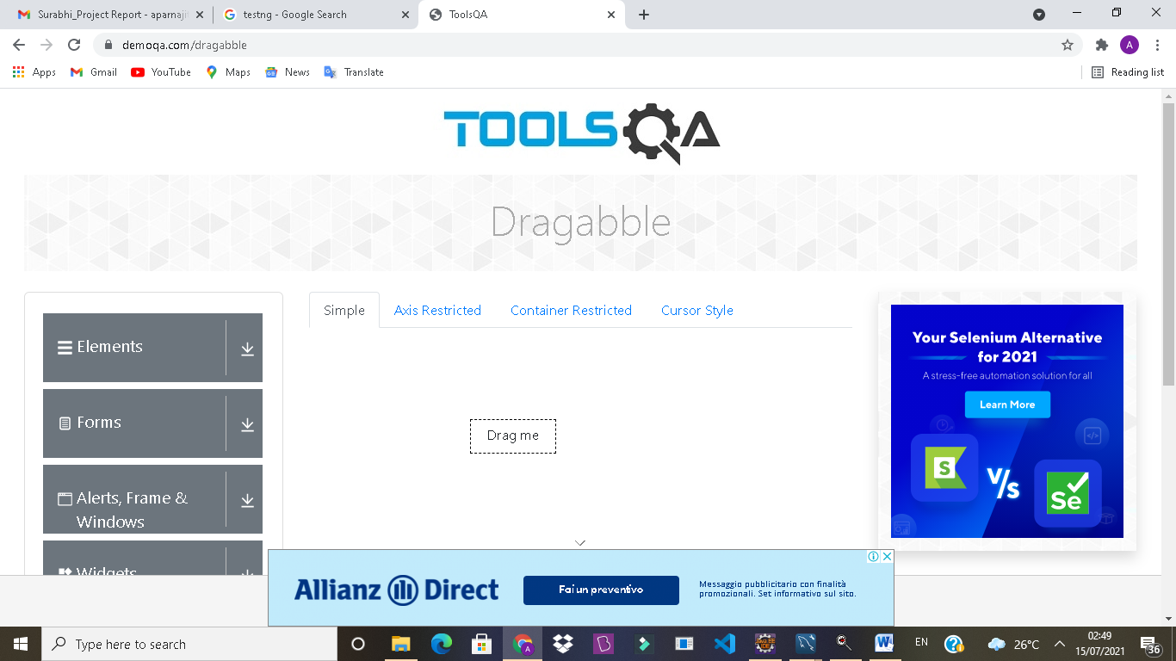

TC163- To verify the functionality of Axis restricted subsection in dragabble, to check whether it dragging according to script or not

TestNG Test Script

W.findElement(By.*id*("draggableExample-tab axisRestriction")).click();

WebElementdragaxisX=W.findElement(By.*id*("restrictedX"));

WebElementdragaxisY = W.findElement(By.*id*("restrictedY"));

Actions actaxis=**new**Actions(W);

actaxis.dragAndDropBy(dragaxisX, 80, 0).build().perform();

actaxis.dragAndDropBy(dragaxisY, 0, 100).build().perform();

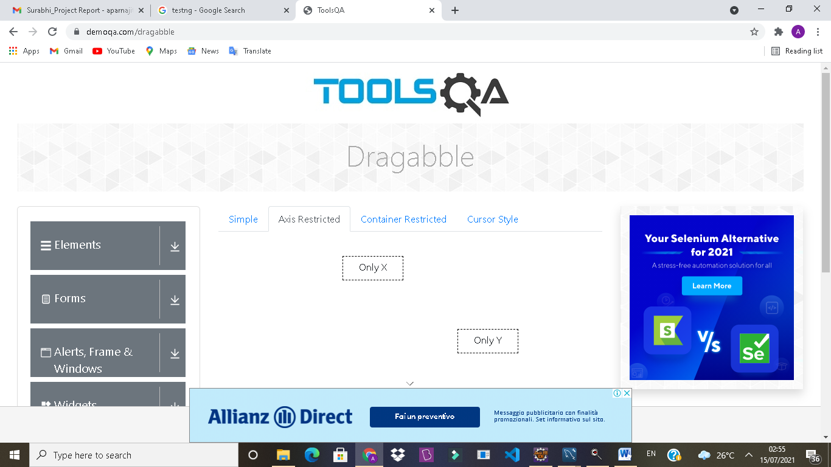

TC164- To verify the functionality of Container Restricted subsection in dragabble, to check whether it dragging according to script or not

TestNG Test Script

W.findElement(By.*id*("draggableExample-tab-containerRestriction")).click();

WebElementdragcontainer=W.findElement(By.*xpath*("//div[contains(text(),\"I'm contained within the box\")]"));

Actions actcont=**new**Actions(W);

actcont.dragAndDropBy(dragcontainer, 60, 90).build().perform();

JavascriptExecutorjscontainer = (JavascriptExecutor) W;

jscontainer.executeScript("window.scrollBy(0,300)");

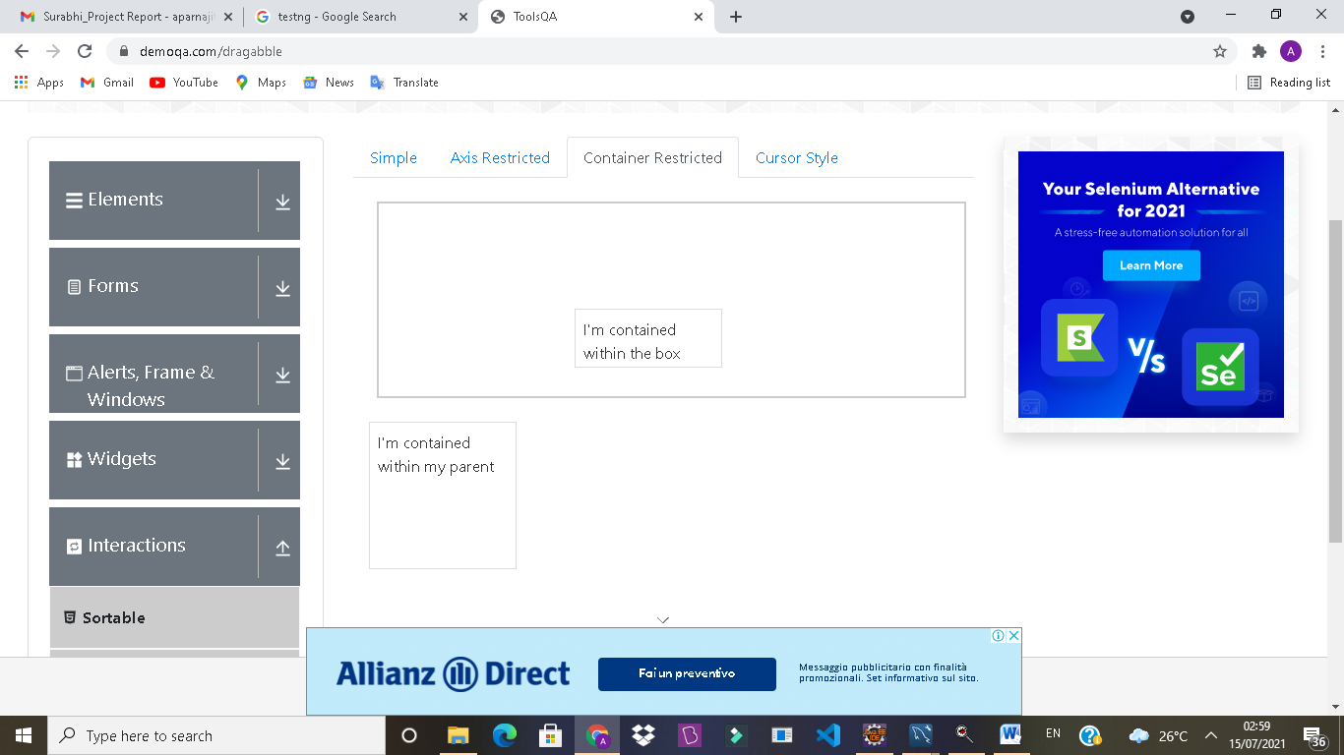

**OUTPUT/DEFECT:**

2nd box not executing as per the script

TC165- To verify the functionality of Cursor subsection in dragabble, to check whether it dragging according to script or not

TestNG Test Script

@Test(enabled = **false**)

**publicvoid**cursorsection() **throws**InterruptedException {

W.findElement(By.*linkText*("Cursor Style")).click();

WebElementdragcursor = W.findElement(By.*id*("cursorCenter"));

Actions actcursor=**new**Actions(W);

actcursor.dragAndDropBy(dragcursor, 170,100).build().perform();

Thread.*sleep*(3000);

WebElementdragcursor1= W.findElement(By.*id*("cursorTopLeft"));

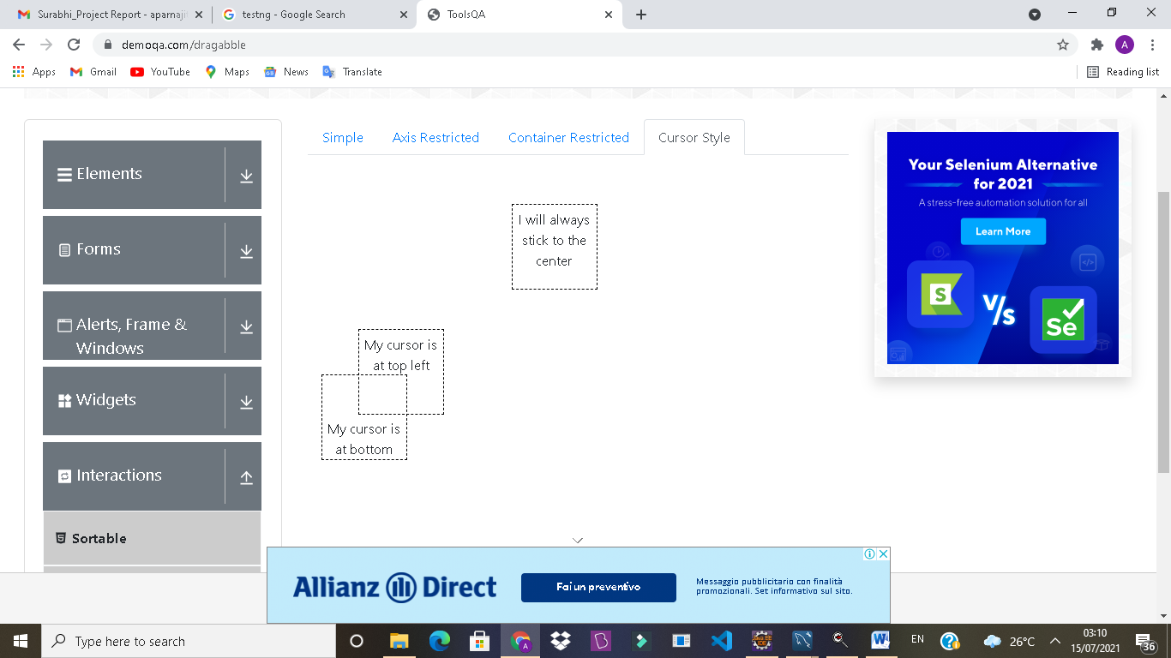

**OUTPUT/DEFECT:**

Cursor section not dragging according to the requirement

TC166- To verify the functionality of closing the current module

TestNG Test Script

@AfterTest

**publicvoid**afterTest() {

W.close();

}

}

***Module No.6 – Book Store Application***

TC167- Launch the Firefox browser and open ToolsQA Website

TestNG Test Script

WebDriver W;

@BeforeTest

**publicvoid**Setproperty() {

System.*setProperty*("webdriver.gecko.driver", "C:\\Users\\hp\\Desktop\\Seleniumjar\\geckodriver.exe");

W = **new**FirefoxDriver();

W.get("https://demoqa.com/");

System.***out***.println("Web browser launch");

}



TC168- To verify the functionality of Book Store Application module of ToolsQA Website

TestNG Test Script

@Test

**publicvoid**mainpage() **throws**InterruptedException {

WebElement apps1= W.findElement(By.*xpath*("//body[1]/div[2]/div[1]/div[1]/div[2]/div[1]/div[6]/div[1]"));

JavascriptExecutorjs1 = (JavascriptExecutor) W;

js1.executeScript("arguments[0].scrollIntoView();" , apps1);

apps1.click();

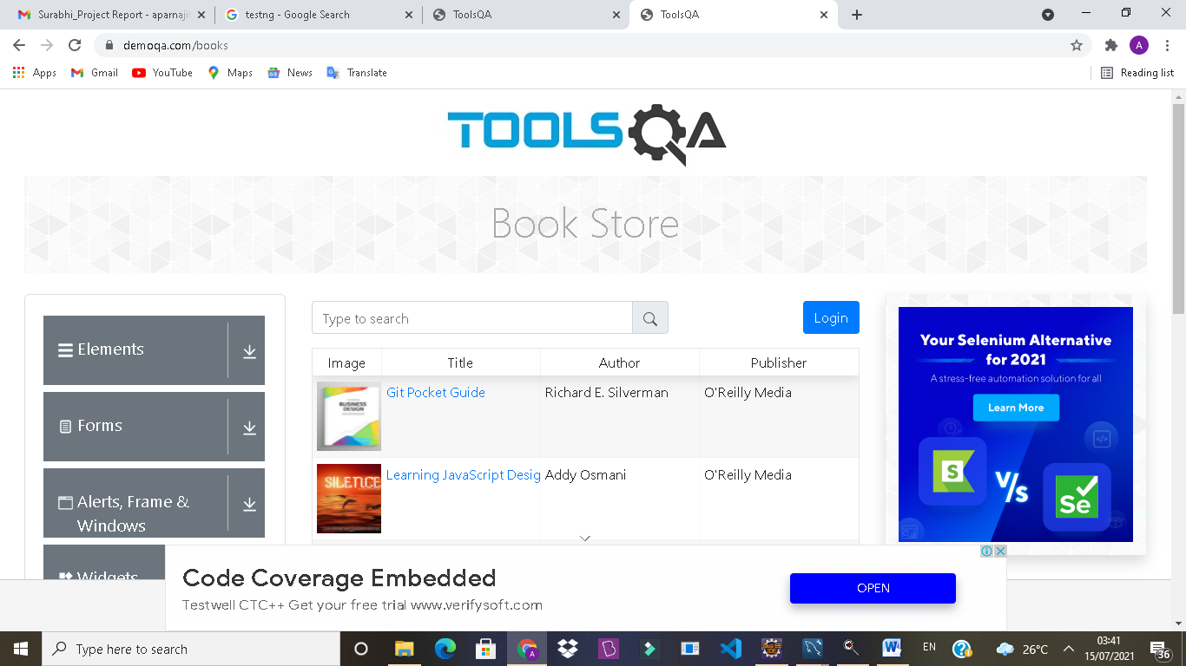

**OUTPUT/DEFECT:**

In Book store Application module arrow functionality is Not working by scripting way and also without clicking an arrow , it automatically open the subsection of Book Store Application as well as it display the book store subsection.

TC169- To verify and display the Current URL as well as Tittle of Current page

TestNG Test Script

System.***out***.println("Current URL is +W.getCurrentUrl());

System.***out***.println(("Tittle of page is " +W.getTitle()));

**OUTPUT:-**Current URL is https://demoqa.com/books

Tittle of page is ToolsQA

TC170- To verify the functionality of submodule (Login section) of Book store Application module

TestNG Test Script

@Test(dependsOnMethods = {"mainpage"})

**publicvoid**registerpage() **throws**InterruptedException {

W.navigate().to("https://demoqa.com/login");

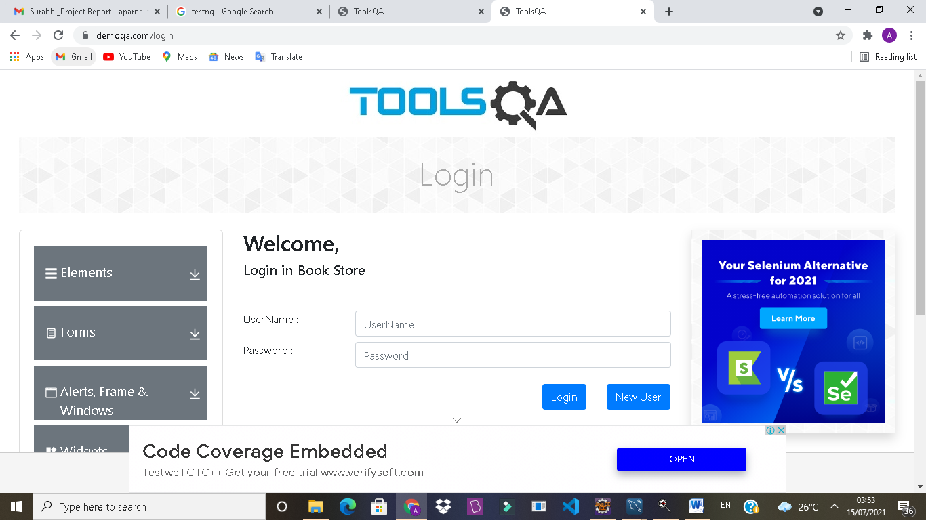

TC171- To verify the functionality of New User in Login section

TestNG Test Script

W.findElement(By.*id*("newUser")).click();

W.findElement(By.*id*("firstname")).sendKeys("APPS");

W.findElement(By.*id*("lastname")).sendKeys("T");

W.findElement(By.*id*("userName")).sendKeys("APPS");

W.findElement(By.*id*("password")).sendKeys("APPS44");

//Validation is compulsory to register(i'm not robot)

WebElementstore1 = W.findElement(By.*id*("register"));

JavascriptExecutorjsstore1 = (JavascriptExecutor) W;

jsstore1.executeScript("arguments[0].scrollIntoView();" , store1);

store1.click();

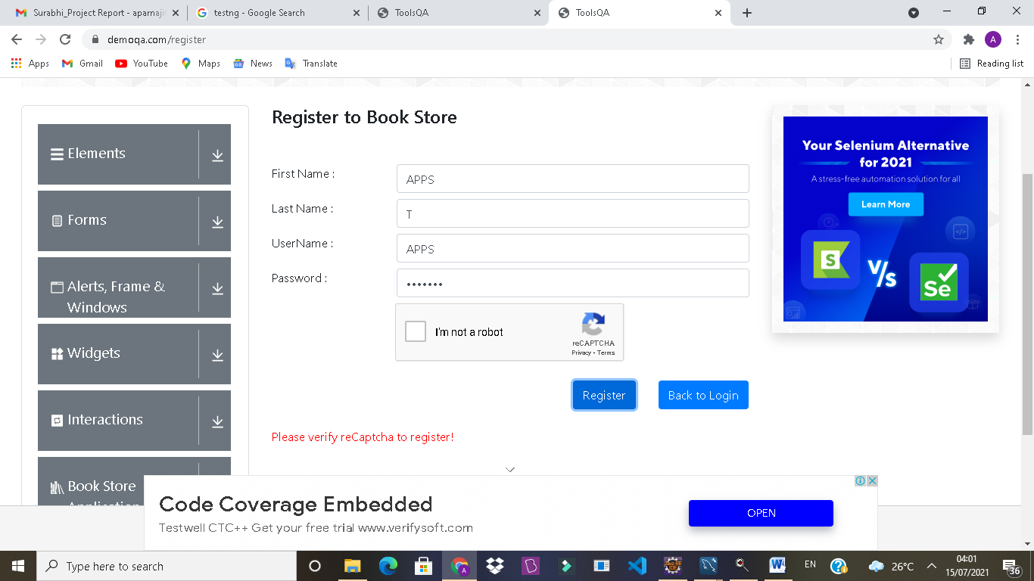

**OUTPUT/DEFECT:**

Registration form don’t have validation for first name and last name it accepting special characters as well as blank

TC172 - To verify the functionality of go to login button from register to Login section

TestNG Test Script

Thread.*sleep*(4000);

WebElementstore= W.findElement(By.*id*("gotologin"));

JavascriptExecutorjsstore = (JavascriptExecutor) W;

jsstore.executeScript("arguments[0].scrollIntoView();" , store);

store.click();

}

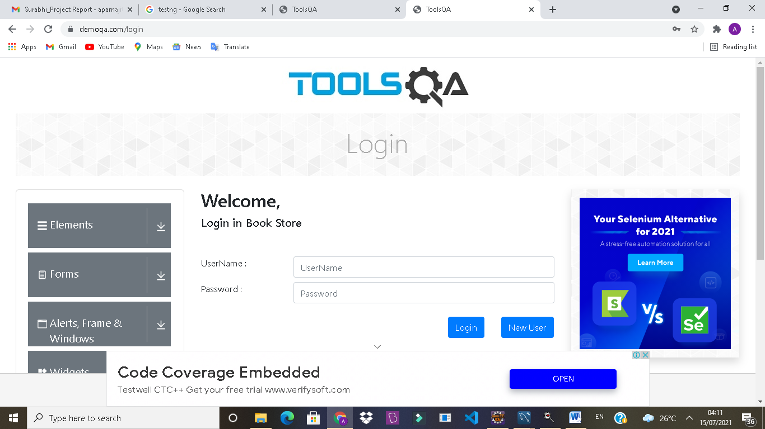

TC173 - To verify the functionality of navigating submodule (Book store section) page from Login section

TestNG Test Script

@Test(dependsOnMethods = {"registerpage"})

**publicvoid**bookpage() **throws**InterruptedException {

W.navigate().to("https://demoqa.com/books");

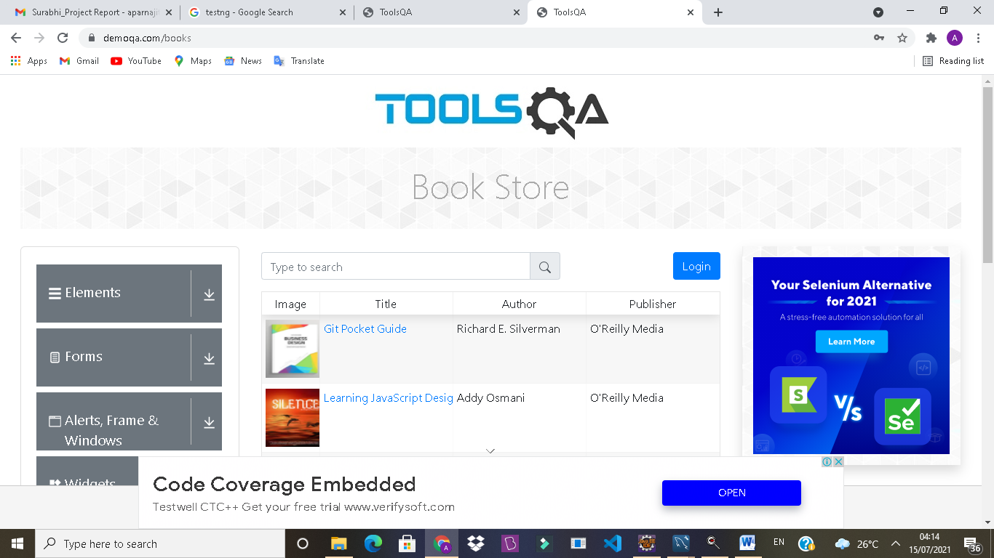

TC174- To verify the functionality of Git Pocket Guide in Book store section, to check whether it opening the details of book or not

TestNG Test Script

WebElementbook1=

W.findElement(By.*linkText*("Git Pocket Guide"));

JavascriptExecutorjsbook1 = (JavascriptExecutor) W;

jsbook1.executeScript("arguments[0].scrollIntoView();" , book1);

book1.click();

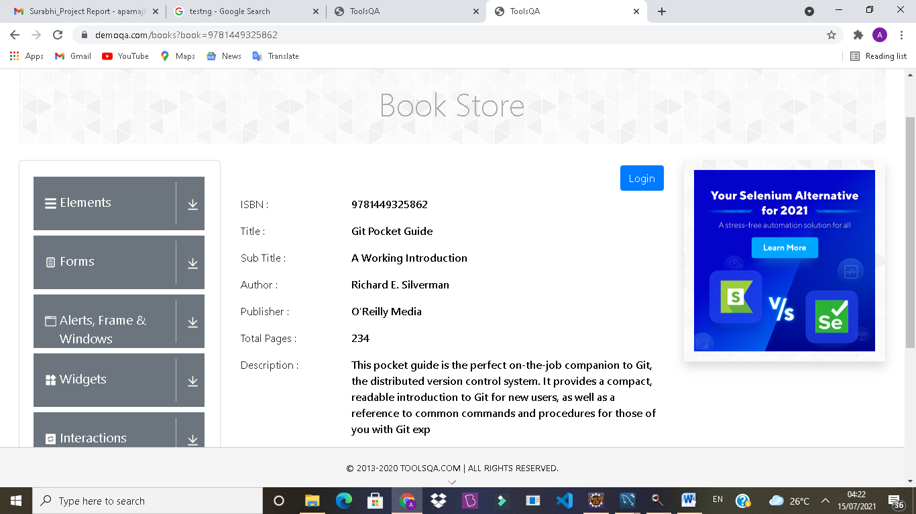

TC178 - To verify the functionality of Back to Book store button from Git Pocket Guide to Book store section

TestNG Test Script

WebElementclick1= W.findElement(By.*id*("addNewRecordButton"));

JavascriptExecutorjsclick1 = (JavascriptExecutor) W;

jsclick1.executeScript("arguments[0].scrollIntoView();" , click1);

click1.click();

Thread.*sleep*(4000);

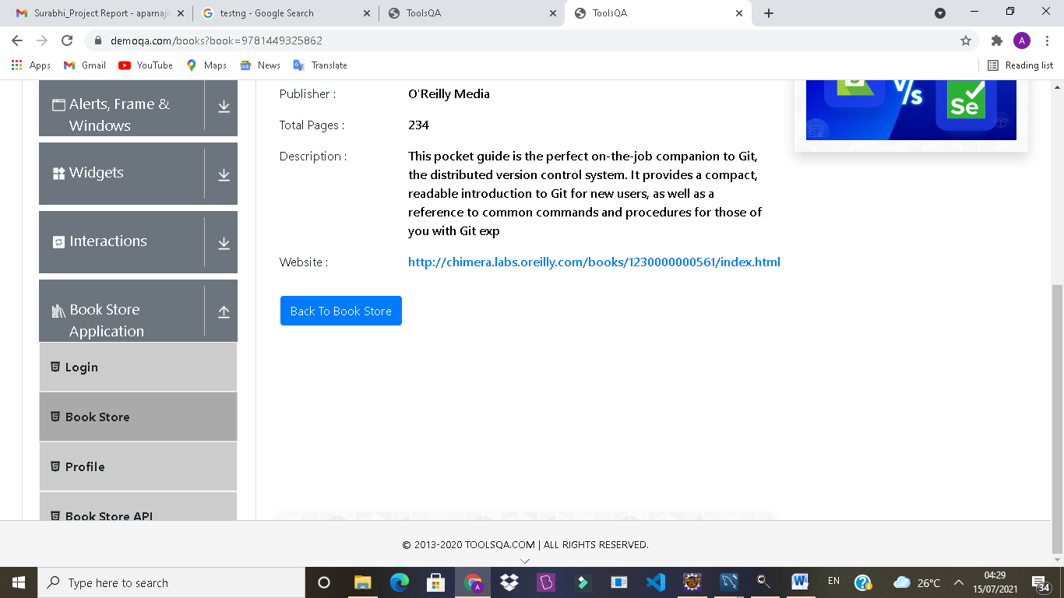

TC179- To verify the functionality of Designing Evolvable Web in Book store section, to check whether it opening the details of book or not

TestNG Test Script

WebElementbook3=W.findElement(By.*linkText*("Designing Evolvable Web APIs with ASP.NET"));

JavascriptExecutorjsbook3 = (JavascriptExecutor) W;

jsbook3.executeScript("arguments[0].scrollIntoView();" , book3);

book3.click();

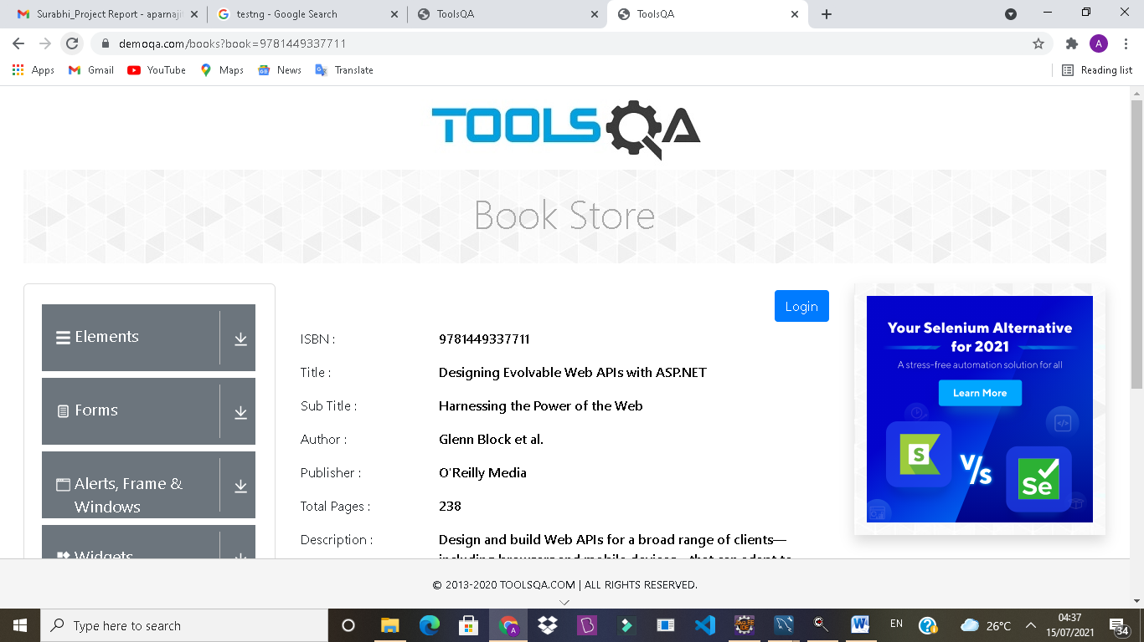

TC180 - To verify the functionality of Back to Book store button from Designing Evolvable Web to Book store section

WebElementclick3= W.findElement(By.*id*("addNewRecordButton"));

JavascriptExecutorjsclick3 = (JavascriptExecutor) W;

jsclick3.executeScript("arguments[0].scrollIntoView();" , click3);

click3.click();

Thread.*sleep*(4000);

TestNG Test Script

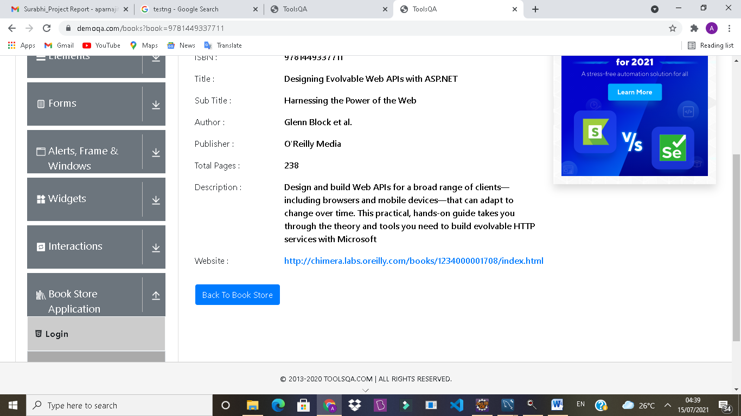

TC181- To verify the functionality of Speaking JavaScript in Book store section, to check whether it opening the details of book or not

TestNG Test Script

WebElementbook4=W.findElement(By.*linkText*("Speaking JavaScript"));

JavascriptExecutorjsbook4 = (JavascriptExecutor) W;

jsbook4.executeScript("arguments[0].scrollIntoView();" , book4);

book4.click();

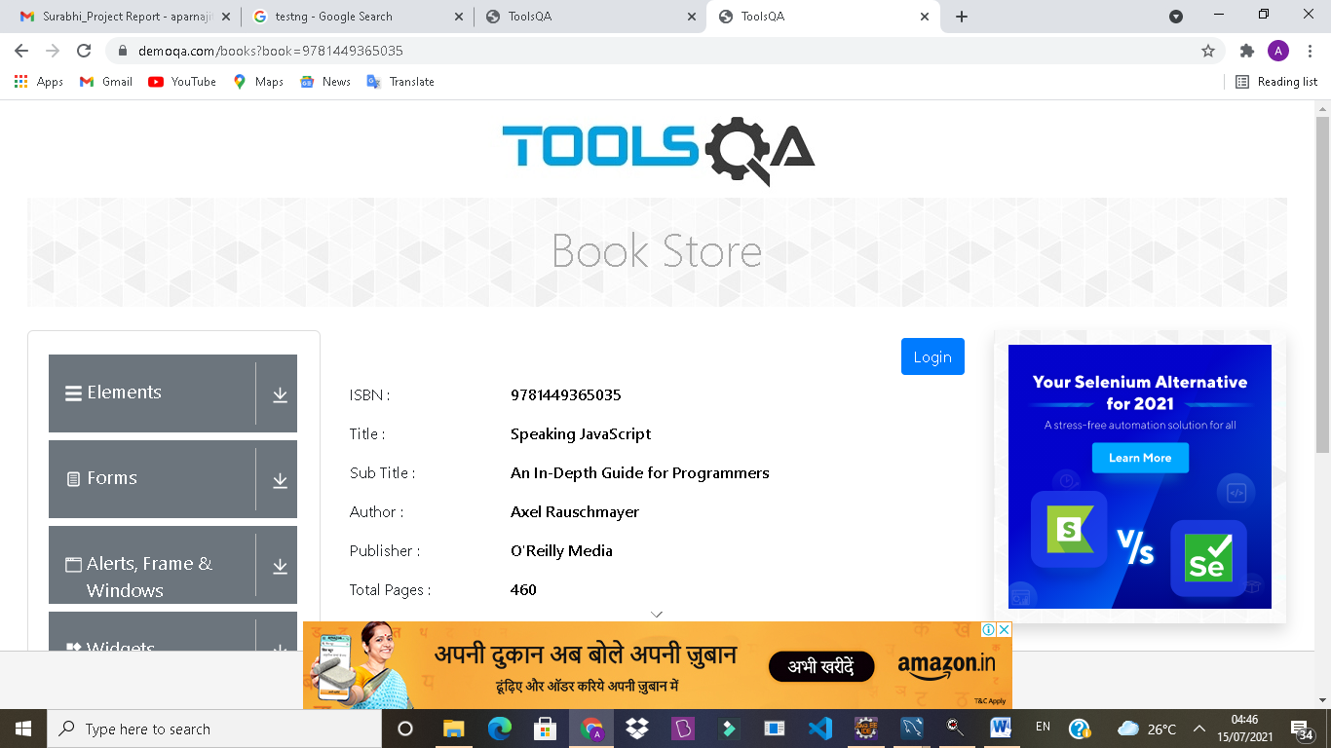

TC182 - To verify the functionality of Back to Book store button from Speaking JavaScript to Book store section

TestNG Test Script

WebElementclick4=W.findElement(By.*id*("addNewRecordButton"));

JavascriptExecutorjsclick4 = (JavascriptExecutor) W;

jsclick4.executeScript("arguments[0].scrollIntoView();" , click4);

click4.click();

Thread.*sleep*(4000);

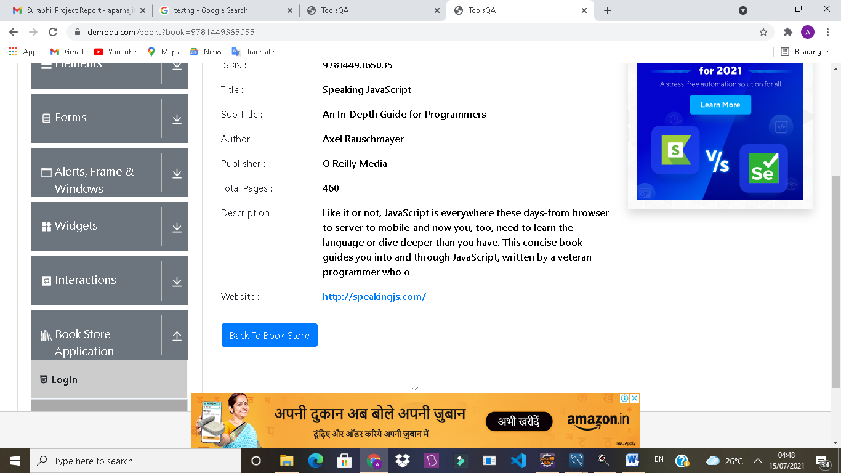

TC183- To verify the functionality of You Don’t Know JS in Book store section, to check whether it opening the details of book or not

TestNG Test Script

WebElementbook5= W.findElement(By.*linkText*("You Don't Know JS"));

JavascriptExecutorjsbook5 = (JavascriptExecutor) W;

jsbook5.executeScript("arguments[0].scrollIntoView();" , book5);

book5.click();

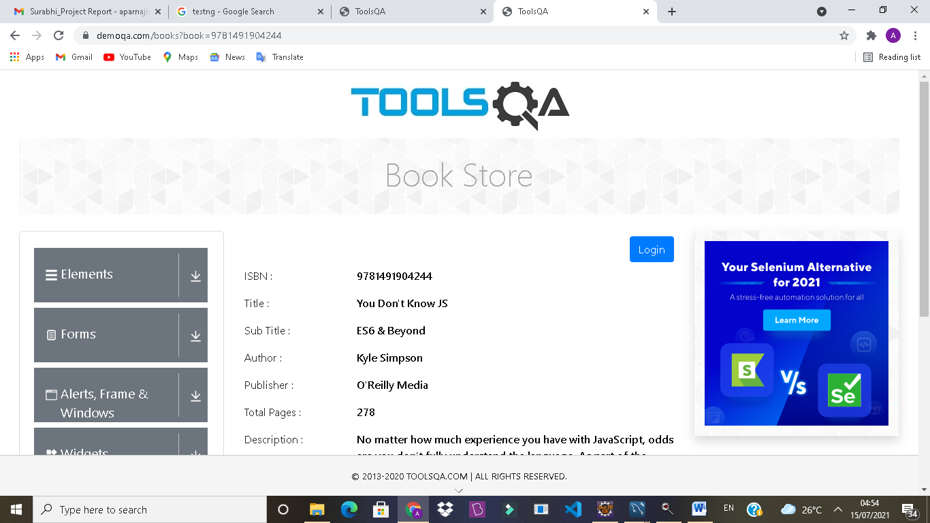

TC184 - To verify the functionality of Back to Book store button from You Don’t Know JS to Book store section

TestNG Test Script

WebElementclick5= W.findElement(By.*id*("addNewRecordButton"));

JavascriptExecutorjsclick5 = (JavascriptExecutor) W;

jsclick5.executeScript("arguments[0].scrollIntoView();" , click5);

click5.click();

Thread.*sleep*(4000);

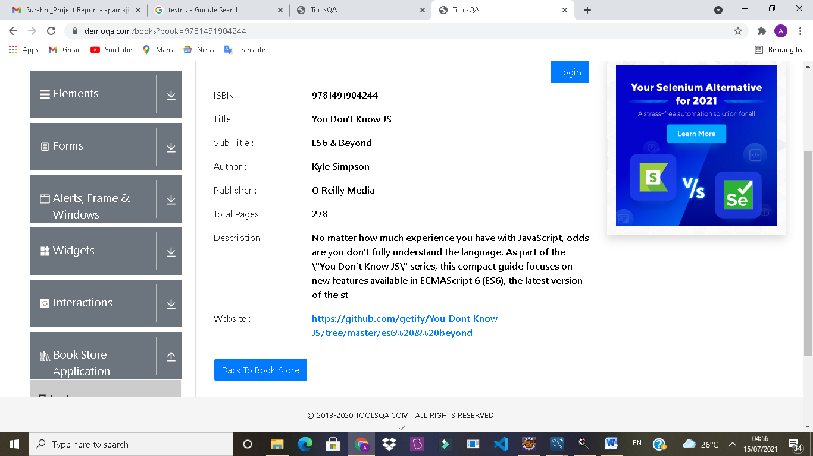

TC185- To verify the functionality of Programming JavaScript in Book store section, to check whether it opening the details of book or not

TestNG Test Script

WebElementbook6 = W.findElement(By.*linkText*("Programming JavaScript Applications"));

JavascriptExecutorjsbook6 = (JavascriptExecutor) W;

jsbook6.executeScript("arguments[0].scrollIntoView();" , book6);

book6.click();

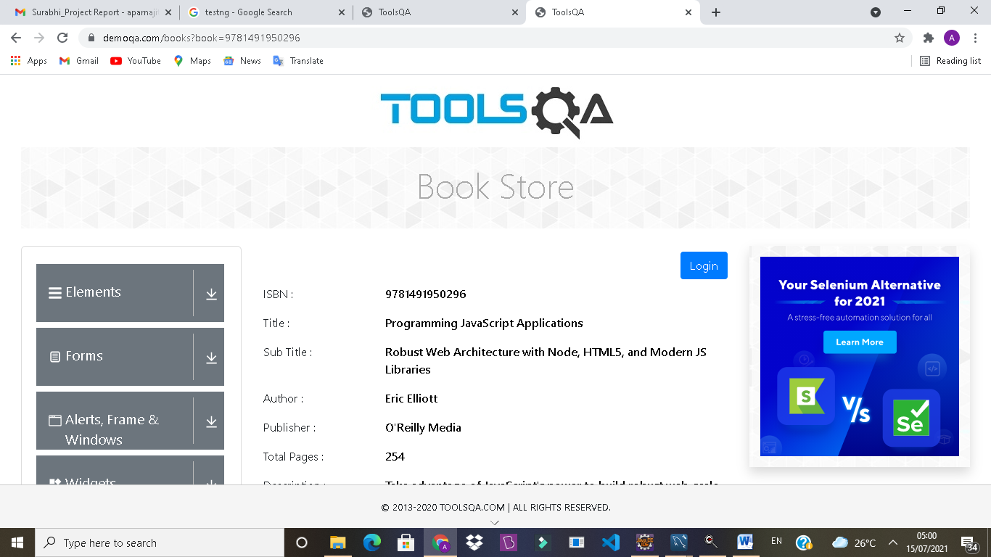

TC186 - To verify the functionality of Back to Book store button from Programming JavaScript to Book store section

TestNG Test Script

WebElementclick6= W.findElement(By.*id*("addNewRecordButton"));

JavascriptExecutorjsclick6 = (JavascriptExecutor) W;

jsclick6.executeScript("arguments[0].scrollIntoView();" , click6);

click6.click();

Thread.*sleep*(4000);

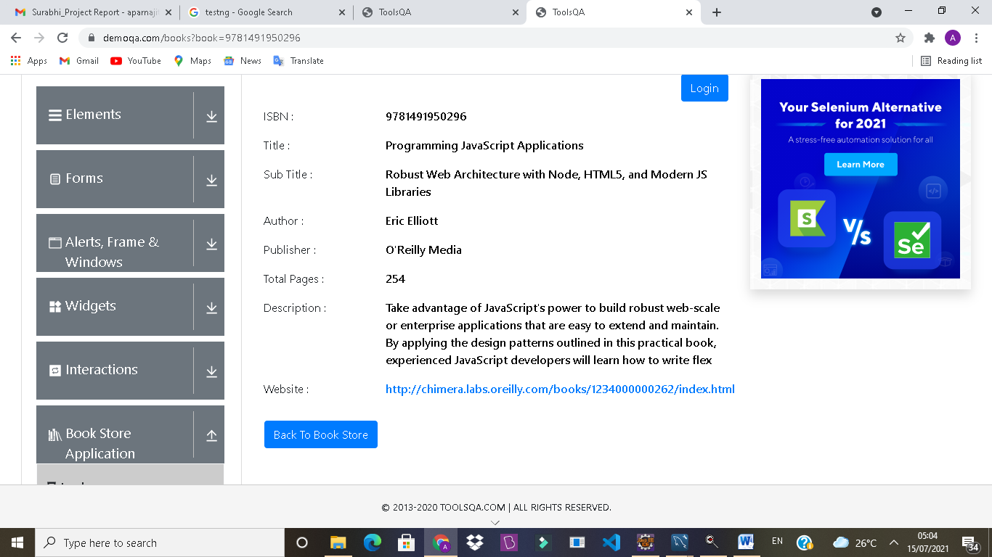

TC187- To verify the functionality of Eloquent JavaScript in Book store section, to check whether it opening the details of book or not

TestNG Test Script

WebElementbook7= W.findElement(By.*linkText*("Eloquent JavaScript, Second Edition"));

JavascriptExecutorjsbook7 = (JavascriptExecutor) W;

jsbook7.executeScript("arguments[0].scrollIntoView();" , book7);

book7.click();

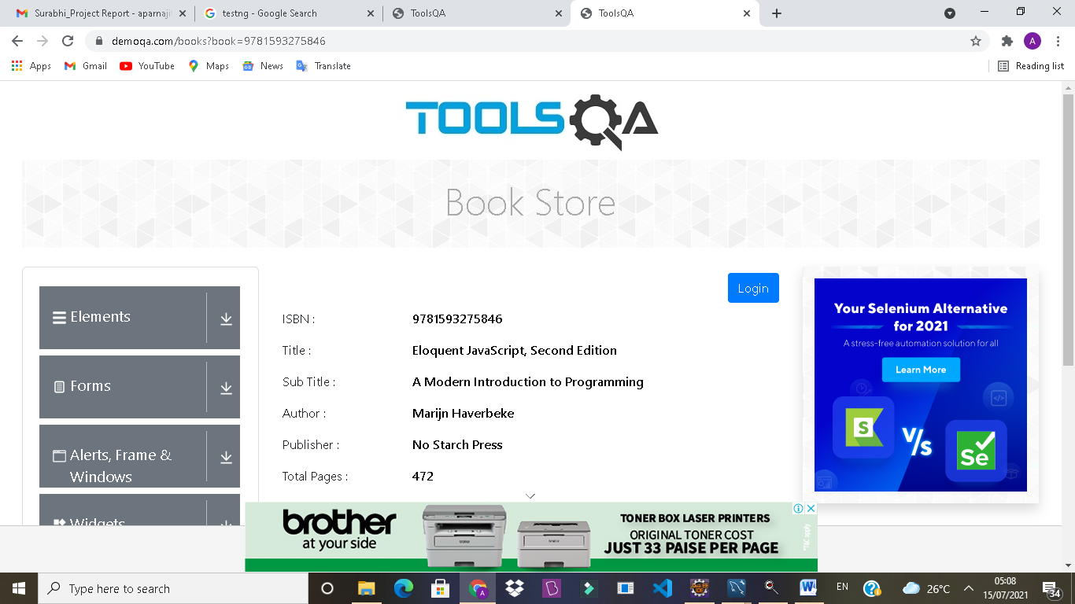

TC188 - To verify the functionality of Back to Book store button from Programming JavaScript to Book store section

TestNG Test Script

WebElementclick7= W.findElement(By.*id*("addNewRecordButton"));

JavascriptExecutorjsclick7 = (JavascriptExecutor) W;

jsclick7.executeScript("arguments[0].scrollIntoView();" , click7);

click7.click();

Thread.*sleep*(4000);

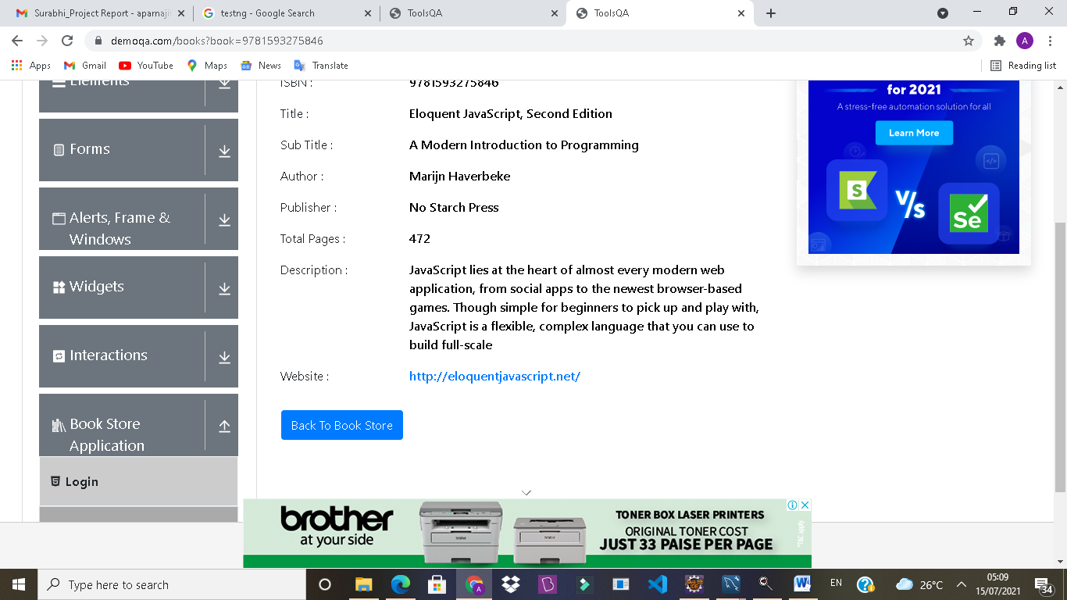

TC189- To verify the functionality of Understanding ECMA Scripting in Book store section, to check whether it opening the details of book or not

TestNG Test Script

WebElementbook8= W.findElement(By.*linkText*("Understanding ECMAScript 6"));

JavascriptExecutorjsbook8 = (JavascriptExecutor) W;

jsbook8.executeScript("arguments[0].scrollIntoView();" , book8);

book8.click();

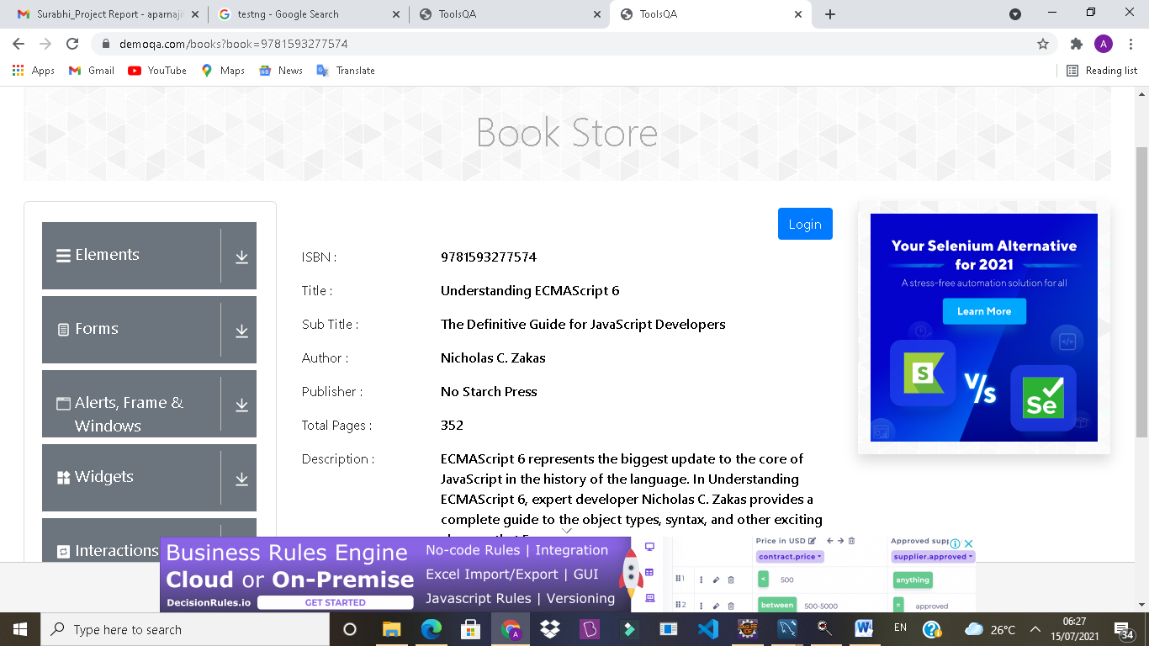

TC190 - To verify the functionality of Back to Book store button from Understanding ECMA Scripting to Book store section

TestNG Test Script

WebElementclick8= W.findElement(By.*id*("addNewRecordButton"));

JavascriptExecutorjsclick8 = (JavascriptExecutor) W;

jsclick8.executeScript("arguments[0].scrollIntoView();" , click8);

click8.click();

Thread.*sleep*(4000);

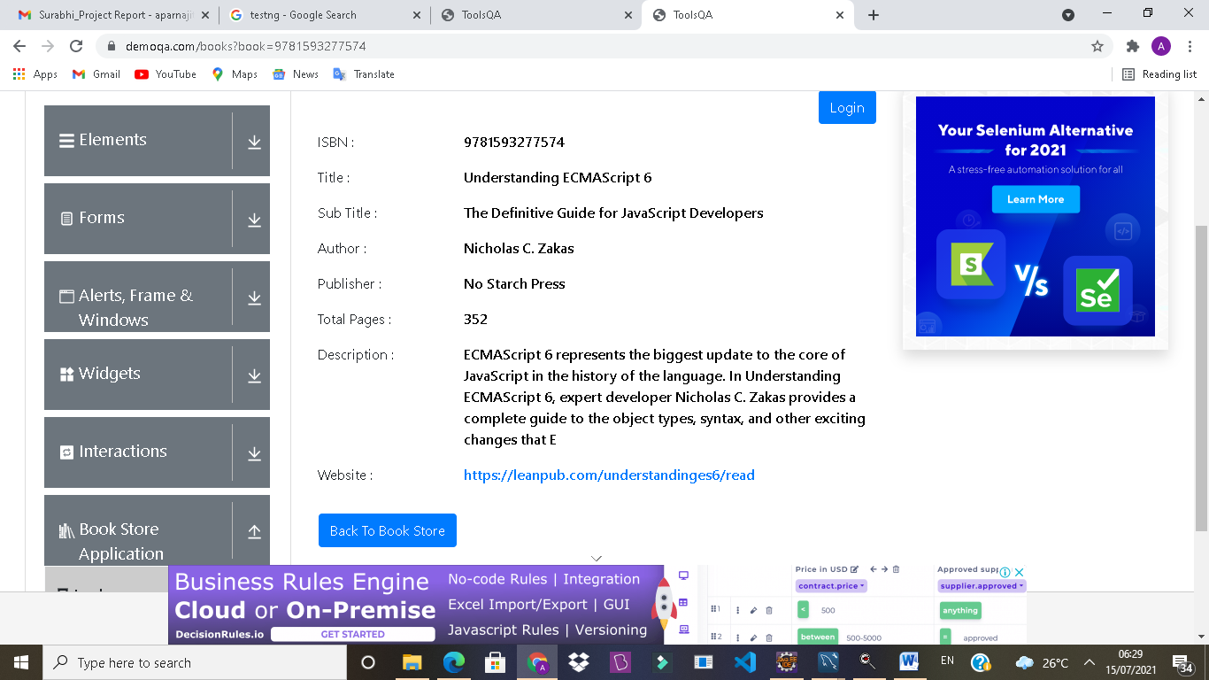

TC191- To verify the functionality of Search button in Book store section

TestNG Test Script

W.findElement(By.*xpath*("//input[@id='searchBox']")).sendKeys("Git Pocket Guide");

W.findElement(By.*xpath*("//body/div[@id='app']/div[1]/div[1]/div[2]/div[2]/div[1]/div[1]/div[1]/div[1]/div[1]/span[1]/span[1]/*[1]")).click();

Thread.*sleep*(3000);

TC192- To verify the functionality of login button in Book store section

TestNG Test Script

W.findElement(By.*id*("login")).click();

}

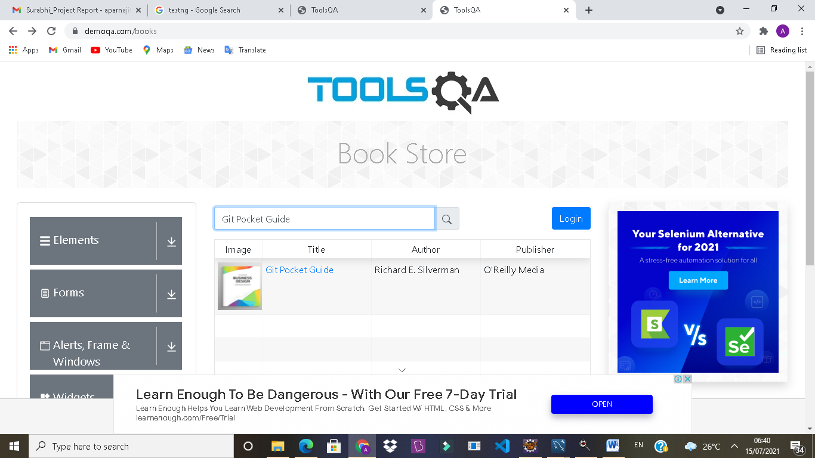

TC193- To verify the functionality of Learning JavaScript Design in Book store section, to check whether it opening the details of book or not

TestNG Test Script

@Test(enabled = **false**)

**publicvoid** bookpage2() **throws**InterruptedException {

WebElementbook2=

W.findElement(By.*linkText*("Learning JavaScript Design Patterns"));

JavascriptExecutorjsbook2 = (JavascriptExecutor) W;

jsbook2.executeScript("arguments[0].scrollIntoView();" , book2);

book2.click();

}

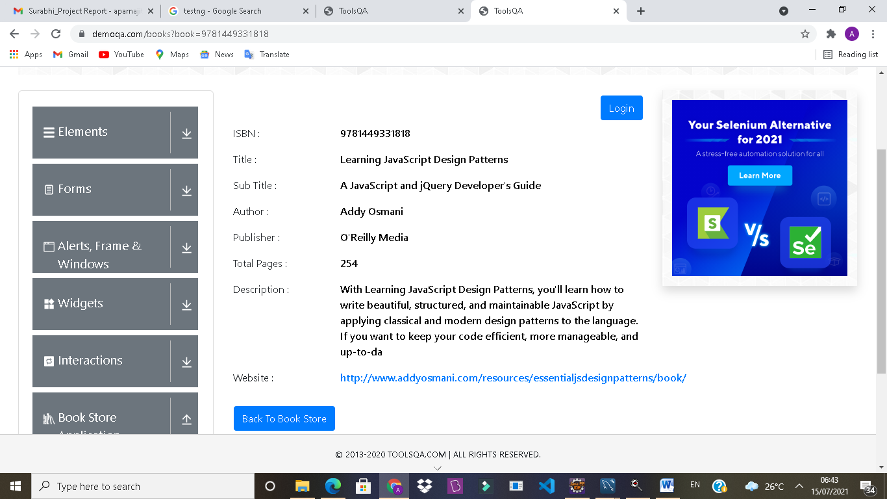

**OUTPUT/DEFECT:**

Back To Book Store button is not working in Learning JavaScript Design which is in Book Store section

TC194- To verify the functionality of submodule (Profile section) of Book store Application module

TestNG Test Script

@Test(dependsOnMethods = {"bookpage"})

**publicvoid**profilepage() **throws**InterruptedException {

W.navigate().to("https://demoqa.com/profile");

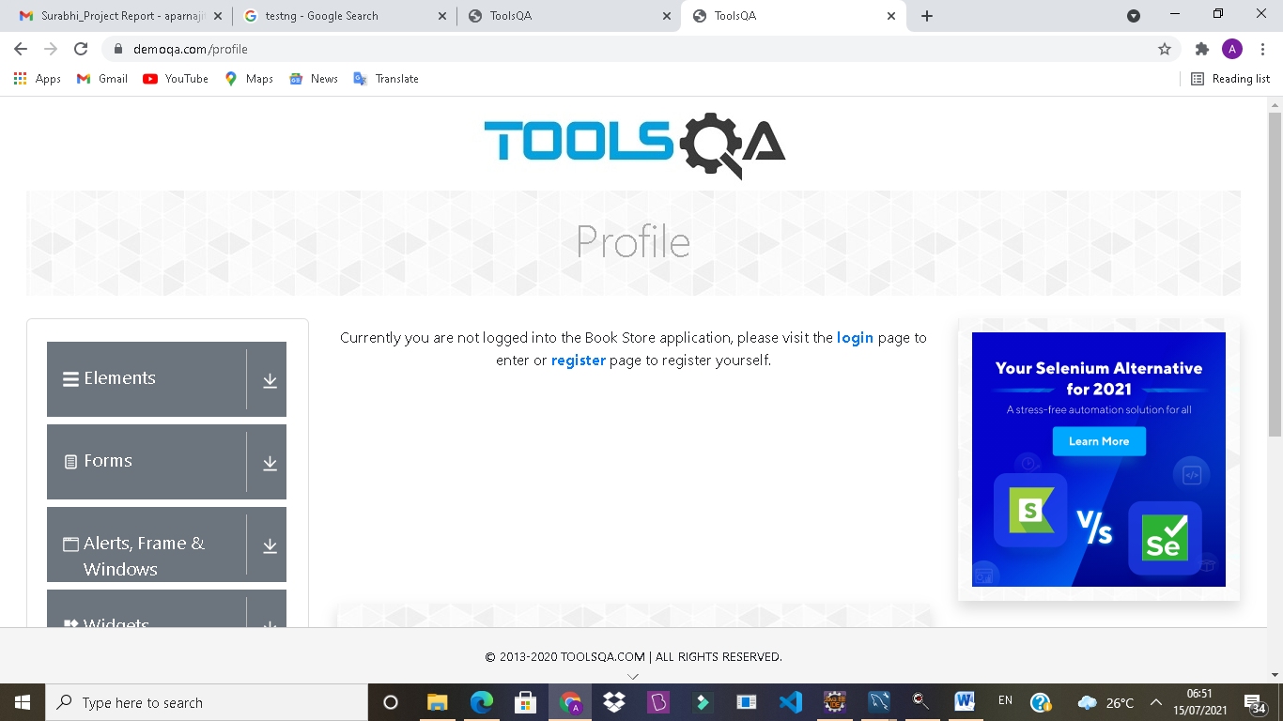

TC195- To verify the functionality of login icon in Profile section

TestNG Test Script

Thread.*sleep*(2000);

W.findElement(By.*linkText*("login")).click();

System.***out***.println("title " +W.getTitle());

System.***out***.println("URL " +W.getCurrentUrl());

Thread.*sleep*(2000) ;

**OUTPUT** :-Title is ToolsQA

URL is <https://demoqa.com/login>

TC196- To verify the functionality of Register icon in Profile section

TestNG Test Script

W.navigate().to("https://demoqa.com/profile");

Thread.*sleep*(2000);

W.findElement(By.*linkText*("register")).click();

System.***out***.println("title " +W.getTitle());

System.***out***.println("URL " +W.getCurrentUrl());

}

**OUTPUT:-**Title is ToolsQA

URLis <https://demoqa.com/register>

TC197- To verify the functionality of submodule (Book Store API section) of Book store Application module

TestNG Test Script

@Test(dependsOnMethods = {"profilepage"})

**publicvoid**bookapipage() **throws**InterruptedException {

W.navigate().to("https://demoqa.com/swagger/");

Thread.*sleep*(3000);

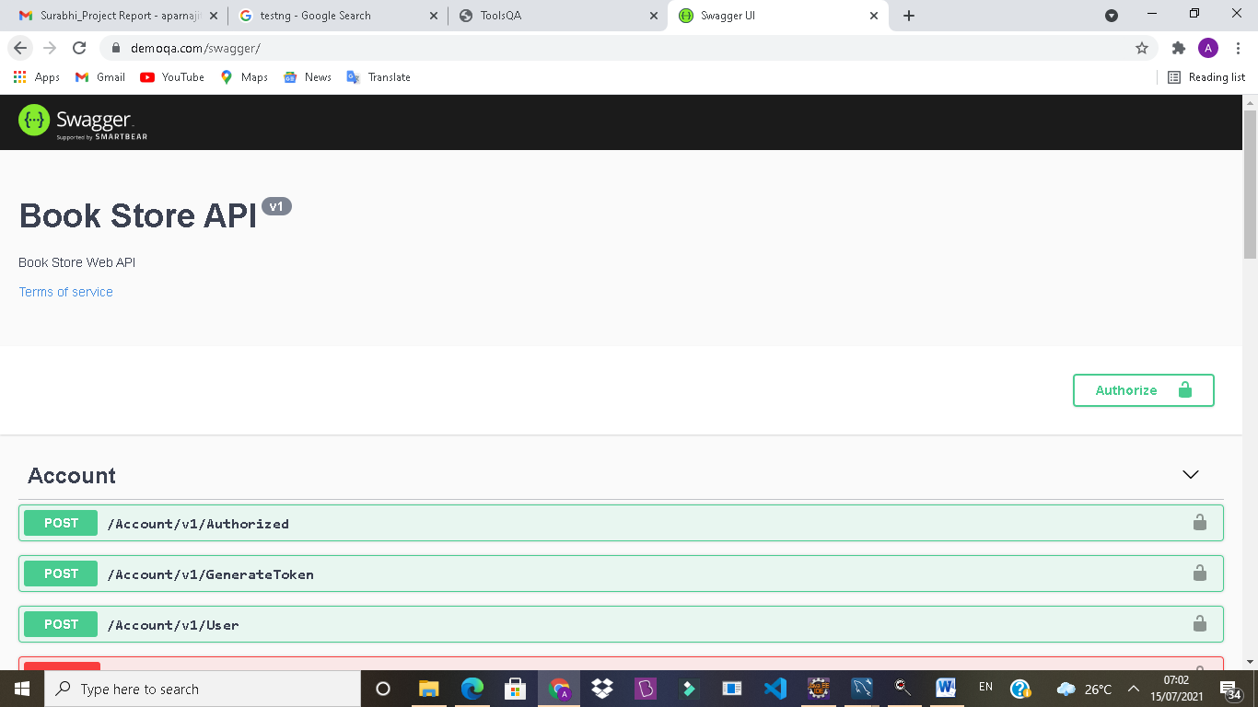

TC198- To verify the functionality of scrolling page in Book store API section

TestNG Test Script

JavascriptExecutorjs = (JavascriptExecutor) W;

js.executeScript("window.scrollTo(0,document.body.scrollHeight)");

System.***out***.println("page end");

Thread.*sleep*(5000);

}

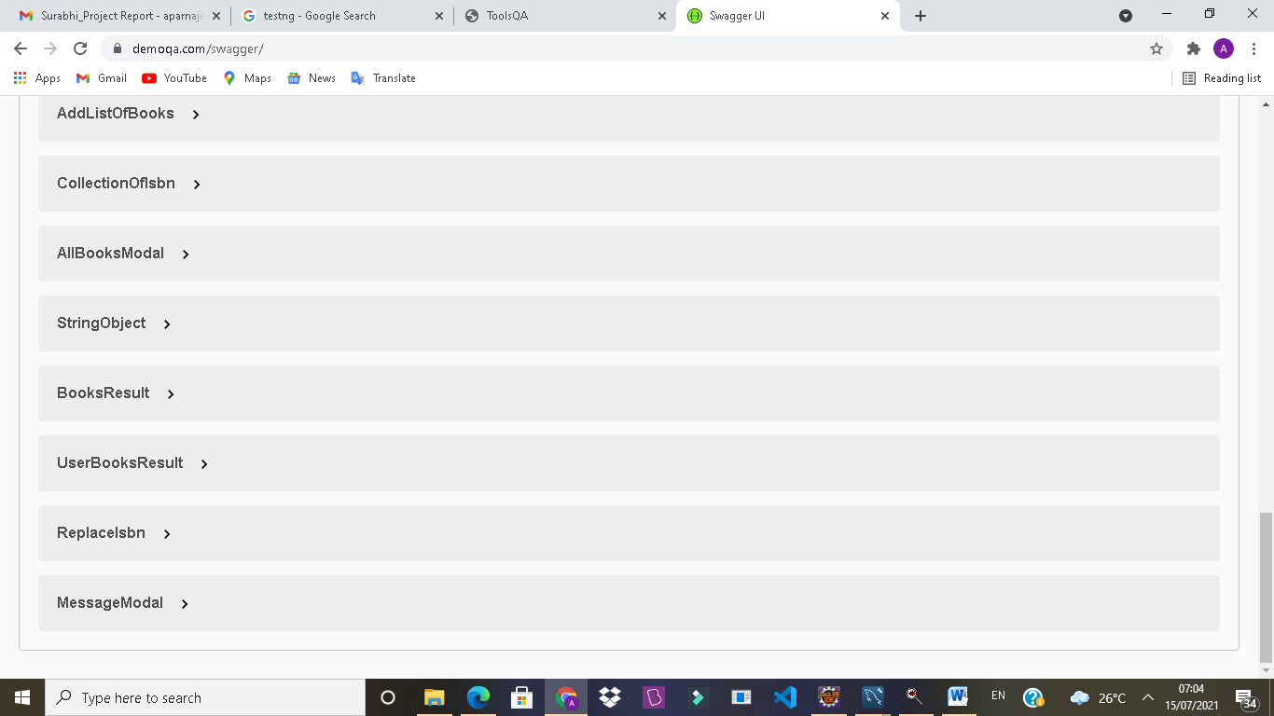

TC199- To verify the functionality of closing the current module

Testng Test Script

@AfterTest

**publicvoid**afterTest() {

W.close();

}

}

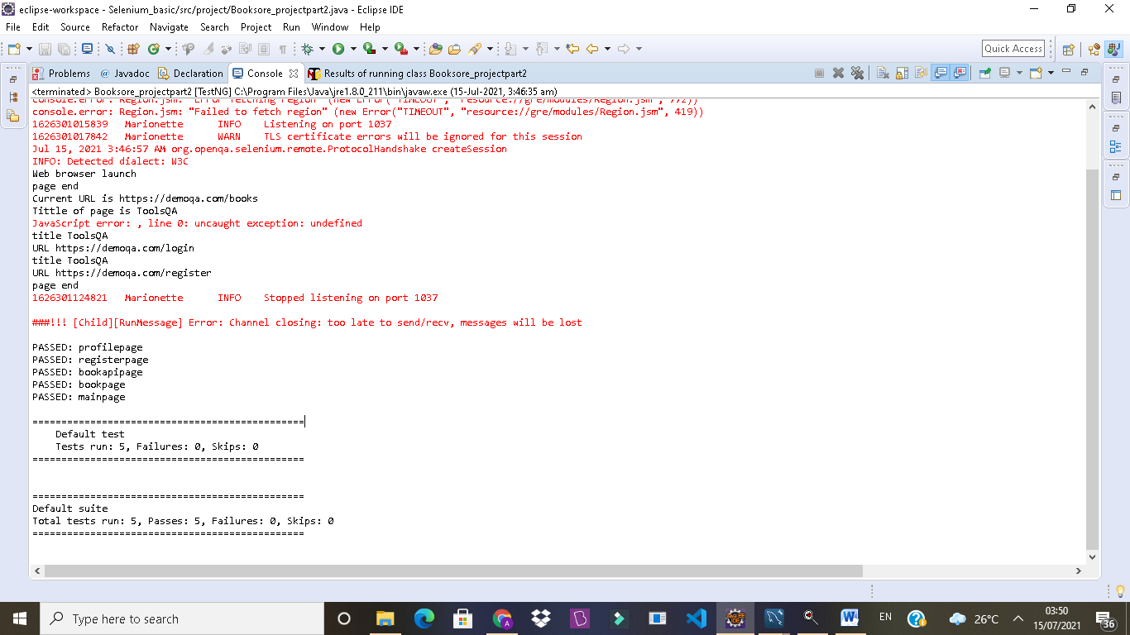

DEFECT raised in Jira tool

Module1:

D01: Enable to click on “No” radio Button

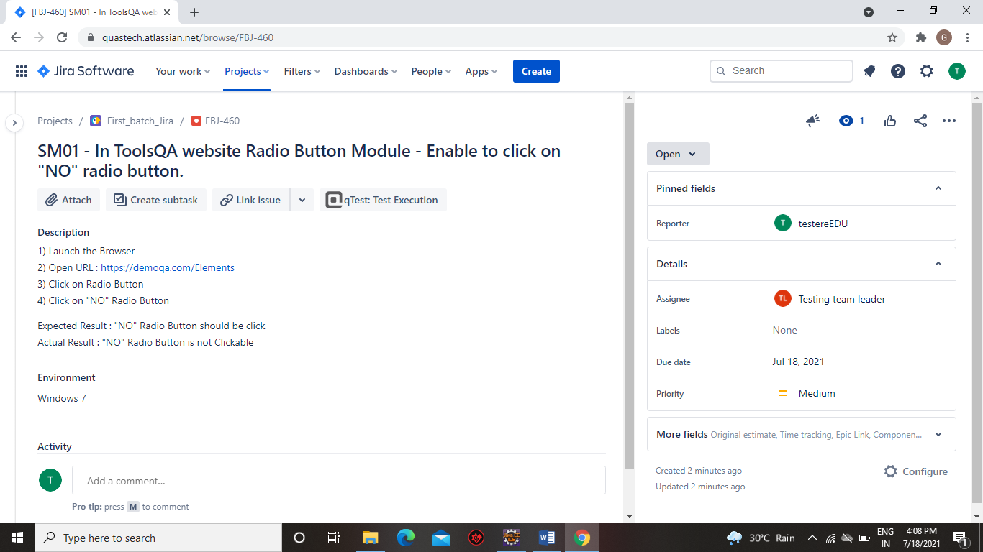

D02:Enable to click on “Click” Button

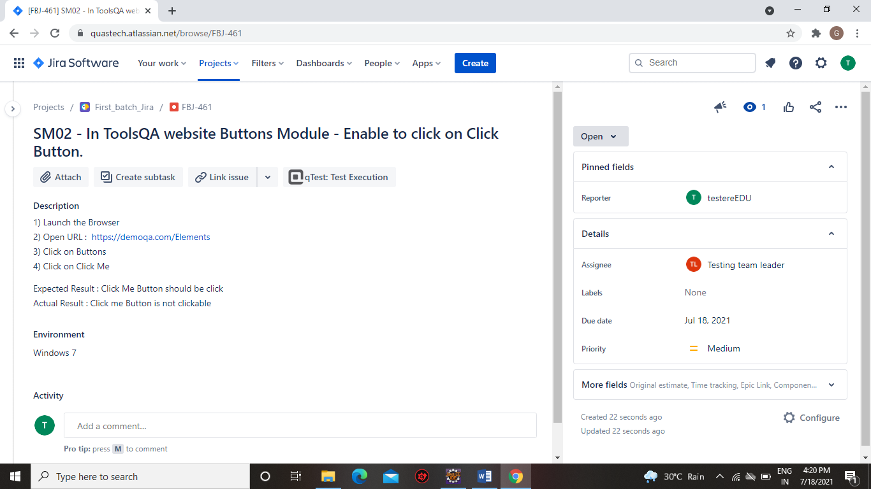

Module 2:

Defect 01 : To Raise defect for Subject in Jira Tool



Defect 02: To Raise defect for State and City in Jira Tool

**

Module 3:

Defect 01:-In Alert option wait alert ok Button is Not clickable by Automatic way but its work manually Properly

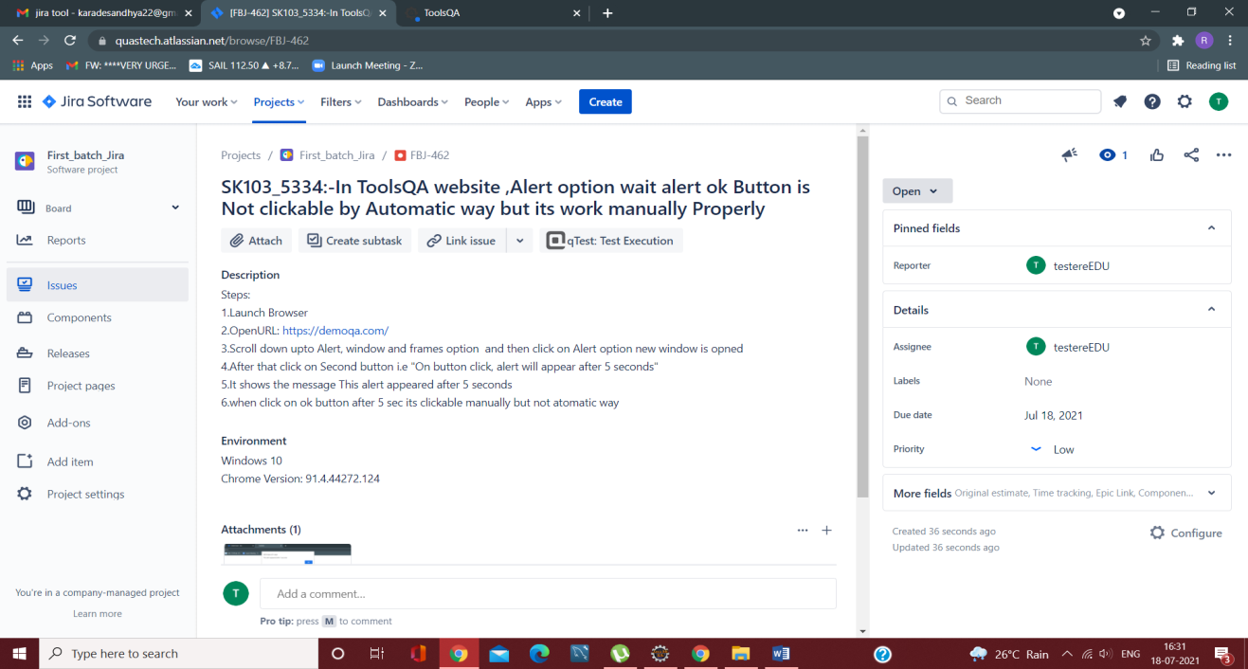

Defect 02:-In Alert option promt alert not showing text while running the program

**



Module 4:

D01: Text field is not working

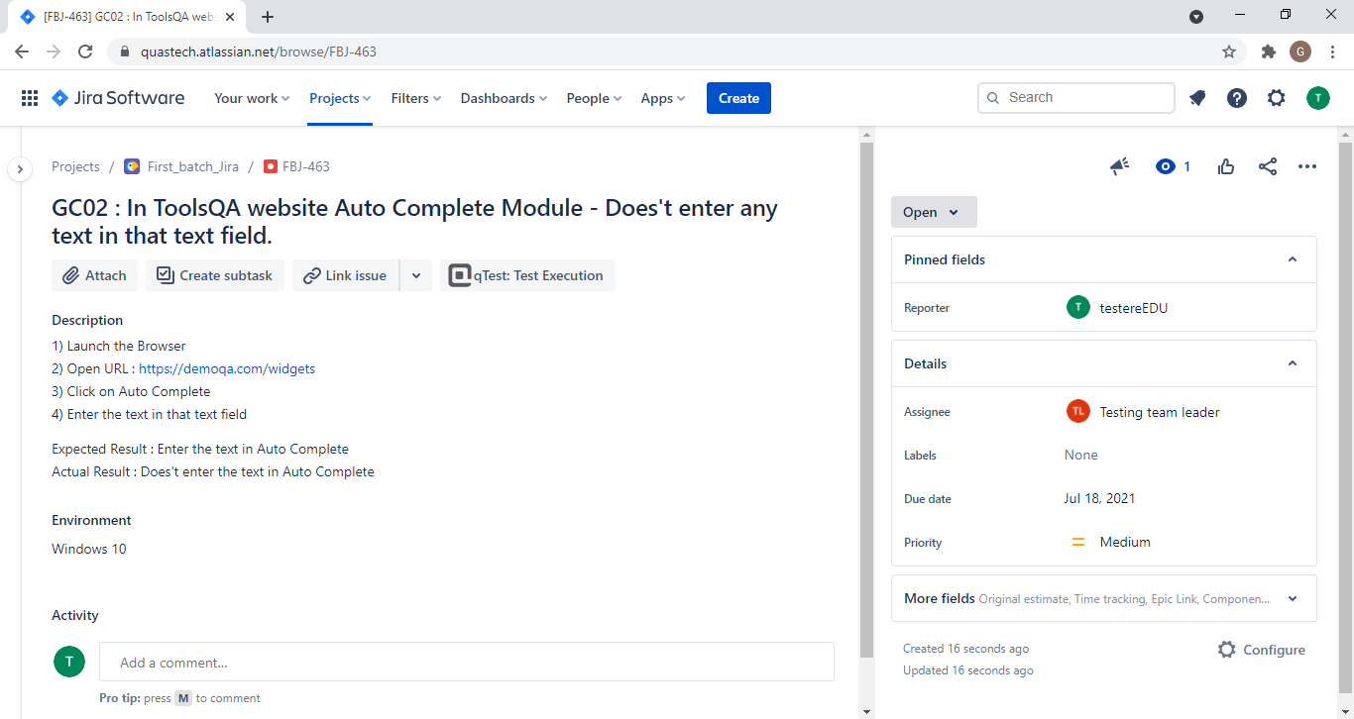

DO2: More tab button is not working

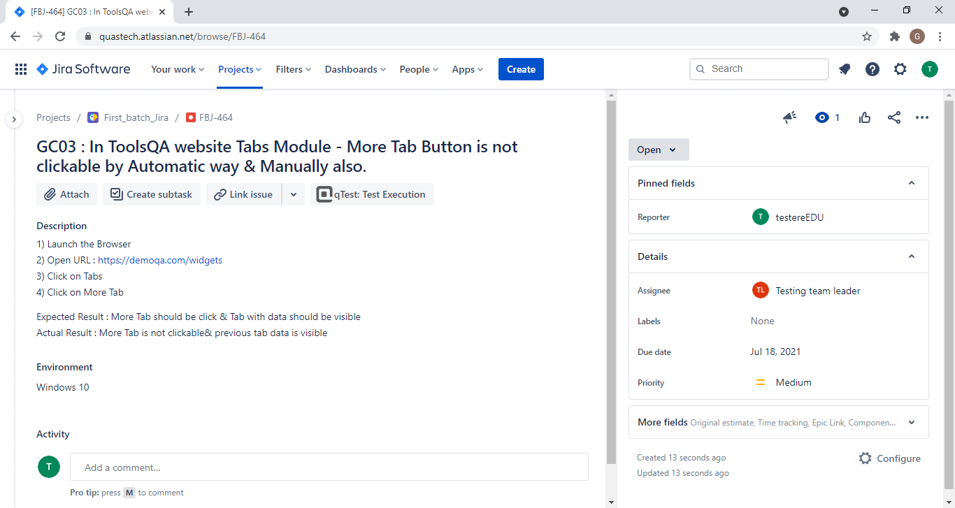

Module 5:

D01: Unable to click

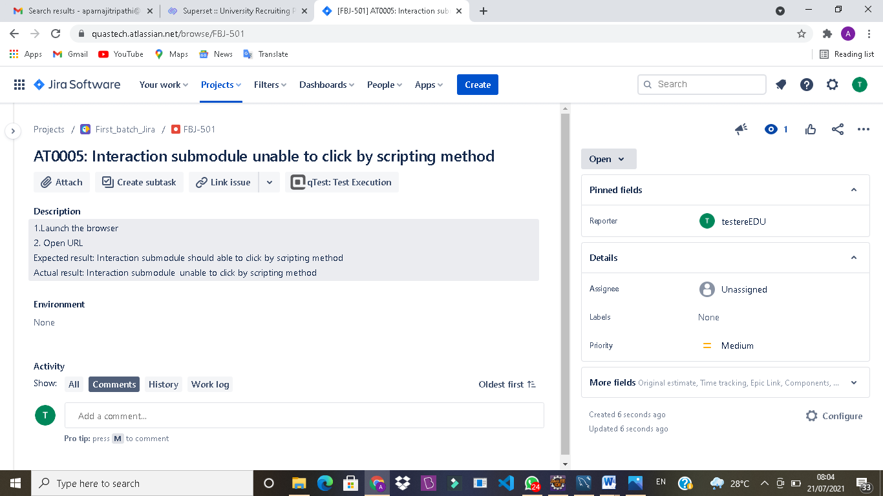

D02: Unable to select 7,8, and 9

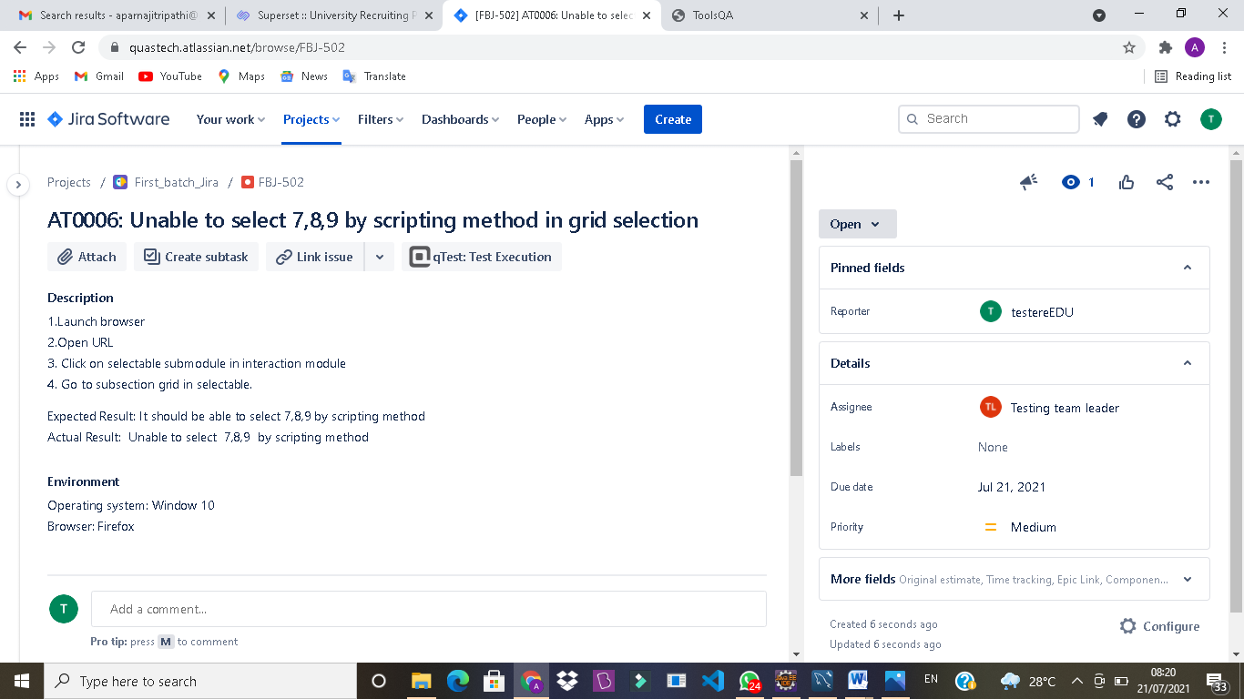

D03: Not Acceptable box is dropping

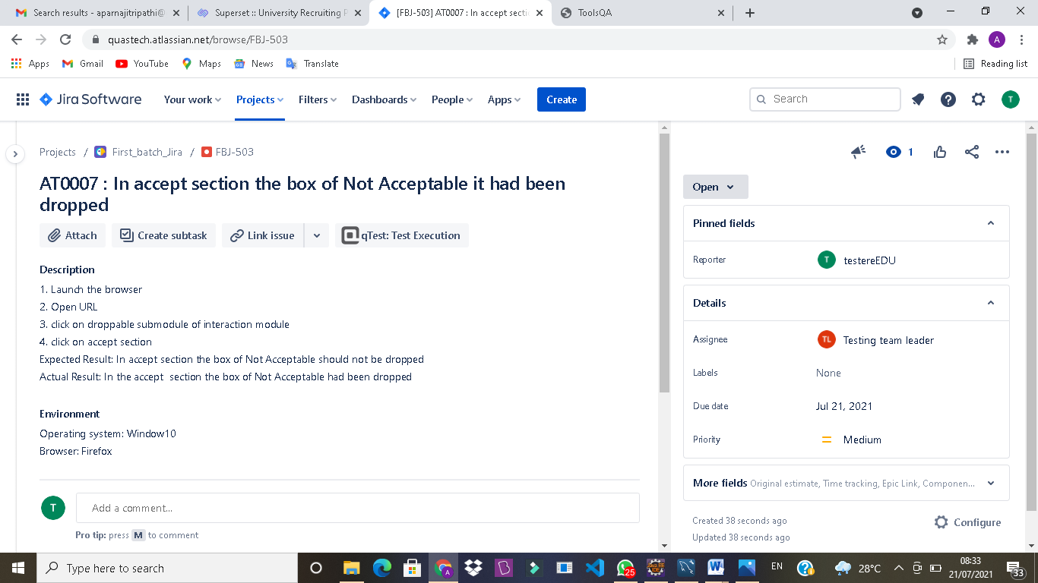

D04: Box is not dropping as per the requirement

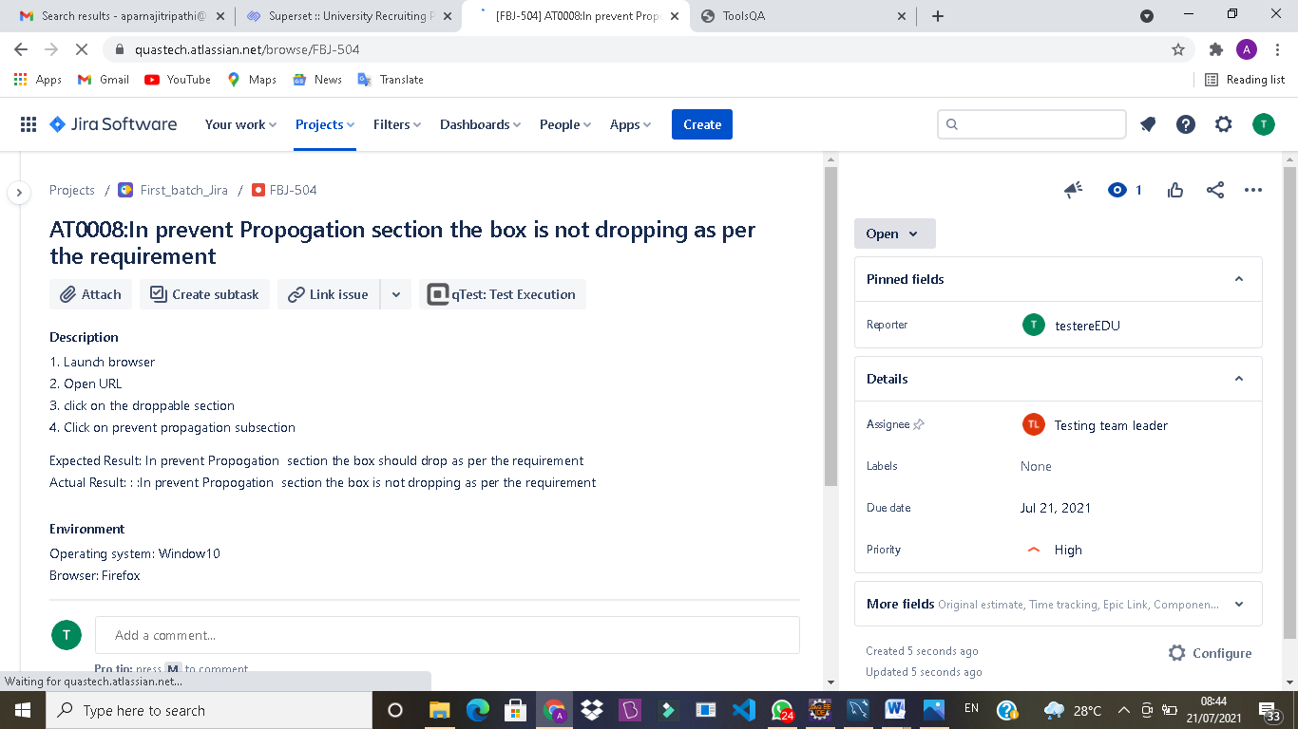

Module 6:

D01: Arrow functionality is not working

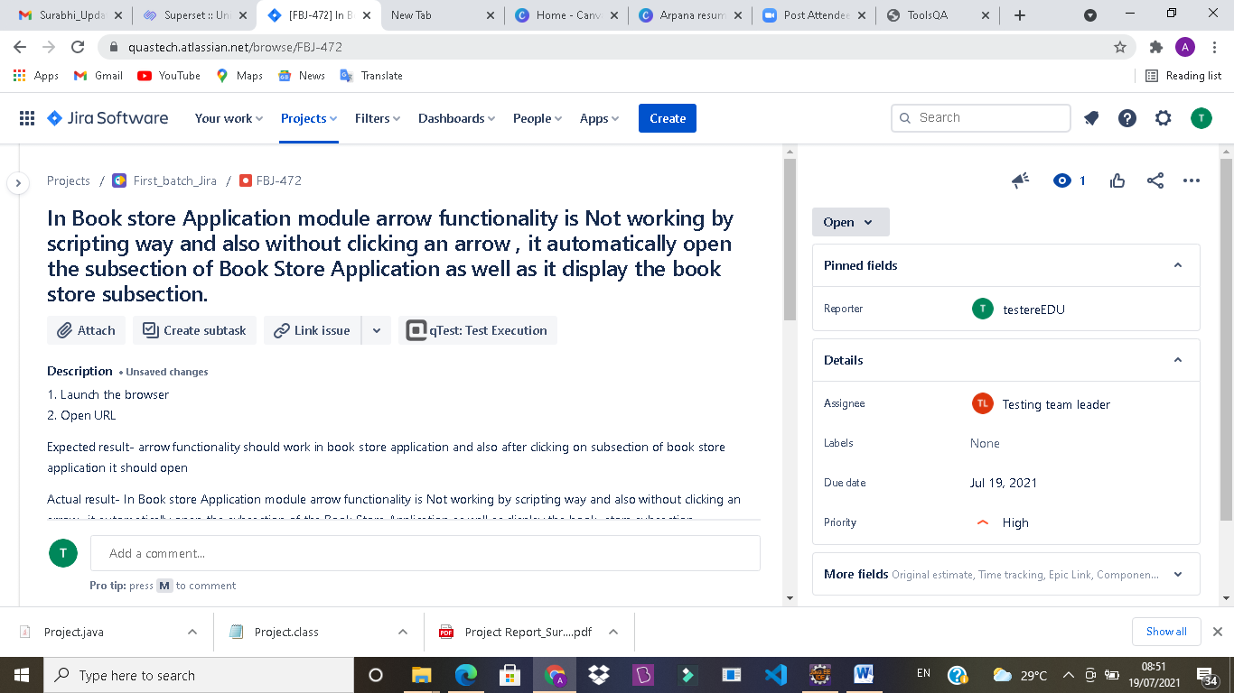

D02: Form don’t have validation

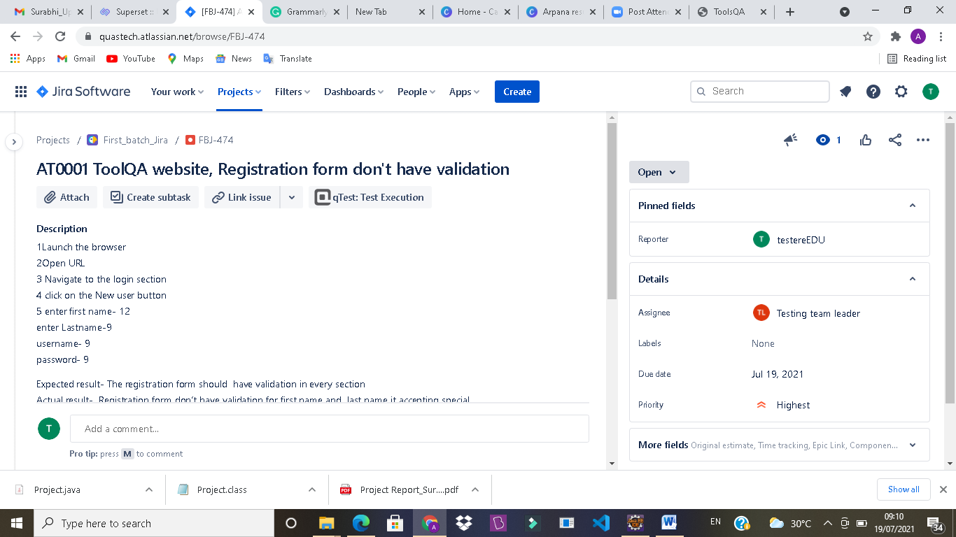

D03: Back To Book Store button is not working

